# Spinach Pie (Byrek me Spinaq)

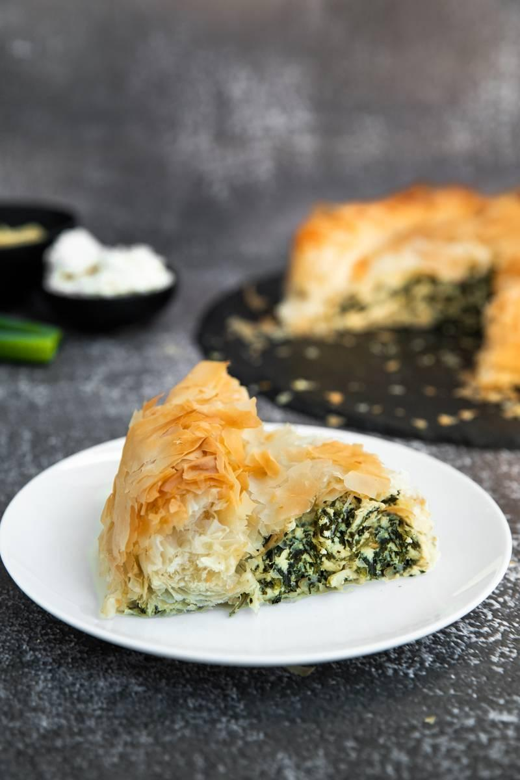

Spinach byrek is a hallmark of Albanian home cooking, cherished for its hearty, nourishing flavors. While byrek is popular across the entire country, spinach variations are particularly favored in the southern and central regions, where fertile valleys produce abundant leafy greens. Though difficult to pinpoint its first recorded mention, variations of green-filled pies appear in family recipe collections passed down through generations, and in ethnographic studies from the early 20th century. The dish’s deep roots in Albania’s agrarian past connect it to a time when families relied on garden-grown produce and simple staple ingredients.

**Why It’s Beloved:**

Byrek me spinaq stands out for its fresh, vegetal flavor and vibrant green color. It embodies the perfect marriage of flaky pastry and tender spinach, often enriched with salty cheese or mild herbs. It’s a dish that nourishes and satisfies, making it a popular choice for breakfast, lunch, or as a centerpiece at family gatherings. Whether served hot from the oven or enjoyed at room temperature, spinach byrek is a versatile comfort food that brings people together.

**Ingredient Adjustments & Personal Touches:**

While traditional recipes call for fresh spinach and a crumbly white cheese (feta-style), feel free to adapt. Use baby spinach for a milder flavor or a mix of spinach and chard for more complexity. Add fresh herbs like dill or parsley for brightness, or a handful of chopped scallions for sweetness. If you prefer a lighter dish, brush the phyllo layers with olive oil instead of butter. For a richer filling, you might stir in a spoonful of yogurt or a beaten egg. Each small tweak can make this time-honored dish feel distinctively yours.

**Serves:** About 6-8

**Time:** Approximately 1.5 hours (including preparation and baking)

**Ingredients:**

* 12-16 sheets of phyllo dough (homemade or store-bought)
* 500-600 g (about 1 lb) fresh spinach (washed, stemmed, roughly chopped)
* 200 g (about 1 cup) crumbled white cheese (feta-style), optional but traditional
* 1 small bunch fresh dill or parsley, chopped (optional)
* 2-3 scallions, finely sliced (optional)
* 1-2 eggs (optional, for richness and binding)
* 100-150 g (about ½ cup) melted butter or olive oil (or a mixture)
* Salt and pepper to taste

**Method:**

1. **Prepare the Filling:** Place the chopped spinach in a large bowl. If it’s very moist, pat it dry or squeeze gently to remove excess water. Add the crumbled cheese (if using), fresh herbs, and scallions. Beat the eggs lightly (if using) and mix them in. Season with salt and pepper, keeping in mind the saltiness of the cheese.
2. **Layer the Phyllo:** Preheat your oven to 180°C (350°F). Lightly grease a baking dish. Lay a sheet of phyllo in the dish and brush it lightly with butter or oil. Repeat with about half of the phyllo, layering and brushing each sheet. Don’t worry about perfection; the layers can be rustic.
3. **Add the Filling:** Spread the spinach mixture evenly over the prepared layers. Top with the remaining phyllo sheets, brushing each with butter or oil. Give the top layer an extra brush for that golden, crisp finish.
4. **Score & Bake:** With a sharp knife, gently score the top layers into portions—this helps steam escape and will make slicing easier later. Transfer to the oven and bake for around 40-50 minutes, or until the byrek is deeply golden and crisp on top.
5. **Rest & Serve:** Let the pie rest for about 10 minutes before serving. It’s wonderful warm, but also tastes great at room temperature. Serve it as a main dish accompanied by a simple salad, or as part of a larger spread at gatherings.

**Your Adaptations:**

This recipe invites experimentation. Vary the greens based on what’s fresh at your market, incorporate new herbs for complexity, or adjust the richness by altering the fat content. The joy of byrek me spinaq lies not only in its traditional flavors but also in the freedom to mold this heritage dish into something personal and meaningful for your family’s table.

# Cheese-Filled Savory Pie (Byrek me djathë)

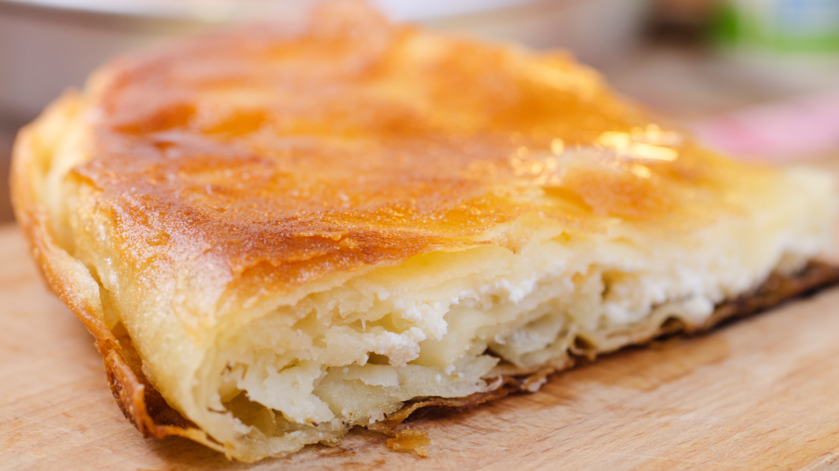

Byrek, a layered savory pie often made with thin phyllo dough, is a cornerstone of Albanian cuisine. Cheese-filled byrek (Byrek me djathë) is among the most ubiquitous variations. While this dish is enjoyed countrywide, its strongest roots are often associated with the central and southern regions of Albania, especially areas near Berat and Elbasan, where dairy traditions flourish. Early accounts of byrek-like pastries appear in written documents and travelers’ notes from the late Ottoman period (19th century), though its heritage likely stretches back centuries earlier, evolving from the broader Balkan and Mediterranean pastry traditions.

**Why It’s Beloved:**

Byrek is comfort food—the sort of dish you encounter at family gatherings, village festivals, or as an everyday meal in Albanian households. It’s simple and approachable, yet endlessly adaptable. Cheese byrek in particular spotlights the creamy, slightly tangy character of Albania’s local white cheeses (similar to feta), encased in delicate, flaky layers of dough.

**Ingredient Adjustments & Personal Touches:**

This recipe is forgiving. While traditional Albanian byrek often relies on homemade dough rolled into paper-thin sheets, store-bought phyllo pastry can be used for convenience. The filling typically calls for a mildly salty white cheese—feta or a local equivalent—but you could blend in other cheeses like ricotta or a crumbly goat’s cheese for personal flair. Play with herbs, too: a bit of chopped dill or parsley can add a fresh note. Feel free to adjust the saltiness of the filling and the richness of the butter or oil used to brush the layers, depending on your family’s taste.

**Serves:** About 6-8

**Time:** 1.5 hours (including assembly and baking)

**Ingredients:**

* 12-16 sheets of thin phyllo dough (homemade or store-bought)
* 400-500 g (about 2 cups) of crumbled white cheese (feta-style)
* 2-3 large eggs (optional, for binding and richness)
* 100-150 g (about ½ cup) melted butter or olive oil (or a mix)
* A few tablespoons of milk or yogurt (optional, for a creamier filling)
* Salt to taste (if needed, depending on cheese saltiness)
* Optional chopped herbs (dill, parsley, or mint)

**Method:**

1. **Prepare the Filling:** In a mixing bowl, crumble the white cheese. If using eggs, beat them lightly and fold them into the cheese along with a splash of milk or yogurt. Taste and adjust saltiness. If desired, stir in a small handful of finely chopped fresh herbs.
2. **Layer the Phyllo:** Preheat your oven to 180°C (350°F). Brush a large baking dish with butter or oil. Lay down a sheet of phyllo and lightly brush it with butter or oil. Repeat with about half the phyllo sheets, layering one on top of another. Don’t worry if sheets tear; just piece them together—it all bakes beautifully.
3. **Add the Filling:** Spread the cheese mixture evenly over the layered phyllo. Top with the remaining phyllo sheets, brushing each layer lightly with butter or oil. Reserve a bit more butter for the top layer so it crisps nicely.
4. **Score & Bake:** Using a sharp knife, gently score the top layers of phyllo into serving squares or diamond shapes without cutting all the way through to the bottom. This helps steam escape and makes slicing easier later. Bake for about 40-50 minutes or until the top is golden and crispy.
5. **Rest & Serve:** Allow the byrek to cool for at least 10 minutes before serving. Serve warm or at room temperature, accompanied by fresh salads, pickled vegetables, or a simple cup of yogurt. It can be enjoyed as a main dish or a savory snack throughout the day.

**Your Adaptations:**

Feel free to make this byrek your own. Adjust the richness by using more or less butter, swap in half whole-wheat phyllo for a nuttier flavor, or experiment with other mild cheeses. The key is harmony in flavors and a balance of flaky dough and creamy filling—true to its Albanian roots, but always open to your personal twist.

# Meat Pie (Byrek me mish)



Byrek me mish is a savory Albanian pie filled with seasoned meat, often ground beef or lamb, nestled between layers of crisp, flaky pastry. This hearty variant of byrek has historical links to rural communities throughout Albania, though it’s particularly beloved in northern and central regions, where meat pies have long been a comforting staple during colder months. References to meat-filled pastries can be found in local culinary manuscripts and oral histories dating back to the late Ottoman era (19th century), suggesting that as trade and livestock farming grew, so did the prominence of richly flavored meat pies on the Albanian table.

**Why It’s Beloved:**

This dish is a satisfying blend of tender, savory filling and delicate dough. It’s often served as a main meal, perfect for special gatherings or Sunday family lunches. Meat byrek resonates with Albanian culinary identity, balancing the robust flavors of well-seasoned meat with the subtle, buttery flakiness of its pastry layers. In its warm and aromatic embrace, families find comfort and tradition, while newcomers discover an authentic Albanian classic.

**Ingredient Adjustments & Personal Touches:**

The meat filling is flexible. Ground beef is common, but a mix of beef and lamb or even minced veal can lend complexity. Sautéed onions often provide sweetness, while a pinch of allspice or paprika adds depth—feel free to experiment with these spices. Stirring in a handful of chopped parsley or dill can introduce fresh, herbal notes. For a lighter version, brush the phyllo with olive oil instead of butter. For a richer taste, add a spoonful of yogurt to the meat mixture. The idea is to start with the core tradition, then adjust to your family’s tastes.

**Serves:** About 6-8

**Time:** About 1.5 hours (including preparation and baking)

**Ingredients:**

* 12-16 sheets of phyllo dough (homemade or store-bought)
* 500 g (about 1 lb) ground beef, lamb, or a mixture
* 1 large onion, finely chopped
* 2-3 tbsp olive oil or butter for sautéing the filling
* 100-150 g (about ½ cup) melted butter or olive oil for brushing the pastry
* Salt and pepper to taste
* Optional spices: a pinch of allspice, paprika, or chili flakes (to taste)
* Optional herbs: chopped parsley or dill (a small handful)
* Optional 1-2 tbsp yogurt (for richness in the filling)

**Method:**

1. **Prepare the Filling:** In a large skillet over medium heat, warm the olive oil or butter. Add the chopped onion and sauté until it turns translucent. Add the ground meat, breaking it up with a wooden spoon as it cooks. Season with salt, pepper, and any chosen spices. Cook until the meat is browned and the excess liquid evaporates. Stir in fresh herbs and yogurt if using, then taste and adjust seasoning.
2. **Layer the Phyllo:** Preheat your oven to 180°C (350°F). Brush a baking dish with melted butter or oil. Lay down one sheet of phyllo and brush it lightly with butter or oil. Repeat with about half of the phyllo sheets. It’s fine if sheets tear; byrek is forgiving.
3. **Add the Filling:** Spread the cooked meat mixture evenly over the layered phyllo. Top with the remaining phyllo sheets, brushing each with butter or oil. Give the top layer a good brush so it turns crispy and golden.
4. **Score & Bake:** Use a sharp knife to gently score the top into squares or diamond shapes. This helps steam escape and makes slicing easier later. Transfer to the oven and bake for about 40-50 minutes, or until the pastry is golden and the aroma fills your kitchen.
5. **Rest & Serve:** Let the byrek sit for 10-15 minutes before cutting and serving. Enjoy it warm with a side salad, pickled vegetables, or a simple yogurt sauce. It makes for a hearty main dish, perfect for sharing.

**Your Adaptations:**

Adjust the meat type, level of spice, and richness of the filling based on what your family loves. Perhaps you prefer a lighter, herb-forward filling in the spring, or a richer, spicier version in winter. Byrek me mish is a canvas for personal expression—rooted in tradition yet flexible enough to evolve with every generation’s palate.

# Leek Pie (Byrek me presh)

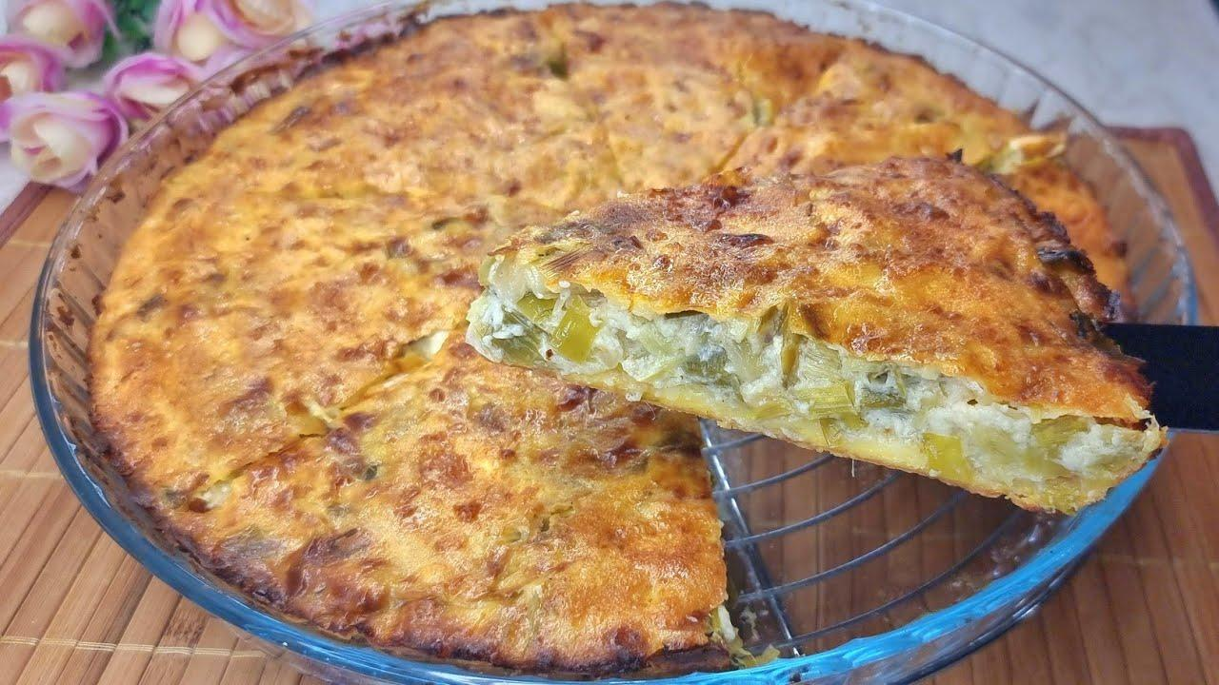

Leek pie, or Byrek me presh, is a beloved Albanian specialty that bridges the gap between hearty comfort food and the subtle elegance of garden-fresh produce. Its presence is felt strongly in central and southeastern Albania, where fertile soils and a tradition of small-scale farming make fresh leeks readily available. While exact historical references are sparse, dishes of this nature—vegetable-stuffed pastries—appear in local culinary folklore, market food traditions, and traveler accounts from the early 20th century. Over time, regional variations emerged, with some families adding a touch of dairy or herbs, ensuring that leek byrek remains both a culinary heirloom and a canvas for personal flair.

**Why It’s Beloved:**

Gentle and mildly sweet, leeks offer a distinct flavor that sets this pie apart from more robust byrek fillings. In Byrek me presh, the delicate onion-like sweetness of the leeks pairs beautifully with the flaky phyllo, creating a balanced, aromatic dish. Often prepared for family gatherings or as a comforting midday meal, this pie speaks to the Albanian ethos of savoring simple, honest ingredients prepared with care.

**Ingredient Adjustments & Personal Touches:**

Traditionally, finely chopped leeks are lightly sautéed and seasoned with salt and pepper. You can enrich the filling by adding a handful of crumbled white cheese (feta-style) or a dollop of yogurt for creaminess. For an herbal dimension, try a sprinkle of fresh dill or parsley. If you prefer a lighter version, use olive oil for brushing the phyllo; for more indulgence, opt for butter. The idea is to let the subtle leek flavor shine while giving yourself freedom to tailor the richness and complexity to your family’s palate.

**Serves:** About 6-8

**Time:** About 1.5 hours (including preparation and baking)

**Ingredients:**

* 12-16 sheets of phyllo dough (homemade or store-bought)
* 4-5 large leeks (white and light green parts), cleaned and thinly sliced
* 2-3 tbsp olive oil or butter (for sautéing the leeks)
* 100-150 g (about ½ cup) melted butter or olive oil (for brushing the phyllo)
* Salt and pepper to taste
* Optional: 100-150 g (about 1 cup) crumbled white cheese (feta-style)
* Optional: 1-2 tbsp yogurt
* Optional: A handful of chopped dill or parsley

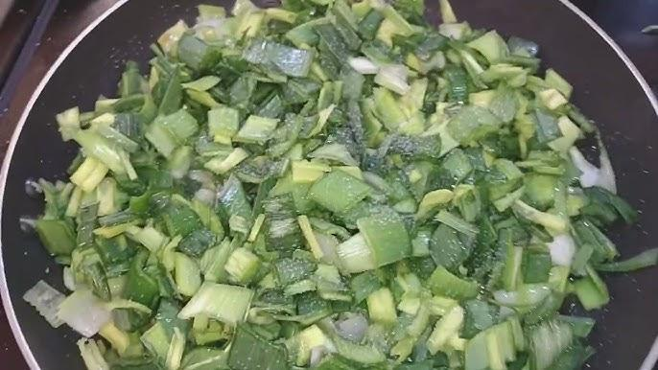

**Method:**

1. **Prepare the Filling:** In a large skillet over medium heat, warm the olive oil or butter. Add the sliced leeks and cook gently until softened, about 5-8 minutes. Season with salt and pepper, keeping in mind any cheese you might add will bring saltiness. If desired, fold in the crumbled cheese, yogurt, and herbs. Taste and adjust seasoning.
2. **Layer the Phyllo:** Preheat your oven to 180°C (350°F). Lightly grease a baking dish with melted butter or oil. Lay one sheet of phyllo and brush it lightly with butter or oil. Repeat until about half the phyllo is used, creating a base. Imperfection is part of the charm, so don’t worry if sheets tear.
3. **Add the Filling:** Spread the leek mixture evenly over the layered base. Cover with the remaining phyllo sheets, brushing each layer with butter or oil, and give the top an extra brush for crispness.
4. **Score & Bake:** With a sharp knife, gently score the top layers into portions, without cutting all the way through. This helps steam escape and simplifies serving. Bake for about 40-50 minutes, or until the top is golden, flaky, and aromatic.
5. **Rest & Serve:** Let the pie rest for about 10 minutes before slicing. Serve warm as a main course with a simple salad or as part of a larger spread. It also tastes lovely at room temperature, making it a delightful addition to picnics or potlucks.

**Your Adaptations:**

Feel free to adjust the richness by using more or less butter, add depth with a hint of spice (like paprika or dried chili flakes), or experiment with different herb combinations. Byrek me presh is both traditional and infinitely adaptable, allowing each generation to rewrite the recipe ever so slightly while keeping its comforting spirit intact.

# Onion and Tomato Pie (Byrek me qepë e domate)

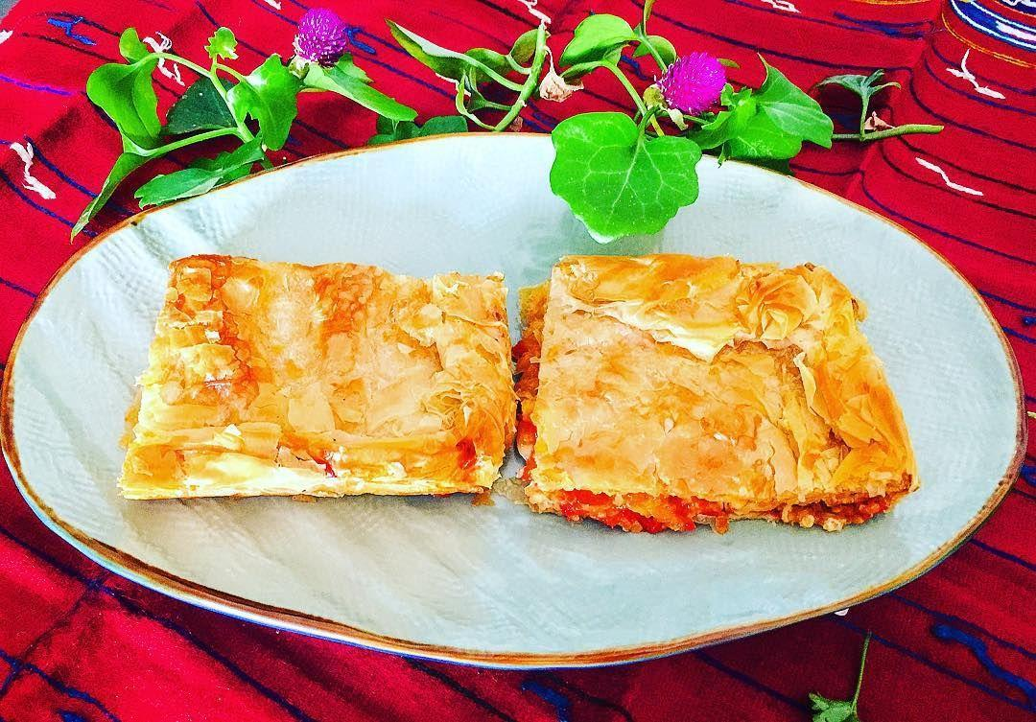

Onion and tomato byrek, though less commonly mentioned in older written sources compared to its cheese or spinach cousins, is a variation that clearly reflects Albania’s embrace of Mediterranean produce. Tomatoes, introduced more widely into the Balkans by the 19th century, gradually found their place in traditional Albanian dishes. This particular byrek is often associated with regions in central and southern Albania, where tomatoes flourish in warm, sun-kissed gardens. Oral histories and family notebooks from the early to mid-20th century often reference “byrek with summer vegetables,” and the sweet, tangy combination of onions and tomatoes likely evolved as local cooks experimented with abundant seasonal harvests.

**Why It’s Beloved:**

Byrek me qepë e domate highlights the natural sweetness and acidity of ripe tomatoes, balanced by the mellow savoriness of softened onions. The filling’s brightness contrasts beautifully with the flaky phyllo layers, making for a light, summery twist on more robust byrek varieties. Served warm or at room temperature, this pie often appears on summertime family tables, at casual gatherings, and even as a quick, satisfying lunch.

**Ingredient Adjustments & Personal Touches:**

This pie is a perfect canvas for improvisation. Consider adding sliced peppers for extra color and flavor, or crumble in a bit of white cheese if you crave a touch of creaminess. Adjust the onion-to-tomato ratio based on your family’s preference: more onion for sweetness and body, more tomato for a tangy, juicy bite. A handful of fresh basil, dill, or parsley can elevate the aroma. For richer layers, use butter to brush the phyllo; for a lighter, fresher taste, stick to olive oil.

**Serves:** About 6-8

**Time:** About 1.5 hours (including preparation and baking)

**Ingredients:**

* 12-16 sheets of phyllo dough (homemade or store-bought)
* 2-3 medium onions, thinly sliced
* 3-4 ripe tomatoes, thinly sliced or roughly chopped
* 2-3 tbsp olive oil or butter (for sautéing)
* 100-150 g (about ½ cup) melted butter or olive oil (for brushing the dough)
* Salt and pepper to taste
* Optional additions: sliced peppers, crumbled white cheese, fresh herbs (basil, dill, parsley)

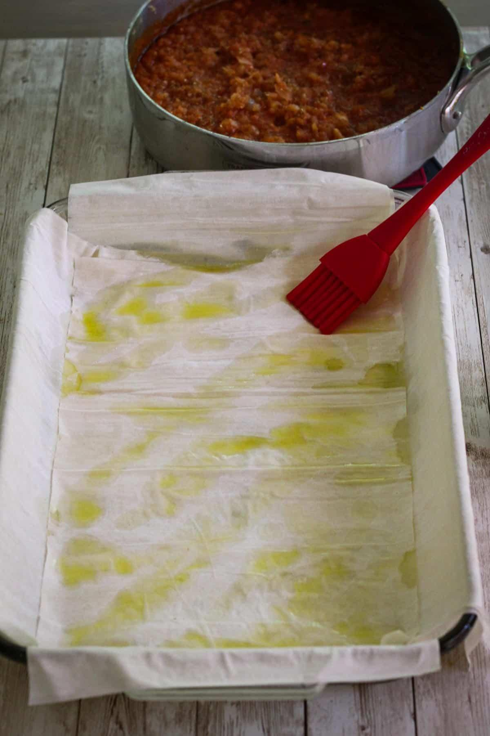

**Method:**

1. **Prepare the Filling:** In a skillet over medium heat, warm the olive oil or butter. Add the onions and cook until softened and lightly golden. Season lightly with salt and pepper. If using peppers, add them now. Set aside the onions and allow them to cool slightly. In a separate bowl, combine the sliced or chopped tomatoes with a pinch of salt, letting them release some juice. Drain off any excess liquid before assembling.
2. **Layer the Phyllo:** Preheat your oven to 180°C (350°F). Grease a baking dish with butter or oil. Place one sheet of phyllo and brush it lightly with butter or oil. Repeat until half the phyllo sheets are used to form the base.
3. **Add the Filling:** Spread the softened onions evenly over the base, followed by an even layer of tomatoes. If adding cheese or herbs, scatter them over the tomatoes. Top with the remaining phyllo sheets, brushing each layer with butter or oil. Give the top layer a generous brush so it crisps beautifully.
4. **Score & Bake:** With a sharp knife, gently score the top layers into squares or diamonds to allow steam to escape. Bake for about 40-50 minutes, or until the top is golden brown and crisp, and the aroma of sweet onions and baked tomatoes fills your kitchen.
5. **Rest & Serve:** Allow the pie to rest for about 10 minutes before slicing. Serve warm or at room temperature, perhaps with a side salad or yogurt sauce. Its light, bright flavors make it especially appealing during warmer months.

**Your Adaptations:**

Feel free to lean into the season—use vine-ripened heirloom tomatoes for maximum flavor, or try a sweeter onion variety for a gentler taste. Add herbs or a hint of cheese to suit your personal preference. Onion and tomato byrek is a testament to the adaptability of Albanian cuisine: rooted in tradition, yet always open to whatever the garden and imagination provide.

# Zucchini Pie (Byrek me kungull të njomë)

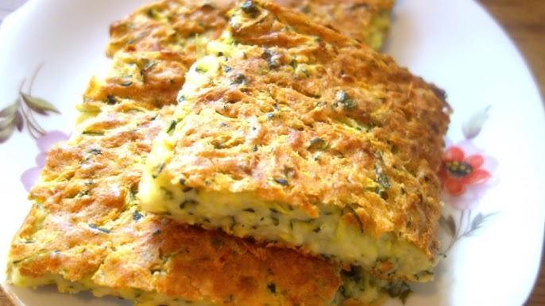

Zucchini pie is a delightful reflection of Albania’s deep connection to seasonal produce. In the lush valleys and coastal plains of western and southern Albania, where summertime gardens overflow with young, tender zucchini, this byrek variation has flourished. While it’s harder to find direct historical references to zucchini pies in old texts, anecdotal evidence from family recipes and oral histories points to its evolution in the mid-20th century, when home cooks embraced local harvests and interwove them into the longstanding tradition of layered pies. The dish is a shining example of how Albanians continuously adapt their cuisine to what the land offers at any given moment.

**Why It’s Beloved:**

Zucchini byrek is light and subtly sweet, capturing the essence of warm, sunny days. The delicate flavor of the young zucchini mingles with flaky pastry layers, often enhanced by salty white cheese or fresh herbs. This comforting yet fresh-tasting pie can be served at any meal—breakfast, lunch, or as part of a larger dinner spread. Its gentle flavors and adaptable nature have won it a place in many Albanian homes, creating memories and traditions tied closely to the summer season.

**Ingredient Adjustments & Personal Touches:**

While many cooks rely on finely grated zucchini and a sprinkle of feta-style cheese, feel free to customize. Add a handful of fresh dill or mint for brightness, stir in some grated onion for extra depth, or even fold in a spoonful of yogurt to add creaminess. If you prefer a richer byrek, brush the phyllo layers generously with butter; if you want something lighter, use olive oil. Balance the salt according to taste—zucchini is mild, so a touch of extra seasoning or a bit more cheese can make the flavors pop.

**Serves:** About 6-8

**Time:** Approximately 1.5 hours (including preparation and baking)

**Ingredients:**

* 12-16 sheets of phyllo dough (homemade or store-bought)
* 500-600 g (about 1 lb) young zucchini, grated or finely chopped
* 200 g (about 1 cup) crumbled white cheese (optional, feta-style)
* 2-3 scallions, finely chopped (optional)
* A handful of fresh dill, mint, or parsley, chopped (optional)
* 1-2 eggs (optional, for richness and binding)
* 100-150 g (about ½ cup) melted butter or olive oil (for brushing the phyllo)
* Salt and pepper to taste

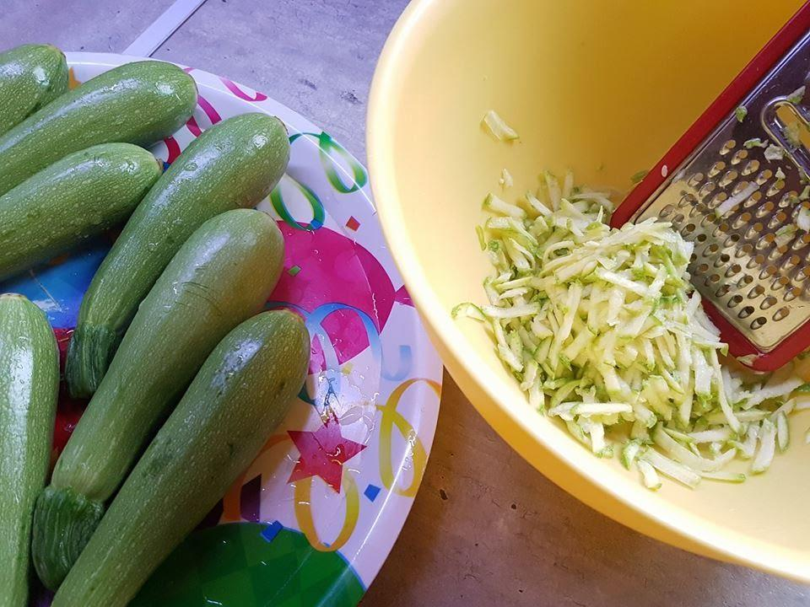

**Method:**

1. **Prepare the Filling:** Place the grated zucchini in a colander and sprinkle lightly with salt. Let it sit for about 10-15 minutes to release excess moisture. Squeeze gently to remove more liquid. Transfer to a bowl and add the crumbled cheese (if using), chopped herbs, scallions, and the beaten eggs (if using). Season with salt and pepper, adjusting to taste.
2. **Layer the Phyllo:** Preheat your oven to 180°C (350°F). Grease a baking dish with butter or oil. Lay one sheet of phyllo and brush it lightly with butter or oil. Repeat until about half the phyllo sheets are used, forming a base. Don’t worry about perfection—rustic layering is part of byrek’s charm.
3. **Add the Filling:** Evenly spread the zucchini mixture over the base. Top with the remaining phyllo sheets, brushing each layer with butter or oil. Give the top layer an extra brush to ensure a crisp, golden finish.
4. **Score & Bake:** With a sharp knife, gently score the top layers into portions. This helps steam escape and makes serving easier. Bake for about 40-50 minutes, or until the top is golden and crispy, and your kitchen is filled with the aroma of warm pastry and fresh zucchini.
5. **Rest & Serve:** Allow the byrek to rest for about 10 minutes before cutting and serving. It’s delicious warm but also holds its flavors well at room temperature, making it a great addition to outdoor lunches, picnics, or light summer suppers.

**Your Adaptations:**

Experiment with the herb and cheese combinations or play with the proportion of zucchini to achieve the ideal balance for your family’s preferences. For a heartier version, you might add a spoonful of sour cream or yogurt to the filling, or incorporate other grated summer vegetables. Zucchini byrek stands as a reminder that Albanian cuisine thrives on both tradition and personal creativity, blending familiar flavors with the ever-changing bounty of nature’s garden.

# Wild Cabbage Pie (Byrek me Pazija , lakër të egër)

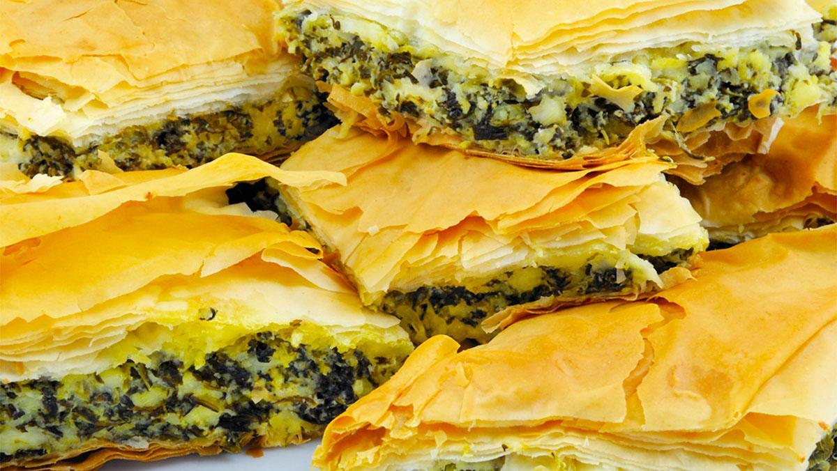

Byrek me lakër të egër spotlights the rugged yet fertile landscapes of Albania, where wild greens and foraged plants have long sustained rural communities. Particularly in mountainous and hilly regions—such as areas around Kruja, Mat, and even parts of southern Albania—wild cabbage (a forerunner to cultivated cabbage varieties) has been gathered for centuries. While formal historical records about this particular pie are sparse, oral traditions and local folklore suggest that wild greens were integral to Albanian diets well before widespread agricultural domestication. This byrek thus stands as a culinary echo of an ancient food culture rooted in respect for the natural environment.

**Why It’s Beloved:**

The flavor of wild cabbage is earthier, bolder, and slightly more robust than its cultivated counterpart. When paired with layers of flaky phyllo, this pie offers a taste of Albania’s old-world character—a savory, herbaceous filling that connects eaters to nature’s bounty. Byrek me lakër të egër is often made during the cooler seasons or whenever wild greens are in good supply. Its presence at the table evokes memories of ancestral wisdom, resourcefulness, and the enduring Albanian tradition of making the most of what the land provides.

**Ingredient Adjustments & Personal Touches:**

If you can’t find true wild cabbage, consider substituting kale, collard greens, or Swiss chard for a similar depth of flavor. Some cooks like to blend these greens with a little white cheese to mellow out the bitterness. Others add fresh herbs like dill or parsley for brightness, or a finely chopped onion or scallion for sweetness. Decide on the fat level—opt for butter to elevate richness or olive oil to honor the pie’s earthy simplicity. The beauty of this dish lies in its adaptability and the personal nuances you choose to highlight.

**Serves:** About 6-8

**Time:** Approximately 1.5 hours (including preparation and baking)

**Ingredients:**

* 12-16 sheets of phyllo dough (homemade or store-bought)
* 500-600 g (about 1 lb) wild cabbage leaves or a sturdy green like kale/collards, washed and finely chopped
* Optional: 100-150 g (about 1 cup) crumbled white cheese (feta-style)
* 1 small onion or 2-3 scallions, finely chopped (optional)
* A handful of fresh dill or parsley, chopped (optional)
* 1-2 eggs (optional, for binding and richness)
* 100-150 g (about ½ cup) melted butter or olive oil (for brushing phyllo)
* Salt and pepper to taste

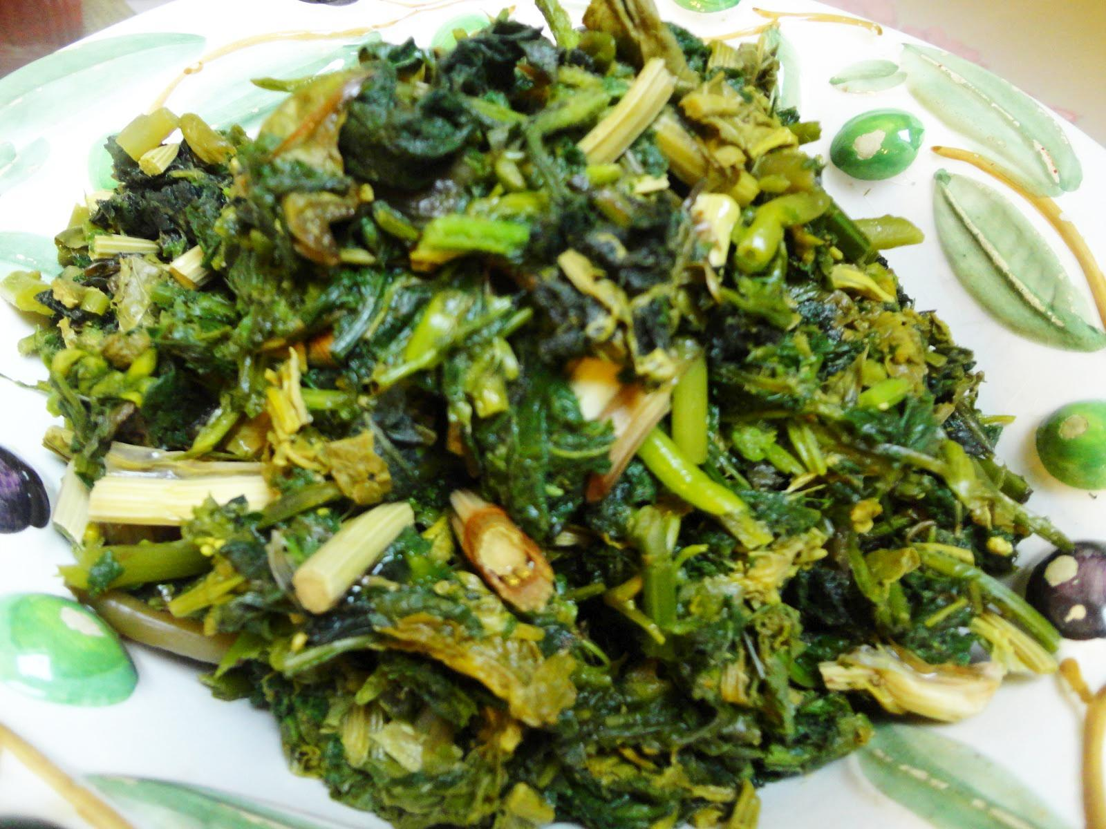

**Method:**

1. **Prepare the Filling:** Blanch the wild cabbage or sturdy greens in lightly salted boiling water for a minute or two if they’re very tough, then drain well and squeeze out excess moisture. In a mixing bowl, combine the chopped greens, cheese (if using), herbs, and onion. Beat the eggs lightly (if using) and stir them in. Season with salt and pepper, remembering cheese will add saltiness. Adjust the balance of flavors according to your preference.
2. **Layer the Phyllo:** Preheat your oven to 180°C (350°F). Lightly grease a baking dish. Lay down one sheet of phyllo and brush it with butter or oil. Repeat with about half the phyllo sheets, forming a base. No need for perfection; a rustic approach is entirely authentic.
3. **Add the Filling:** Spread the greens mixture evenly over the layered base. Cover with the remaining phyllo sheets, brushing each layer with butter or oil. Give the top layer a generous brush for a crisp finish.
4. **Score & Bake:** Use a sharp knife to score the top into portions. This allows steam to escape and makes serving easier. Bake for about 40-50 minutes, or until the top is golden and the aroma of savory greens and pastry greets you warmly.
5. **Rest & Serve:** Let the byrek rest for about 10 minutes before slicing. Serve warm, alongside yogurt or a tangy salad. Its earthy, robust flavors pair beautifully with simple accompaniments.

**Your Adaptations:**

Experiment freely with the type of greens available, adjust the salt to your liking, and add different herbs or a hint of spice if desired. Byrek me lakër të egër is an edible tapestry of Albanian heritage, reminding us that some of the most treasured flavors can be found just beyond our doorsteps, growing wild and waiting to be celebrated at the family table.

# Thin-Layered Pie from Korça (Lakror)



Lakror is a traditional pie closely associated with the southeastern region of Albania, particularly the city of Korça and its surrounding villages. The dish can be viewed as a cousin of byrek, but it’s often distinguished by its technique of rolling and stretching the dough into paper-thin layers, sometimes cooked outdoors over a wood fire or heated stones. Early mentions of lakror appear in local oral traditions, family recipe collections, and ethnographic works from the late 19th and early 20th centuries. In the past, lakror-making was often a community event—a skill passed down through generations, symbolizing both hospitality and the pride of local craftsmanship. Today, lakror continues to represent the culinary identity of Korça: refined, delicate, and grounded in seasonal ingredients.

**Why It’s Beloved:**

Lakror stands out for its delicate, almost translucent layers of dough that enfold simple, fresh fillings. It is prized for its craftsmanship, taste, and the sense of nostalgia it carries. Families in Korça enjoy lakror at festive gatherings, village fairs, and family reunions, honoring both the region’s culinary heritage and the hands-on artistry required to make it. It can be sweet or savory, vegetarian or meaty, adapting easily to what’s in season or what a family prefers.

**Ingredient Adjustments & Personal Touches:**

Traditionally, lakror might be filled with greens (like spinach or leeks), cheese, or even a combination of onions and tomatoes. In contemporary kitchens, it’s open to interpretation. Add a handful of fresh herbs, use olive oil instead of butter, or mix in a spoonful of yogurt to enrich the filling. If rolling out paper-thin homemade dough feels daunting, you can use store-bought phyllo as a shortcut—while it might not fully replicate the texture of authentic lakror, it still offers a path to enjoying this regional treasure. The key is finding the balance between delicately crisp layers and a harmonious, flavorful filling.

**Serves:** About 6-8

**Time:** Approximately 2 hours (including dough preparation and baking, if making from scratch)

**Ingredients (Basic Savory Version):**

* For the Dough (if making from scratch):
* 500 g (about 4 cups) all-purpose flour
* 250-300 ml (about 1 to 1¼ cups) lukewarm water
* 1 tsp salt
* A drizzle of oil for kneading
* For the Filling (example: spinach and cheese):
* 500 g (about 1 lb) fresh spinach, washed and chopped
* 200 g (about 1 cup) crumbled white cheese (feta-style)
* 1-2 scallions, finely chopped (optional)
* A handful of fresh dill or parsley, chopped (optional)
* Salt and pepper to taste
* For Assembling:
* 100-150 g (about ½ cup) melted butter or olive oil (for brushing layers)

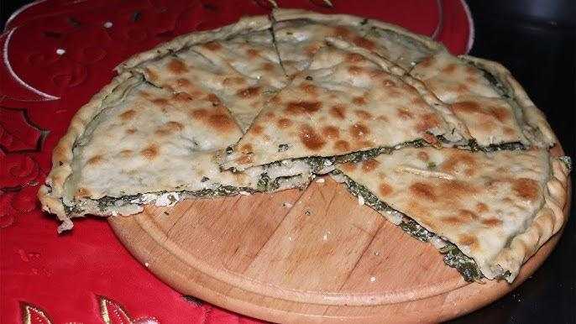

**Method (Traditional Approach):**

1. **Make the Dough:** In a large bowl, combine the flour and salt. Slowly add the lukewarm water while mixing until a shaggy dough forms. Knead on a lightly floured surface until smooth and elastic. Divide the dough into small, equal balls (usually 6-8). Cover and let them rest for at least 30 minutes to relax the gluten.
2. **Prepare the Filling:** While the dough rests, prepare your filling. For spinach and cheese, lightly salt the spinach and let it sit for a few minutes, then squeeze out excess moisture. Mix in the cheese, herbs, and scallions (if using). Taste and adjust seasoning, remembering that the cheese may add saltiness.
3. **Roll the Layers:** On a lightly floured surface, roll each dough ball into a thin circle. Traditionally, lakror layers are rolled paper-thin, almost translucent. If that’s challenging, just roll as thinly as you comfortably can; more layers will still create a lovely texture.
4. **Assemble the Lakror:** Preheat your oven to 180°C (350°F). Grease a large, round baking pan. Place one rolled dough sheet in the pan and brush lightly with butter or oil. Repeat with about half of the sheets, stacking them. Spread the spinach and cheese filling evenly over these layers. Top with the remaining rolled sheets, brushing each with butter or oil. Reserve a bit more butter for the final layer so it bakes crisp and golden.
5. **Bake:** Score the top gently to allow steam to escape, then bake for about 40-50 minutes or until the top is golden and crisp. Baking times may vary depending on the thickness of the layers and your oven’s specifics.
6. **Rest & Serve:** Let the lakror rest for about 10 minutes before cutting. Serve warm, and enjoy it as a main dish, a savory snack, or part of a larger feast.

**Your Adaptations:**

Feel free to switch up the fillings—use onions and tomatoes in summer, leeks and peppers in spring, or even a potato and herb mixture in cooler weather. If pressed for time, consider using high-quality phyllo dough instead of homemade sheets. While it might not capture every nuance of the traditional technique, it opens the door to experiencing the soul of Korça’s cuisine: the thoughtful layering of simple ingredients to create something remarkably delicate and delicious.

# Rice and Herb Fritters from Gjirokastra (Qifqi)

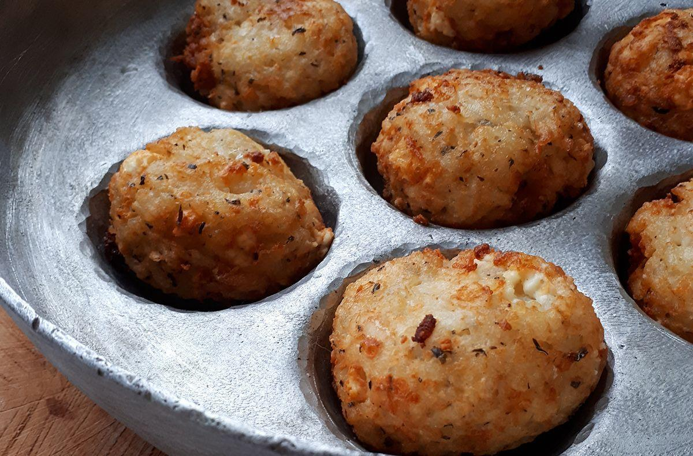

Qifqi hail from the historic city of Gjirokastra in southern Albania, a region known for its stone architecture, literary heritage, and distinctive culinary traditions. These small, aromatic rice fritters are believed to have emerged in local households generations ago, reflecting a resourceful and delicious way to transform simple pantry staples—rice, eggs, and herbs—into a memorable dish. While written references to qifqi are relatively scarce, oral histories and old family recipe collections point to their longstanding presence at Gjirokastrian tables, particularly as part of festive spreads or as a flavorful side dish. They connect directly to the region’s Ottoman-influenced past and its emphasis on creating refined flavors out of humble ingredients.

**Why They’re Beloved:**

Crisp on the outside, tender within, qifqi are prized for their gentle, comforting flavors. The fragrant herbs woven into the rice lend them a fresh, green note, while the delicate texture makes them irresistibly snackable. They are often enjoyed as a vegetarian delight, served alongside yogurt, salads, or a selection of mezze-style dishes. Qifqi are also a culinary emblem of Gjirokastra’s local identity, symbolizing the city’s hospitality and the rich food culture that thrives behind its stone walls.

**Ingredient Adjustments & Personal Touches:**

The core ingredients—rice, eggs, and herbs—can be adapted to taste. While mint is traditional and distinctive, feel free to incorporate parsley or dill. Some cooks add a spoonful of grated cheese or a hint of pepper. If you find it challenging to shape the fritters, adjust the egg-to-rice ratio for better binding. Traditionally fried in molds to achieve their signature round shape, qifqi can be formed by hand if special molds aren’t available. Consider baking them in a well-oiled muffin tin for a lighter version. The idea is to honor tradition while making the recipe accessible and enjoyable in your own kitchen.

**Serves:** About 4-6 as a side dish

**Time:** About 1 hour (including cooking the rice and shaping the fritters)

**Ingredients:**

* 200 g (about 1 cup) uncooked rice (short- or medium-grain)
* 2-3 eggs (depending on size and desired binding)
* 1 small bunch fresh mint, finely chopped (traditional choice)
* Optional herbs: a handful of parsley or dill, finely chopped
* Salt and pepper to taste
* 2-3 tbsp olive oil or butter (for greasing molds or for shallow frying)
* Optional: a small handful of grated white cheese (feta-style) for added flavor

**Method:**

1. **Cook the Rice:** Rinse the rice and cook it in lightly salted water until just tender but not mushy. Drain well and let it cool slightly. The rice should be sticky enough to hold together but not overly wet. Spread it on a tray to steam off excess moisture if needed.
2. **Mix the Fritter Base:** In a large bowl, beat the eggs lightly. Stir in the chopped mint and any other herbs you’re using. Add the cooled rice and combine thoroughly. Season with salt and pepper, and mix in cheese if desired. Taste and adjust seasoning. The mixture should hold together when pressed between your fingers—if it’s too crumbly, add another beaten egg.
3. **Shape the Qifqi:** Traditionally, qifqi are shaped using special round molds, but you can also form small walnut-sized balls by hand. Lightly oil your hands and press the rice mixture firmly together. If you have a muffin tin or a set of round molds, grease them and pack the mixture inside, then carefully invert them to form neat rounds.
4. **Cook the Fritters:** In a non-stick skillet over medium heat, warm a little oil or butter. Add the formed fritters and cook until lightly golden on each side. Handle gently when flipping to maintain their shape. For a lighter approach, you can brush or spray them with oil and bake in a preheated 180°C (350°F) oven for about 20-25 minutes, or until firm and slightly crisp.
5. **Rest & Serve:** Let the qifqi cool for a few minutes to help them set. Serve warm, accompanied by yogurt or a tangy dipping sauce. They make an excellent appetizer, side dish, or part of a mezze platter.

**Your Adaptations:**

Qifqi encourage culinary exploration. Adjust the herbs based on what’s fresh and available, experiment with a hint of chili for heat, or add a sprinkling of sesame seeds for crunch. The key is achieving that delicate balance of tender rice and fresh herbs, a whisper from Gjirokastra’s past that can easily find a cherished spot in your modern kitchen.

# Cornbread (Bukë misri Kallamoqe)

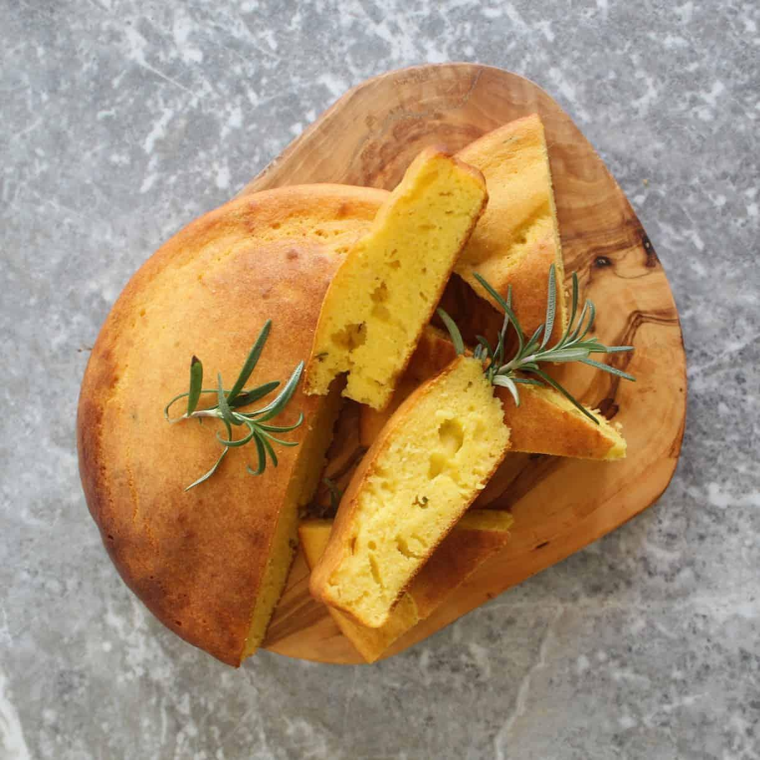

Cornbread, or bukë misri, has deep roots in Albanian rural life, especially in the northern and southeastern regions, where corn historically grew well and provided a reliable staple alongside wheat. Before widespread commercial milling, families would grind their own corn into flour and bake dense, hearty loaves to sustain them through harsh winters and long working days. References to cornbread in Albanian cuisine date back at least to the 19th century through travelers’ accounts and ethnographic research. Over time, bukë misri became a symbol of resourcefulness, simplicity, and the comforting taste of home, often enjoyed alongside dairy products, vegetable stews, and pickled accompaniments.

**Why It’s Beloved:**

Bukë misri is cherished for its rustic, wholesome flavor—a slightly sweet, nutty taste that captures the essence of the fields. Its texture, more substantial than wheat bread, makes it a versatile companion to hearty soups or meaty stews. Although once considered a “peasant” food, it now holds a place of reverence as a culinary heritage item. Families appreciate its no-frills nature and its ability to bring them closer to the land and traditions of their ancestors.

**Ingredient Adjustments & Personal Touches:**

Traditional bukë misri consists primarily of cornmeal, water, and salt, sometimes enriched with a little wheat flour or a spoonful of yogurt to improve texture. Feel free to play with ratios until you achieve a consistency your family enjoys. Using fine cornmeal will yield a smoother crumb, while a coarser grind brings rustic charm. You can also fold in herbs, diced chili peppers, or grated cheese for a contemporary twist. Experiment with baking vessels—cast-iron skillets, baking pans, or even bread tins all lend different crust characteristics.

**Serves:** About 6-8

**Time:** About 1 hour (including baking)

**Ingredients (Basic Version):**

* 300 g (about 2½ cups) fine or medium-ground cornmeal
* 200 g (about 1½ cups) all-purpose flour (optional, can reduce or omit for a denser loaf)
* About 500 ml (2 cups) lukewarm water, or more as needed
* 1 tsp salt
* Optional: 2-3 tbsp plain yogurt or sour cream (for moisture and flavor)
* Optional: 1-2 tbsp olive oil or melted butter (for tenderness)

**Method:**

1. **Mix the Dough:** In a large bowl, combine the cornmeal, flour (if using), and salt. Add the yogurt or sour cream (if using) and start pouring in lukewarm water, stirring constantly to form a thick batter-like consistency. If adding oil or butter, stir it in as well. The mixture should be thick but spreadable, not a kneadable dough.
2. **Adjust Consistency & Rest:** Let the mixture sit for about 10-15 minutes so the cornmeal can absorb the moisture. If it seems too thick afterward, stir in a bit more water.
3. **Prepare the Pan:** Preheat your oven to 200°C (390°F). Grease a baking dish, cast-iron skillet, or loaf pan generously with oil or butter. Transfer the cornmeal mixture into the prepared pan, smoothing the top with a wet spatula if necessary.
4. **Bake:** Place the pan in the oven and bake for about 30-40 minutes or until the cornbread is firm to the touch, lightly golden on top, and a toothpick inserted in the center comes out clean. Baking times may vary based on the thickness and moisture of the batter.
5. **Rest & Serve:** Let the cornbread rest for at least 10 minutes before slicing. Serve it warm alongside yogurt, feta cheese, or a hearty stew. It also makes a delightful base for soaking up sauces or enjoying with honey and butter for a simple, rustic treat.

**Your Adaptations:**

Bukë misri invites experimentation. Play with the corn-to-wheat ratio, introduce herbs like rosemary or thyme, or fold in small bits of savory cheese for depth of flavor. You can also serve leftover slices toasted with butter for breakfast. In this way, a humble bread becomes a personal signature—an evolving testament to the enduring Albanian tradition of making the most of honest, grainy goodness.

# Triangular Pastries with Cheese, Egg, and Parsley (Trigona me djathë, vezë e majdanoz)

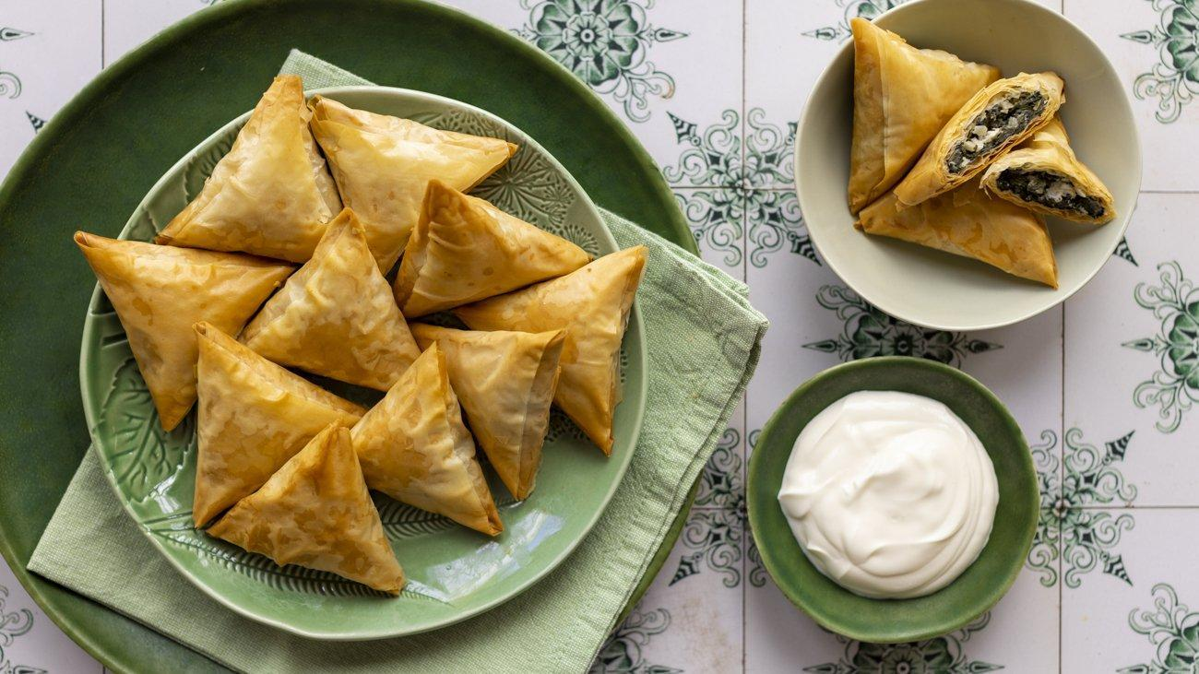

Trigona are individually shaped pastries that capture the essence of Albanian snack and appetizer culture. They are found throughout the country, but are especially popular in central and southern Albania, where fresh dairy and fragrant herbs define much of the local cuisine. While exact historical documentation is scarce, community cookbooks and oral histories from the early 20th century describe similar folded pastries served at family celebrations, weddings, and neighborhood gatherings. Over time, these dainty triangles have become emblematic of both Albanian hospitality and its longstanding tradition of working with simple, honest ingredients like cheese, eggs, and fresh greenery.

**Why They’re Beloved:**

Trigona are appealing on multiple levels. Their crisp, flaky layers contrast beautifully with a creamy, savory filling, making them an irresistible finger food. They’re small, neat, and easily portable, which is why they’ve long been a feature at social events. To this day, many Albanian families will set out a plate of warm trigona to welcome friends—an edible invitation to slow down, chat, and savor a moment of shared pleasure.

**Ingredient Adjustments & Personal Touches:**

The classic trio of white cheese (often feta-style), eggs, and parsley is versatile. Add a sprinkle of dill or mint if you’d like more herbal complexity, or fold in a spoonful of yogurt for extra creaminess. The cheese can vary in saltiness, so always taste before adding more salt. If you prefer a richer pastry, brush the layers of phyllo with melted butter; for a lighter touch, use olive oil. Feel free to experiment with shape or size—smaller ones are perfect for parties, while larger triangles can be a lunchtime treat.

**Serves:** About 8-10 (depending on size)

**Time:** Approximately 1 hour (including assembly and baking)

**Ingredients:**

* About 500 g (1 lb) thin phyllo dough (homemade or store-bought)
* 200-250 g (1-1¼ cups) crumbled white cheese (feta-style)
* 2-3 eggs, lightly beaten
* 1 small bunch parsley, finely chopped (about ¼ cup)
* 100-150 g (about ½ cup) melted butter or olive oil (for brushing the dough)
* Salt and pepper to taste (adjust based on cheese’s saltiness)
* Optional: A spoonful of yogurt or a bit of grated hard cheese for added flavor

**Method:**

1. **Prepare the Filling:** In a bowl, combine the cheese, beaten eggs, parsley, and any optional yogurt or grated cheese. Season with pepper and taste before adding salt, since feta-style cheese is often salty enough on its own.
2. **Shape the Pastries:** Preheat the oven to 180°C (350°F). Place one sheet of phyllo on a clean surface and brush it lightly with butter or oil. Fold it lengthwise into thirds to form a long strip. Place a spoonful of filling at one end. Fold the pastry up and over the filling to form a triangle, then continue folding along the strip, creating a neat triangular parcel. Repeat with the remaining phyllo and filling.
3. **Arrange & Bake:** Place the filled triangles on a greased baking sheet, seam-side down. Brush the tops with more butter or oil. Bake for about 20-30 minutes, or until the trigona are golden and crisp. Keep an eye on them, as baking time varies by oven and phyllo thickness.
4. **Rest & Serve:** Allow them to cool slightly before serving. Trigona are best enjoyed warm, offering their full aromatic and textural appeal. Serve as appetizers, party snacks, or as part of a brunch spread with yogurt, fresh salads, and olives.

**Your Adaptations:**

This recipe welcomes personal flair. Switch up the herbs, try different cheeses, or experiment with dipping sauces. Whether you maintain authenticity or add a twist, trigona remain a delightful, timeless bite—proof that a few simple ingredients and a deft hand can create pastries that bring people together, generation after generation.

# Sheep’s head soup (Paçe koke)

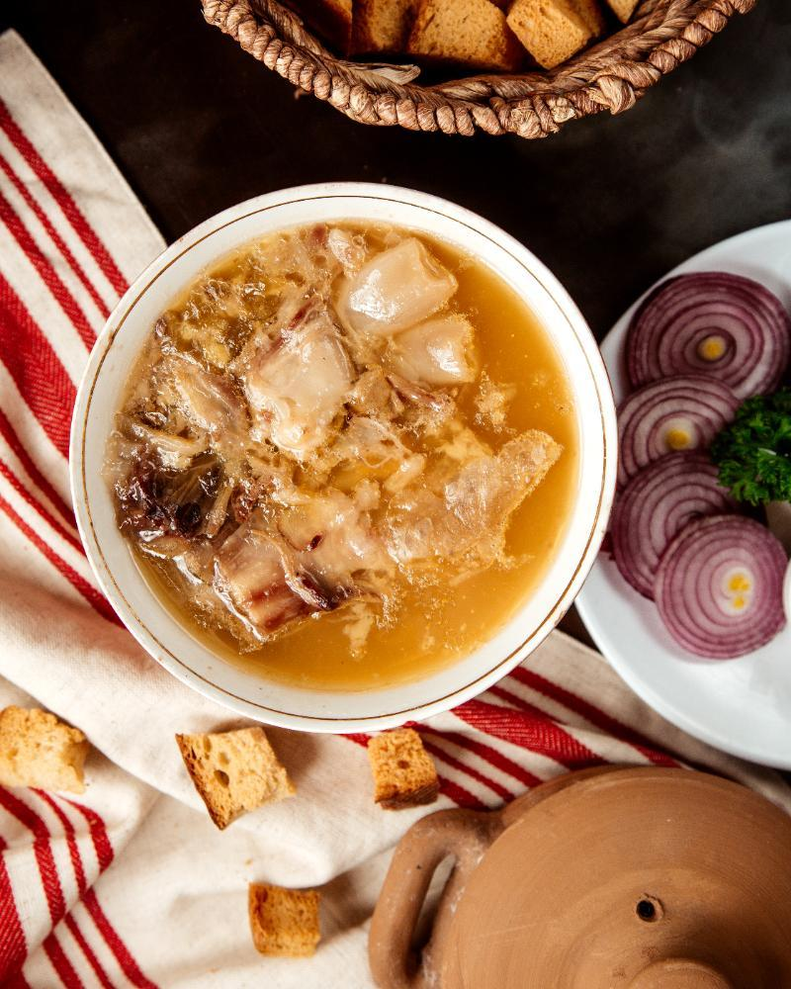

Paçe koke is one of Albania’s most traditional and rustic dishes, with roots stretching deep into the country’s pastoral past. Historically, when families slaughtered a sheep or lamb, no part of the animal went to waste; the head, with its tender and collagen-rich meat, was carefully prepared to create this nourishing, flavorful soup. References to paçe appear in local folklore and oral histories well before the early 20th century, often linked to highland areas in northern and northeastern Albania, such as the regions around Kukës and Tropoja. Over time, as trade routes expanded and culinary influences circulated within the Balkans, paçe koke became widespread, cherished for its ability to transform humble ingredients into a warming, sustaining meal.

**Why It’s Beloved:**

Paçe koke offers a rich, velvety broth infused with intense, meaty flavor. This robust soup isn’t just sustenance—it’s an expression of Albanian thrift, culinary wisdom, and respect for the animal. It’s often associated with festive occasions, communal feasts, or comforting winter meals. While some might be wary of its boldness, those who try it often delight in its depth and silky texture. Accompanied by bread, pickled vegetables, and a glass of raki, paçe koke tells a story of rural resilience and culinary heritage, one spoonful at a time.

**Ingredient Adjustments & Personal Touches:**

Traditionally, the soup relies on the sheep’s head, onion, garlic, vinegar, and salt to create its characteristic flavor. Feel free to add aromatic herbs like bay leaf or thyme for subtle complexity. Some recipes include a splash of lemon juice or a drizzle of olive oil at the end. If you prefer a milder taste, you can blend in some regular lamb stock or add extra vegetables for balance. Although paçe koke has historically been prepared in a straightforward manner, there’s no harm in making gentle tweaks to suit modern palates—just be sure to maintain the essence of the dish’s rustic soul.

**Serves:** About 6-8

**Time:** Several hours (including simmering)

**Ingredients:**

* 1 sheep’s head, thoroughly cleaned (ask your butcher to split it in half if possible)
* 1 large onion, halved
* 2-3 garlic cloves, whole and peeled
* 2-3 bay leaves (optional)
* Salt and pepper to taste
* 2-3 tbsp vinegar (wine vinegar or apple cider vinegar)
* Water to cover
* Optional additions: a sprig of thyme, a few black peppercorns, or a squeeze of lemon juice at the end

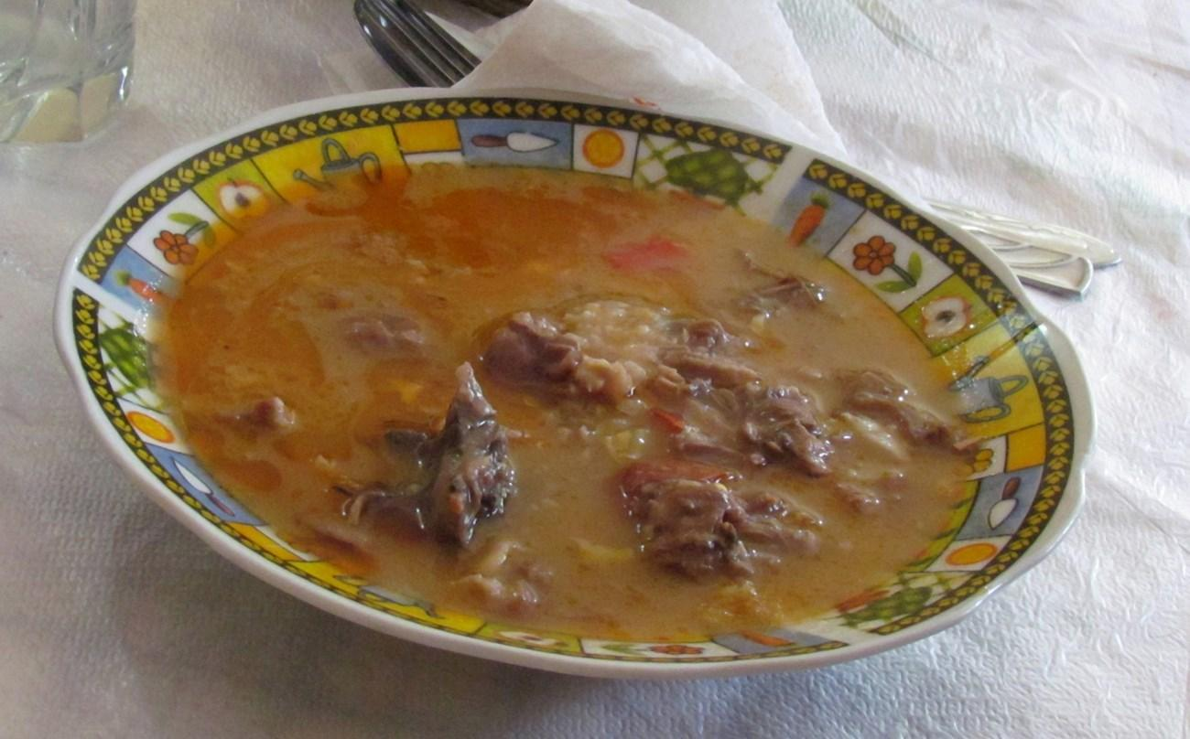

**Method:**

1. **Prepare the Head:** Rinse the sheep’s head under cold running water. Carefully remove any residual hair by singeing it over a flame or using a small knife. If your butcher hasn’t split it, you may need a heavy cleaver to do so—this helps release the marrow and flavor more efficiently.
2. **Initial Boil & Skim:** Place the head in a large pot and cover with plenty of cold water. Bring to a gentle boil, then reduce to a simmer. Skim off any foam that rises to the surface in the first 10-15 minutes.
3. **Add Aromatics:** Add the onion, garlic cloves, bay leaves, and any optional herbs or spices. Season with salt and pepper. Simmer gently for several hours (2-3 hours or more), until the meat is falling off the bones and the broth is rich and fragrant. Taste and adjust seasoning as it cooks.
4. **Finish & Strain:** When the head is fully cooked, carefully remove it from the broth. Let it cool slightly, then pick the tender meat from the bones and chop it into small pieces. Strain the broth to remove aromatics and return the chopped meat to the pot. Stir in the vinegar, tasting as you go to achieve a pleasant tanginess. Adjust salt and pepper if needed. If desired, finish with a squeeze of fresh lemon juice.
5. **Serve:** Ladle the hot soup into bowls. Offer crusty bread on the side, along with pickled vegetables or a simple salad. A glass of raki or red wine can complement the bold flavors. Serve it piping hot, and let the soup’s warmth and richness remind you of Albania’s pastoral traditions and the comforting embrace of old-world cooking.

**Your Adaptations:**

Paçe koke encourages respectful improvisation. Add a handful of diced carrots or celery for a softer flavor, or include a few chili flakes if your family enjoys a hint of heat. Some cooks prefer to blend part of the broth for a smoother texture, while others relish the rustic charm of leaving the soup as is. Ultimately, this dish is about making use of every part of the animal, honoring a centuries-old tradition, and gathering loved ones around a shared, sustaining meal.

# Tripe Soup (Paçe plëndsi)

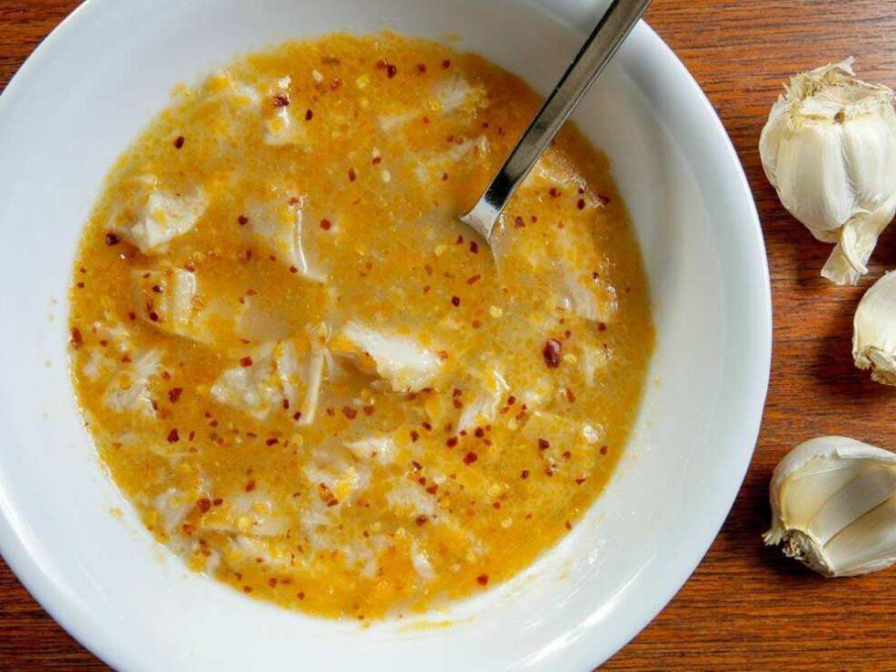

Paçe plëndsi is a traditional Albanian soup made from tripe (stomach lining of a cow, sheep, or goat), historically prominent in rural communities that utilized every part of the animal. This dish has strong roots in central and northern Albania, where herding and dairy farming shaped local diets. Oral histories, travelers’ accounts, and regional cookbooks from the early 20th century mention variations of paçe prepared with offal, providing a hearty, protein-rich meal from otherwise humble ingredients. Over time, paçe plëndsi became a sought-after specialty, served in both rustic farmhouse kitchens and modest roadside taverns, particularly as an energizing meal in cooler weather or after a hard day’s work.

**Why It’s Beloved:**

Paçe plëndsi encapsulates the resourcefulness and depth of flavor found in Albanian peasant cuisine. The slow simmering process transforms a seemingly tough ingredient into a silky, tender delight, with the broth turning rich, comforting, and deeply savory. For many, this soup evokes childhood memories, gatherings of extended family, and a sense of continuity with ancestral traditions. Paçe plëndsi is not just food—it’s an expression of Albania’s culinary identity, one that prizes thrift, hospitality, and full-flavored sustenance.

**Ingredient Adjustments & Personal Touches:**

While classic versions rely on onion, garlic, vinegar, and salt to highlight the flavor of the tripe, feel free to experiment subtly. Adding bay leaves, black peppercorns, or a sprig of fresh thyme can bring complexity. Some cooks brighten the broth with a squeeze of lemon or finish with a spoonful of yogurt for creaminess. Adjust the amount of vinegar to find the perfect tanginess that suits your palate. Although paçe plëndsi is usually simple and rustic, it can be gently adapted to please modern tastes while maintaining its authentic spirit.

**Serves:** About 6-8

**Time:** Several hours (including cleaning and simmering the tripe)

**Ingredients:**

* 500-700 g (1-1½ lbs) tripe (from cow, sheep, or goat), thoroughly cleaned
* 1 large onion, halved or roughly chopped
* 2-3 garlic cloves, whole and peeled
* Salt and pepper to taste
* 2-3 tbsp vinegar (wine or apple cider vinegar), or more to taste
* Water to cover
* Optional: a bay leaf, a few black peppercorns, a sprig of fresh thyme, lemon wedges or yogurt for garnish

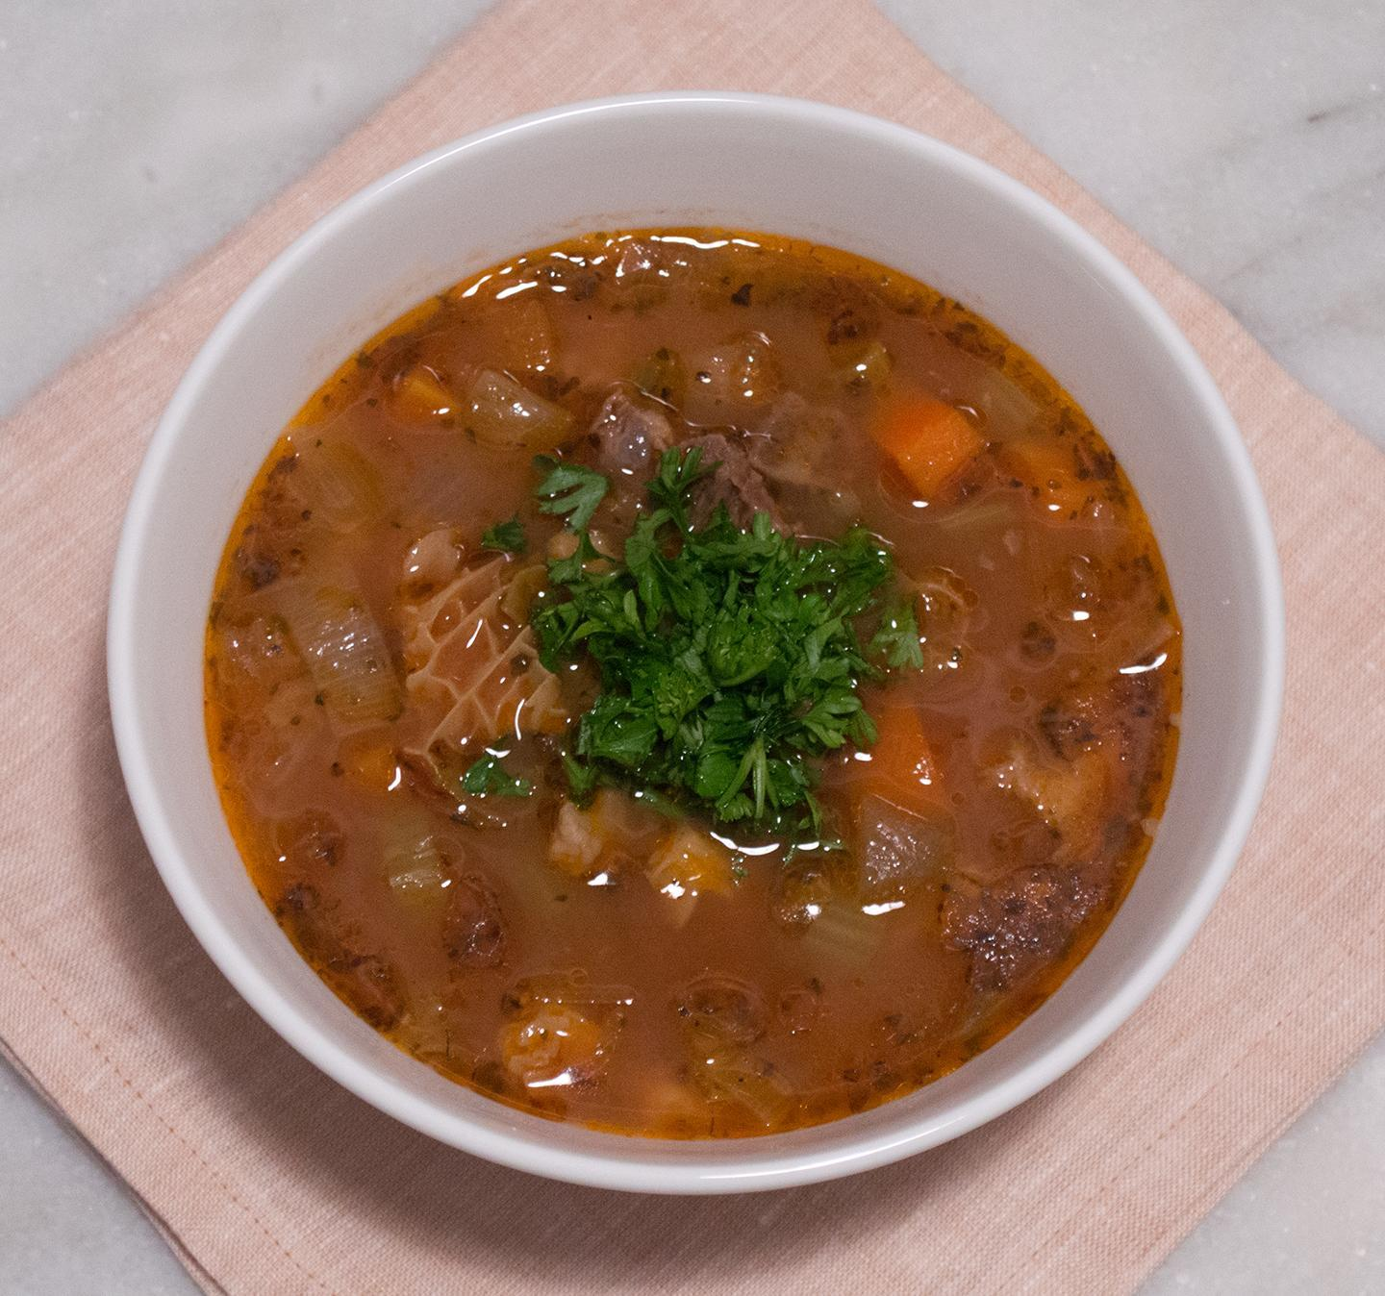

**Method:**

1. **Prepare the Tripe:** If it’s not pre-cleaned, scrub and rinse the tripe thoroughly under cold water to remove any impurities. You may blanch it briefly in boiling water for a few minutes, then discard that water and rinse again. Proper cleaning ensures a pleasant flavor.
2. **Simmer the Tripe:** Place the cleaned tripe in a large pot and cover with fresh water. Bring to a gentle boil, then reduce to a simmer. Skim off any foam that forms in the first 10-15 minutes. Add the onion, garlic, and any optional herbs or spices. Season lightly with salt and pepper.
3. **Slow Cooking:** Let the tripe simmer for 2-3 hours, or until it becomes very tender. Cooking times vary depending on the tripe’s thickness and freshness. Taste the broth occasionally, adjusting salt and pepper as you go.
4. **Finish the Soup:** When the tripe is tender, remove it from the pot. Let it cool slightly, then slice it into small strips or bite-sized pieces. Return the sliced tripe to the broth and add the vinegar to taste, stirring well. Adjust the seasoning, adding more vinegar or salt if desired. For a brighter flavor, you can finish with a squeeze of lemon or a dollop of yogurt.
5. **Serve:** Ladle the hot soup into bowls. Serve with crusty bread, pickled vegetables, or a fresh salad. Accompaniments like a glass of raki or wine complement the robust flavors. Enjoying paçe plëndsi warm from the pot is a comforting, soul-satisfying
6. experience that links you directly to Albania’s rural culinary traditions.

**Your Adaptations:**

Consider gentle variations—maybe a hint of paprika for warmth or a bay leaf for complexity. You might prefer a richer texture by simmering the broth longer, or a lighter taste by adding more lemon. In each small adjustment, you carry this ancient dish forward, ensuring its place at the family table for generations to come.

# Bean Stew (Jahni Fasule) Grosh



Jahni Fasule, a long-simmered bean stew, stands as a pillar of Albanian home cooking—a humble, filling dish that has nurtured families for generations. Its roots lie in the country’s agrarian past, where beans were a dependable source of protein and fields of legumes blanketed the countryside. While exact historical records are scarce, references to hearty bean stews appear in the oral histories and traveler notes from the 19th century, and the dish likely predates that by centuries. Popular across Albania but particularly revered in the central and northern regions, Jahni Fasule became known as an everyday comfort meal—sustenance for peasants, farmers, and traders who depended on simple, nourishing fare.

**Why It’s Beloved:**

Jahni Fasule’s charm lies in its simplicity: tender beans infused with the flavors of onions, garlic, and sometimes a hint of tomato, simmered gently until they yield a velvety broth. It’s the kind of comforting, soul-warming meal that Albanians grew up with, served with crusty bread or cornbread for dipping. This stew is a culinary equalizer—found on the table of both wealthy families and humble households alike, especially during cold seasons. The aroma of a pot of beans slowly bubbling away can evoke memories of grandmother’s kitchen, bustling markets, and the quiet satisfaction of a home well-fed.

**Ingredient Adjustments & Personal Touches:**

While the classic version calls for white beans (like cannellini or navy), feel free to experiment with other bean varieties if preferred. Some cooks add a spoonful of tomato paste or diced tomatoes for subtle acidity and sweetness. A dried red pepper or a sprinkling of paprika can lend depth, while fresh herbs like parsley or dill bring brightness. For richness, stir in a little olive oil near the end or top each serving with a spoonful of yogurt. Jahni Fasule is not fussy—adjust the seasonings, thickness, and garnish to suit your family’s tastes and dietary needs.

**Serves:** About 6-8

**Time:** Several hours (including soaking and simmering)

**Ingredients:**

* 300-400 g (about 2 cups) dried white beans (such as cannellini), soaked overnight
* 1 large onion, finely chopped
* 2-3 garlic cloves, minced
* 2-3 tbsp olive oil or vegetable oil
* 1 bay leaf (optional)
* Salt and pepper to taste
* Optional additions: 1-2 tbsp tomato paste or a handful of diced tomatoes, a pinch of paprika, fresh herbs (parsley, dill), or chili flakes for heat

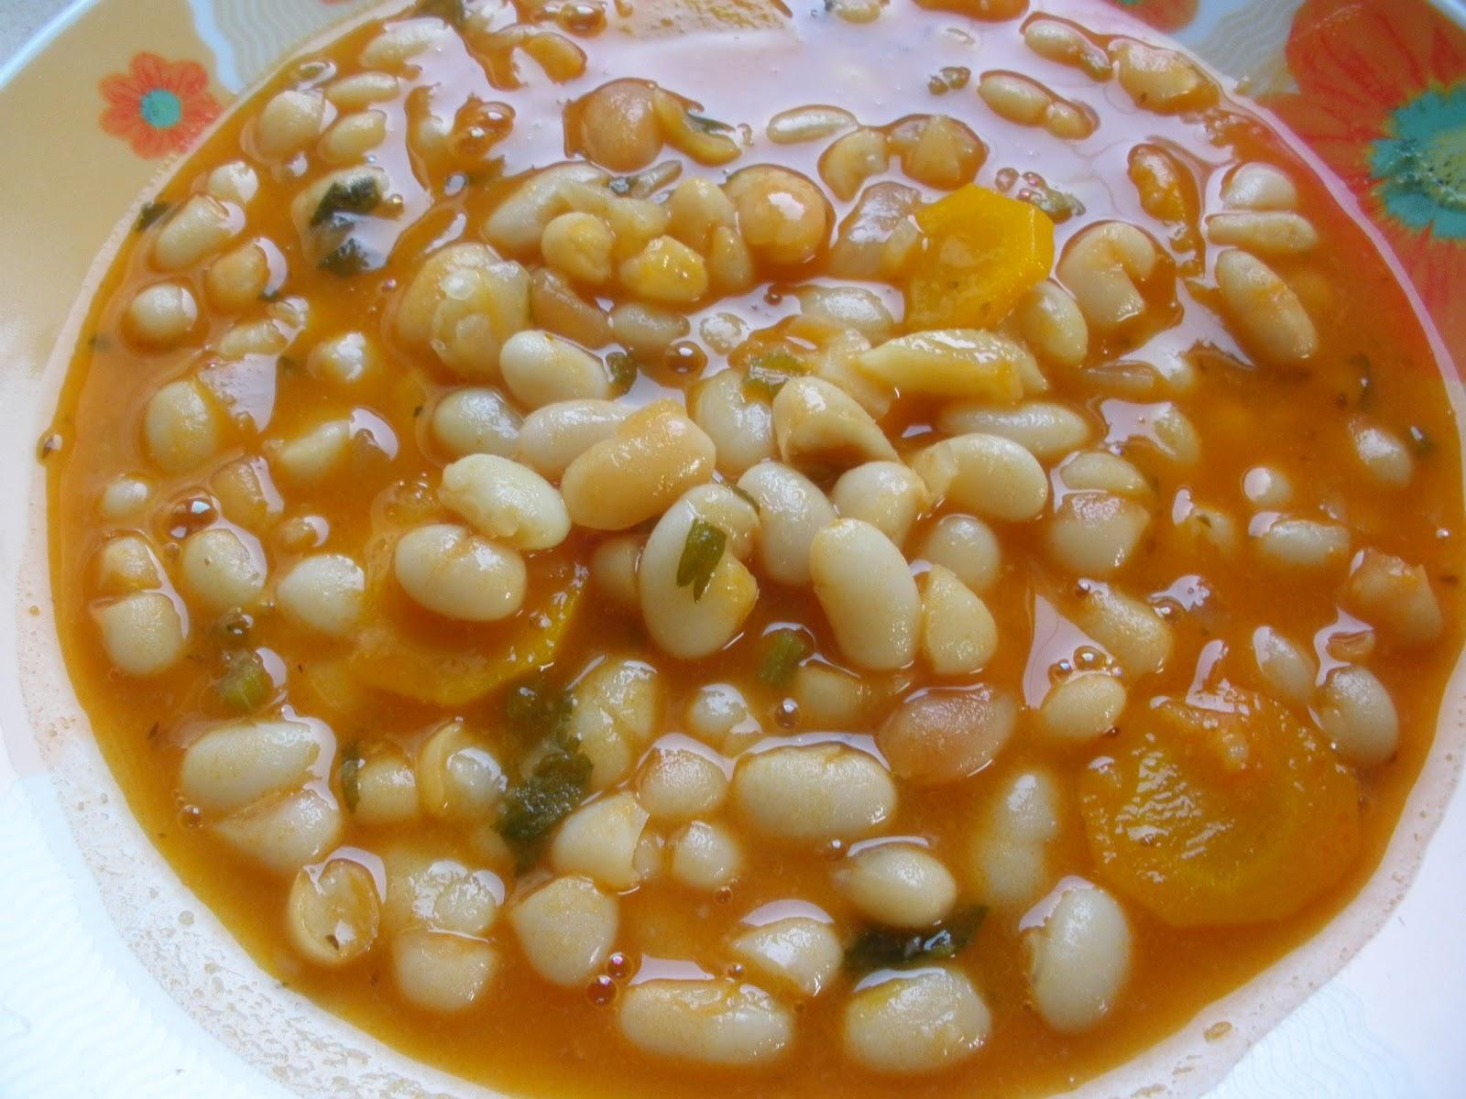

**Method:**

1. **Prepare the Beans:** Drain the soaked beans and rinse well. Place them in a large pot and cover with fresh water. Bring to a boil, then reduce to a simmer. Cook for about 45-60 minutes, or until the beans begin to soften, skimming off any foam that appears.
2. **Build the Flavor:** In a separate saucepan, sauté the chopped onion in the olive oil until it softens and turns golden. Add the minced garlic and cook for another minute, being careful not to burn it. If using tomato paste or diced tomatoes, stir them in now, along with any paprika or chili flakes for a hint of spice.
3. **Combine & Simmer:** Add the sautéed onion mixture to the simmering beans. If using a bay leaf, drop it in. Season lightly with salt and pepper, and let the stew continue to simmer gently for another 30-60 minutes, or until the beans are fully tender and the flavors have melded. Add more water as needed to achieve your preferred consistency—some prefer it thick and creamy, others lighter and brothier.
4. **Taste & Adjust:** Remove the bay leaf (if used) and taste, adjusting seasonings with salt, pepper, or a drizzle of olive oil. Stir in fresh herbs just before serving for a burst of freshness.
5. **Serve:** Ladle the bean stew into bowls and serve hot. It pairs beautifully with crusty bread, cornbread (bukë misri), or pickled vegetables for a contrast of flavors. For a richer meal, accompany it with feta cheese or yogurt.

**Your Adaptations:**

Jahni Fasule welcomes personal interpretation. Tweak the spices, enrich the broth with a bit of butter or ghee, or toss in leftover greens to boost its nutritional profile. The essence of this dish lies in its comforting familiarity, yet it remains flexible enough to reflect the tastes and values of each new generation.

# Meat with Mixed Vegetable Stew (Turlu)

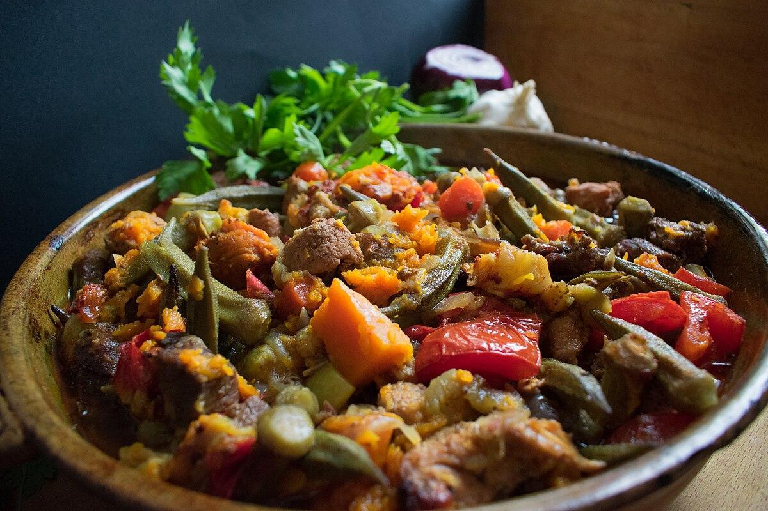

Turlu is a hearty, aromatic stew that exemplifies Albania’s agricultural abundance and the culinary influences shared across the Balkans and the eastern Mediterranean. Its name likely derives from a Turkish root meaning “mixed” or “varied,” reflecting the dish’s medley of vegetables. While Turlu is enjoyed throughout Albania, it finds strong footholds in central and southern regions, where fertile fields yield abundant seasonal produce. Historical references to this type of mixed stew appear in early 20th-century travel writings and family recipe collections, suggesting that Turlu, or something akin to it, has graced Albanian tables for generations. The dish resonates with the idea of using whatever the garden and market provide—a practical and flavorful way to feed a family with nourishing, colorful comfort food.

**Why It’s Beloved:**

Turlu embraces diversity—of ingredients, colors, textures, and flavors. It brings together tender chunks of meat, often lamb or beef, with a variety of vegetables such as eggplants, zucchini, peppers, potatoes, and tomatoes. Gently simmered until each component reaches melting tenderness, this stew is as cozy as it is vibrant. It’s a staple of family gatherings and Sunday lunches, a welcome reminder that simple ingredients can yield layers of comforting complexity. Enjoyed with fresh bread or a side of yogurt, Turlu fosters a sense of togetherness at the table.

**Ingredient Adjustments & Personal Touches:**

While traditional Turlu might feature lamb or beef, feel free to use chicken or skip meat altogether for a vegetarian version. Adjust the vegetable mix based on seasonality—add green beans in summer or root vegetables in cooler months. A hint of garlic, a sprinkle of fresh herbs (parsley, dill, mint), or a spoonful of tomato paste can deepen the flavor. Consider adding a pinch of paprika or crushed red pepper flakes for subtle heat. The balance is yours to strike: keep it simple or layer in new flavors to suit your family’s preferences.

**Serves:** About 6-8

**Time:** Approximately 1.5-2 hours (including prep and simmering)

**Ingredients:**

* 500-700 g (1-1½ lbs) lamb or beef, cut into bite-sized pieces
* 1 large onion, chopped
* 1-2 garlic cloves, minced (optional)
* 1-2 tbsp olive oil or butter
* 1 medium eggplant, cut into cubes (salt and drain if bitter)
* 1-2 zucchinis, sliced or cubed
* 1 red bell pepper, sliced
* 1 green bell pepper, sliced
* 2-3 medium potatoes, peeled and cubed
* 2-3 ripe tomatoes, chopped (or a tablespoon of tomato paste)
* Salt and pepper to taste
* Optional herbs: parsley, dill, or mint, chopped
* Optional spices: paprika, chili flakes
* Water or stock to cover

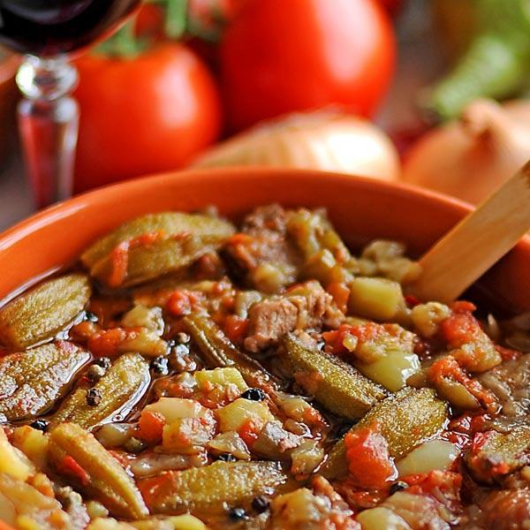

**Method:**

1. **Sear the Meat:** In a large pot over medium heat, warm the olive oil or butter. Add the meat and brown it on all sides, seasoning lightly with salt and pepper. This step builds depth of flavor.
2. **Add Aromatics:** Stir in the chopped onion and cook until it begins to soften and turn translucent. Add the garlic (if using) and cook briefly, being careful not to burn it.
3. **Add Vegetables:** Once the onion is softened, add the eggplant, zucchini, peppers, and potatoes. Stir gently to combine. If using tomatoes, add them now, or stir in tomato paste to enrich the broth.
4. **Simmer Gently:** Pour in enough water or stock to barely cover the ingredients. Bring the mixture to a gentle boil, then reduce the heat to low. Cover and let it simmer for about an hour or until the meat and vegetables are tender. Taste occasionally and adjust seasoning with salt, pepper, or spices as desired.
5. **Finish & Serve:** Stir in a handful of fresh herbs just before serving for brightness. Allow the stew to rest for a few minutes to let the flavors meld. Serve hot with crusty bread or cornbread and a side of yogurt for a cool contrast.

**Your Adaptations:**

Embrace the flexible spirit of Turlu. Swap or omit vegetables depending on what’s available, experiment with adding legumes like chickpeas for extra protein, or incorporate a handful of spinach at the end for a leafy finish. In this stew, tradition and innovation coexist, allowing each cook to create a dish that feels rooted in Albanian heritage while reflecting their own tastes and seasonal inspirations.

# Okra Stew (Gjellë me bamje)

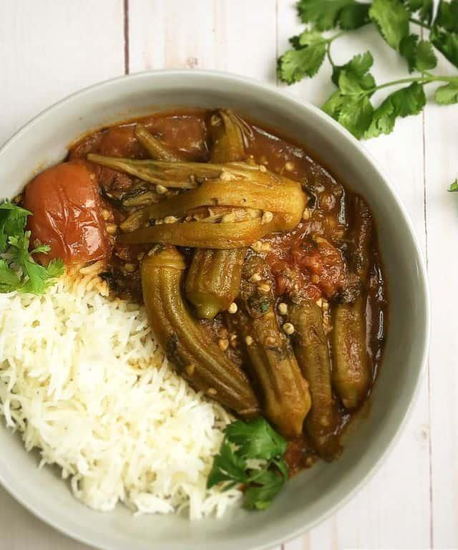

Gjellë me bamje is a traditional Albanian stew that places the spotlight on tender okra—known locally as “bamje.” This dish’s roots run deep in the country’s culinary history, especially in central and southern regions where warm summers yield plentiful harvests of this distinctive vegetable. Historically, Albanian cooks have prepared okra in a variety of ways, often stewing it with tomatoes, onions, and sometimes meat to create a hearty, comforting meal. Early references to okra in Balkan cuisines can be found in 19th-century traveler accounts and family recipe journals, noting its popularity both as a vegetarian dish and as a protein-enriched stew.

**Why It’s Beloved:**

Okra’s subtle grassy flavor and naturally thickening juices make it a perfect candidate for long, slow simmering. Gjellë me bamje is comforting and versatile—serve it over rice or dip crusty bread into the silky sauce. Depending on the region and season, cooks may use different meats or leave it vegetarian, showcasing the adaptability of Albanian home cooking. The inclusion of dried beef or ground beef further demonstrates this stew’s ability to reflect personal taste and available ingredients.

## Version 1: With Dried Beef (Mish i Thatë)

**About Dried Beef in Albanian Cuisine:**

Dried beef (mish i thatë) has a long tradition in Albanian kitchens, originating from the need to preserve meat before refrigeration. Its concentrated, savory flavor and chewy texture add depth and character to dishes like okra stew. The dried beef’s intensity contrasts beautifully with the mild okra and tangy tomatoes.

**Serves:** About 4-6

**Time:** Approximately 1.5 hours

**Ingredients:**

* 300-400 g (about 2 cups) okra, trimmed (fresh or frozen)
* 100-150 g dried beef (mish i thatë), cut into small pieces or strips
* 1 large onion, finely chopped
* 2-3 garlic cloves, minced
* 2-3 ripe tomatoes, chopped (or 1-2 tbsp tomato paste diluted in water)
* 2-3 tbsp olive oil
* Salt and pepper to taste
* ½ tsp paprika or chili flakes (optional)
* Water or mild stock to cover

**Method:**

1. **Prepare the Beef:** If the dried beef is particularly hard or salty, you may briefly rinse or soak it in warm water for a few minutes. Pat it dry.
2. **Sauté the Aromatics:** In a large pot over medium heat, warm the olive oil. Add the chopped onion and sauté until softened. Stir in the garlic and cook for another minute, being careful not to burn it.
3. **Add the Beef & Tomatoes:** Add the dried beef pieces and sauté briefly to release their aroma. Stir in the chopped tomatoes or tomato paste and cook until the tomatoes soften and form a sauce.
4. **Add the Okra:** Add the okra to the pot and stir gently. Season with salt, pepper, and any optional paprika or chili flakes. Keep in mind that dried beef can be salty, so season sparingly at first.
5. **Simmer Gently:** Pour in enough water or stock to just cover the okra and meat. Bring to a simmer, then reduce heat to low, cover, and cook for about 40-60 minutes, or until the okra is tender and the flavors have melded. Taste and adjust seasonings as needed.
6. **Serve:** Ladle the stew into bowls. Serve hot with crusty bread, rice, or pilaf. A simple side salad or pickled vegetables make a lovely accompaniment.

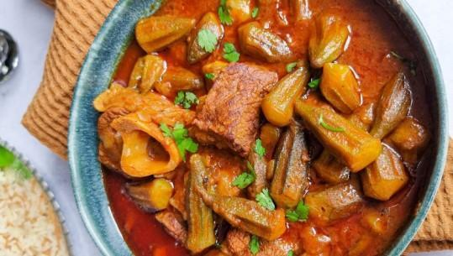

## Version 2: With Ground Beef

**About Using Ground Beef:**

Ground beef offers a different profile—softer texture, more gentle flavor, and a comforting familiarity. This version results in a stew that is still deeply savory, but the flavors are more mellow. It’s a great option if dried beef isn’t readily available and you want a more universally accessible approach.

**Serves:** About 4-6

**Time:** Approximately 1.5 hours

**Ingredients:**

* 300-400 g (about 2 cups) okra, trimmed (fresh or frozen)
* 250-300 g (about ½ - ⅔ lb) ground beef (preferably lean)
* 1 large onion, finely chopped
* 2-3 garlic cloves, minced
* 2-3 ripe tomatoes, chopped (or 1-2 tbsp tomato paste diluted in water)
* 2-3 tbsp olive oil
* Salt and pepper to taste
* ½ tsp paprika or dried herbs (like thyme or oregano) optional
* Water or mild stock to cover

**Method:**

1. **Sauté the Beef & Onions:** In a large pot over medium-high heat, warm the olive oil. Add the chopped onion and cook until translucent. Add the ground beef and cook, breaking it up with a spoon, until it’s browned and no longer pink. Season lightly with salt and pepper.
2. **Add Garlic & Tomatoes:** Stir in the minced garlic and cook briefly, then add the tomatoes or diluted tomato paste. Let this mixture cook until the tomatoes start to break down and form a sauce.
3. **Add the Okra:** Stir in the okra, coating it with the meat and tomato mixture. Adjust seasoning with salt, pepper, and optional paprika or herbs.
4. **Simmer:** Pour in enough water or stock to just cover. Bring the stew to a gentle simmer, then reduce the heat, cover, and let it cook for 40-60 minutes, or until the okra is tender and the flavors are well integrated. Taste and adjust seasonings as you go.
5. **Serve:** Spoon the stew into bowls and serve hot. Accompany with warm bread or rice, and consider a side of yogurt or a bright salad to contrast with the rich, savory stew.

**Your Adaptations:**

Both versions welcome small changes. Add a pinch of sugar if your tomatoes are tart, or stir in fresh parsley at the end for freshness. Consider a squeeze of lemon for brightness, or a drizzle of olive oil for richness. Whether you opt for the rustic flavor of dried beef or the comforting familiarity of ground beef, Gjellë me bamje remains a testament to Albanian cuisine’s adaptability, resourcefulness, and deep connection to the land’s seasonal bounty.

# Baked Lamb and Yogurt Casserole (Tavë Kosi)

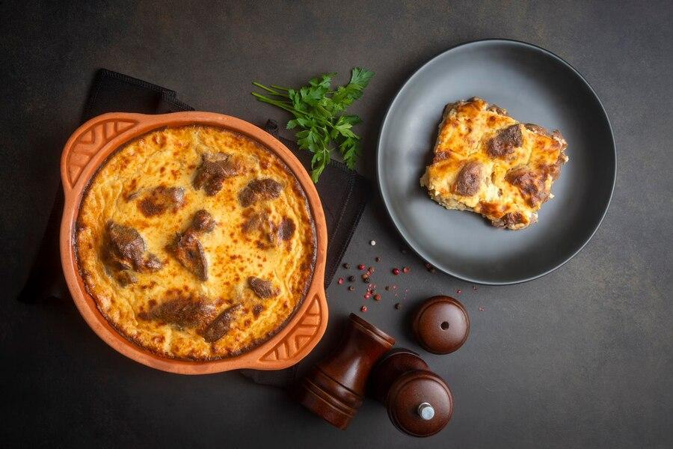

Tavë Kosi is often celebrated as one of Albania’s national dishes—a comforting casserole of tender lamb baked with a tangy, yogurt-based custard. Its roots lie in central and southern Albania, particularly in and around the city of Elbasan, which has lent its name to a well-known variation called “Tavë Elbasani.” Written references and family narratives indicate that Tavë Kosi evolved from a centuries-old tradition of combining lamb—readily available in Albanian pastoral communities—with yogurt, a dairy staple. By the early 20th century, the dish was already held in high regard, appearing at festive occasions, family gatherings, and as a special Sunday meal.

**Why It’s Beloved:**

Tavë Kosi’s allure comes from the interplay of flavors and textures. Gently roasted lamb, with its savory depth, harmonizes beautifully with the bright tanginess of the yogurt topping. As it bakes, the yogurt mixture sets into a creamy custard that encases the tender meat. This dish exemplifies Albanian culinary wisdom: transforming a few simple ingredients into something distinctly comforting, elegant, and celebratory. Served with bread to mop up the savory juices, it evokes a sense of home and heritage.

**Ingredient Adjustments & Personal Touches:**

While lamb is the traditional choice, you can use goat, veal, or even chicken thighs if you prefer. Adjust the tanginess by using a richer, creamier yogurt or adding a bit more lemon juice. Some cooks sprinkle fresh or dried herbs (like oregano or mint) or add a dash of paprika for color. If you like a thicker, creamier custard, incorporate a spoonful of flour or cornstarch. Tavë Kosi is forgiving, encouraging small tweaks while preserving its essential character.

**Serves:** About 6-8

**Time:** Approximately 2 hours (including roasting and baking)

**Ingredients:**

* 1.5–2 kg (3–4 lbs) lamb shoulder or leg, bone-in, cut into serving pieces
* 2-3 tbsp butter or olive oil
* Salt and pepper to taste
* 1 onion, chopped (optional)
* 2-3 garlic cloves, minced (optional)
* 800-900 g (about 3½–4 cups) plain yogurt (full-fat, preferably)
* 2-3 eggs, lightly beaten
* Juice of half a lemon (or more, to taste)
* Optional: 1 tbsp flour or cornstarch (for a thicker custard), a pinch of dried oregano, or a sprinkle of paprika

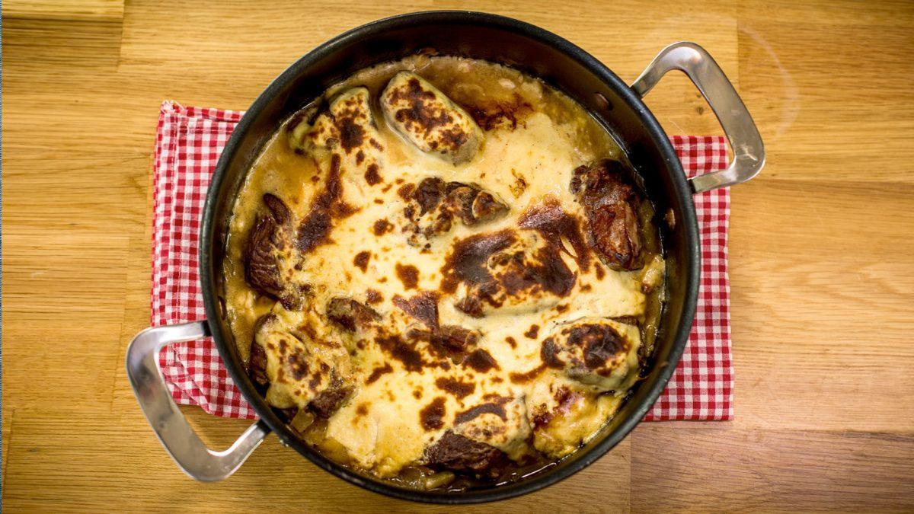

**Method:**

1. **Roast the Lamb:** Preheat your oven to 180°C (350°F). Season the lamb pieces generously with salt and pepper. Melt the butter or heat the oil in a large, oven-safe casserole or roasting dish over medium-high heat. Brown the lamb pieces on all sides to develop flavor. If using onions and garlic, sauté them alongside the lamb until softened. Add a splash of water or stock if needed, then cover and roast in the oven until the lamb is tender, about 1–1½ hours.
2. **Prepare the Yogurt Mixture:** In a bowl, whisk together the yogurt, eggs, and lemon juice. Season with a pinch of salt and pepper. If you’d like a slightly thicker custard, whisk in the flour or cornstarch. Taste and adjust acidity with more lemon if desired. Add herbs or paprika if you like.
3. **Assemble the Casserole:** Once the lamb is tender, remove the dish from the oven. Carefully spoon off any excess fat. If you’ve added onions and garlic, they should now be soft and caramelized. Pour the yogurt mixture evenly over the lamb, shaking the dish gently so the mixture settles into all the nooks.
4. **Bake the Custard:** Increase the oven temperature to about 200°C (390°F). Return the dish to the oven, uncovered, and bake for about 30–40 minutes, or until the yogurt topping sets into a custard-like consistency and turns golden on top. Keep an eye on it toward the end, as it can brown quickly.
5. **Rest & Serve:** Remove from the oven and let Tavë Kosi rest for about 10 minutes before serving. Accompany it with fresh bread, a simple salad, or pickled vegetables. The flavors continue to develop as it sits, making leftovers especially delicious the next day.

**Your Adaptations:**

The essence of Tavë Kosi lies in balancing the richness of lamb and the brightness of yogurt. You can tweak the seasonings, use different meats, or play with herbs to create your own signature version. Whether you keep it utterly traditional or spin it into something personal, Tavë Kosi remains a timeless Albanian classic that brings family, memory, and flavor together on the table.

# Casserole with Meat and Liver (Tavë Dheu)

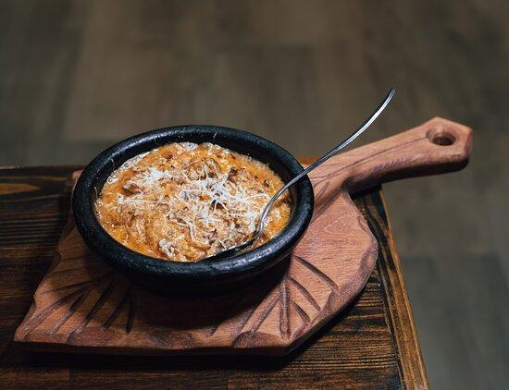

Tavë Dheu is a rustic Albanian casserole traditionally baked in an earthenware dish (tavë), which imparts a unique depth of flavor to the meal. Popular throughout the country—though particularly in central Albania—the dish evolved from an Ottoman-era culinary heritage, blending slow-cooked meats, offal, and dairy into a rich, comforting stew. Early 20th-century travelers and ethnographers note the prevalence of dishes combining liver with robust spices and creamy cheese sauces, and Tavë Dheu aligns perfectly with that tradition. Its preparation once involved using whatever meats were on hand, making it both a thrifty and celebratory dish.

**Why It’s Beloved:**

Tavë Dheu marries tender morsels of meat and liver with a tangy, custard-like sauce often made from gjizë (Albanian fresh curd cheese) or yogurt, and eggs. Baked until bubbly and golden, it offers layers of flavor and texture: the earthy notes of liver, the savory richness of slow-simmered meat, and the creamy tang of dairy, all bound together in a comforting casserole. It’s a hearty, warming dish that appears at family gatherings, Sunday lunches, and holiday feasts, connecting past and present through culinary artistry.

**Ingredient Adjustments & Personal Touches:**

Traditional Tavë Dheu often uses veal or beef and veal liver, though lamb or goat can also be employed. Adjust the seasoning with a hint of paprika or dried chili for extra warmth. Some cooks stir in a spoonful of tomato paste or chopped tomatoes for brightness. If gjizë isn’t available, a mixture of ricotta and feta, or even full-fat yogurt, can be used. Herbs such as parsley or oregano add freshness, while a drizzle of olive oil over the top imparts a luscious finish. This casserole is forgiving and open to interpretation—feel free to adjust flavors to your family’s taste.

**Serves:** About 6-8

**Time:** Approximately 2 hours (including braising and baking)

**Ingredients:**

* 500 g (about 1 lb) veal or beef, cut into bite-sized pieces
* 200-300 g (about ½ lb) veal or beef liver, cleaned and chopped into small cubes
* 1 large onion, finely chopped
* 1-2 garlic cloves, minced
* 2-3 tbsp butter or olive oil
* Salt and pepper to taste
* ½ tsp paprika or chili flakes (optional)
* 1-2 tbsp tomato paste or 1-2 chopped tomatoes (optional)
* 300-400 g (about 1½-2 cups) gjizë (fresh Albanian curd cheese) or a combination of crumbled feta and ricotta
* 2 eggs, lightly beaten
* A handful of chopped fresh parsley or a pinch of dried oregano (optional)

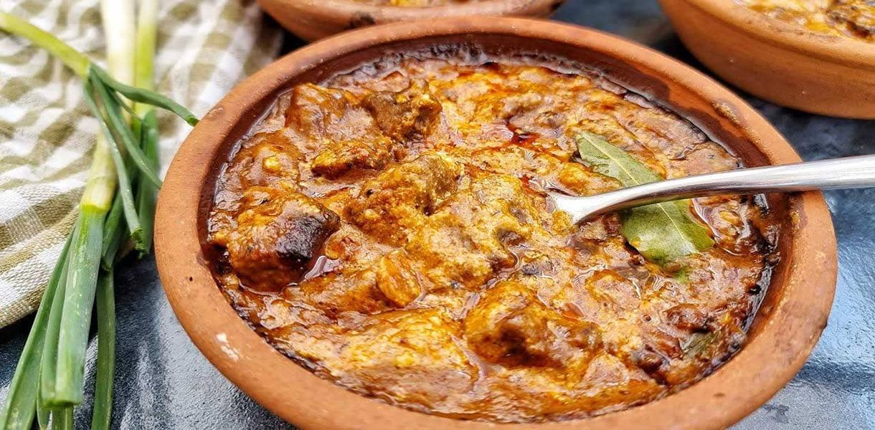

**Method:**

1. **Sear the Meats:** In a large, heavy-bottomed pot, warm the butter or olive oil over medium-high heat. Add the meat (excluding the liver) first and brown on all sides. Season with salt and pepper. If using paprika or chili flakes, stir them in now. Reduce heat to medium and add the onion and garlic, cooking until softened. Stir in the tomato paste or tomatoes if using.
2. **Add the Liver & Simmer:** Add the liver to the pot and sauté briefly until it changes color (take care not to overcook it at this stage). Pour in just enough water or stock to cover the ingredients partially. Bring to a gentle simmer, cover, and let it cook until the meat is tender—about 45-60 minutes. Adjust seasoning as it cooks, tasting for salt and pepper.
3. **Prepare the Dairy Mixture:** In a bowl, whisk together the gjizë (or ricotta and feta mixture) and the beaten eggs. Adjust the tanginess to taste; if you want a creamier, mellower flavor, add a spoonful of yogurt. Stir in chopped parsley or oregano for a fresh note.
4. **Assemble & Bake:** Preheat your oven to 180°C (350°F). Transfer the simmered meat and liver mixture to an earthenware casserole dish (if you don’t have earthenware, a ceramic baking dish works fine). Pour the dairy and egg mixture over the top, gently shaking the dish so it settles into all the crevices.
5. **Bake:** Bake for about 30-40 minutes, or until the top is lightly golden and set, and the casserole is bubbling at the edges. The dish should have a creamy, custard-like topping that holds the tender meat and liver in a rich embrace.
6. **Rest & Serve:** Let the Tavë Dheu cool for about 10 minutes before serving. Present it with fresh bread, a crisp salad, or pickled vegetables. Its hearty flavors pair nicely with a glass of red wine or raki.

**Your Adaptations:**

Feel free to play with the balance of meat and liver—use more liver if you appreciate its depth or reduce it if you prefer a gentler taste. Add different herbs or spices, adjust the dairy components, or brighten it up with lemon zest. Tavë Dheu is a time-honored Albanian classic that adapts well to modern palates, ensuring it remains a flavorful bridge between culinary heritage and personal preference.

# Albanian (Qofte)

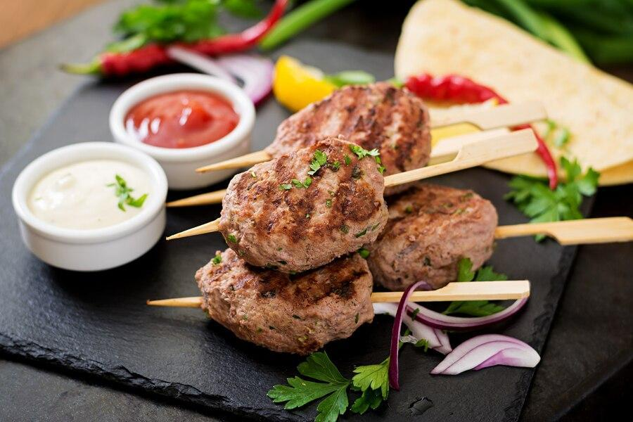

Qofte are a beloved fixture of Albanian cuisine, tracing their roots back to Ottoman influences and the broader Balkan and Mediterranean tradition of seasoned ground meat shaped into patties or balls. These succulent morsels have been a staple for centuries, mentioned in travelers’ accounts and local folk recipes. They are found across the country, though central and coastal areas are often associated with their widespread enjoyment. Whether served as street food wrapped in bread, as part of a family lunch spread, or offered at festive gatherings, qofte represent the comforting, everyday deliciousness that Albanian kitchens deliver.

**Why They’re Beloved:**

Qofte captivate with their perfect blend of simplicity and deep, comforting flavor. Typically made from ground beef or lamb, mixed with herbs and spices, they offer a tender, juicy bite that pairs well with creamy dips, salads, or simple sides like grilled vegetables or roasted potatoes. They can be grilled, pan-fried, or baked, depending on family tradition and convenience. For many Albanians, biting into a well-seasoned qofte recalls family dinners, neighborhood grills, and the communal warmth of shared meals.

**Ingredient Adjustments & Personal Touches:**

While classic qofte often feature ground beef or a beef-lamb combination, feel free to experiment with different meats (veal, chicken) or add a handful of finely chopped onion and herbs. Parsley is common, but mint or dill can add a fresh twist. Some cooks moisten the mixture with a touch of yogurt or grated tomato to enhance tenderness. Adjust the level of salt, pepper, and paprika to suit your family’s palate, and consider a pinch of cumin or dried oregano for subtle complexity.

**Serves:** About 4-6

**Time:** About 1 hour (including shaping and cooking)

**Ingredients:**

* 500 g (about 1 lb) ground beef or a beef-lamb mix
* 1 small onion, finely chopped or grated
* 1 small bunch parsley, finely chopped (about ¼ cup)
* 1-2 garlic cloves, minced (optional)
* 1-2 tbsp breadcrumbs (optional, for binding)
* 1 egg (optional, for binding and richness)
* Salt and pepper to taste
* ½ tsp paprika (optional)
* A pinch of cumin or dried oregano (optional)
* Olive oil or butter for frying, or brush-on if grilling

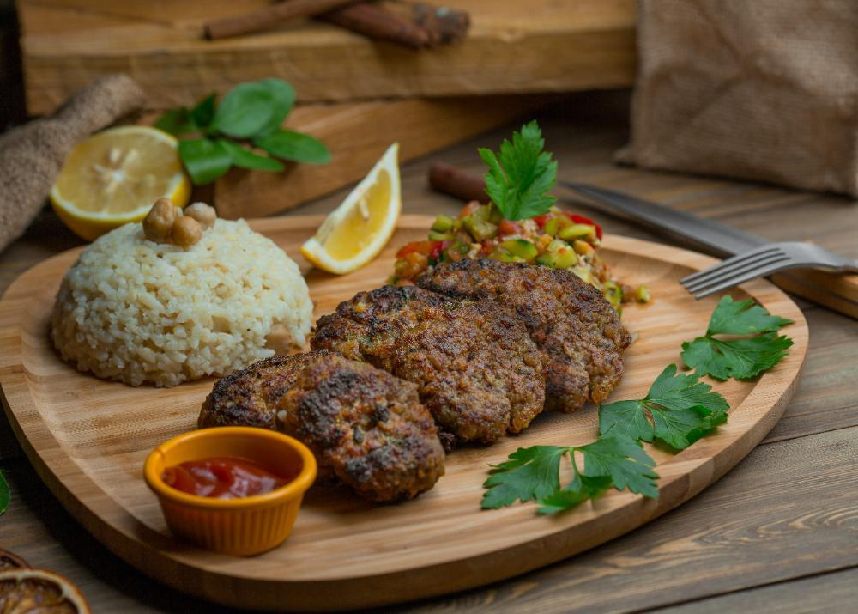

**Method:**

1. **Mix the Meat:** In a large bowl, combine the ground meat, chopped onion, parsley, and garlic. Add the egg and breadcrumbs if using. Season with salt, pepper, paprika, and any additional spices. Mix gently but thoroughly with your hands until all ingredients are evenly distributed. Avoid overmixing to keep the meatballs tender.
2. **Shape the Qofte:** Form the meat mixture into small patties or oval-shaped meatballs. Press gently to ensure they hold together, but don’t compress them too tightly. If time allows, refrigerate the formed qofte for about 20-30 minutes to help them hold their shape during cooking.
3. **Cook to Perfection:**

* **Pan-Fried:** Heat a thin layer of oil or butter in a skillet over medium heat. Add the qofte in batches, cooking until browned on all sides and fully cooked through, about 8-10 minutes total depending on size.
* **Grilled:** Preheat your grill to medium-high. Lightly brush the qofte with oil and grill for about 4-5 minutes per side, or until cooked to your desired doneness.
* **Baked:** Place the qofte on a parchment-lined baking sheet and bake in a preheated 200°C (390°F) oven for about 20-25 minutes, flipping halfway, until nicely browned and cooked through.

1. **Rest & Serve:** Let the cooked qofte rest for a few minutes before serving. Accompany with a tangy yogurt-garlic sauce, fresh salad, pickles, or roasted vegetables. They’re equally enjoyable tucked into warm bread or alongside a simple pilaf.

**Your Adaptations:**

Qofte are endlessly adaptable. Add a spoonful of grated tomato or yogurt to the mixture for extra moisture, experiment with different herbs, or try mixing in a touch of feta cheese for creaminess. Serve them as appetizers, part of a meze spread, or as a main dish with your favorite sides. In every variation, qofte maintain their role as a cherished symbol of Albanian hospitality and home cooking.

# Onion and Meat Stew (Mish Jahni )

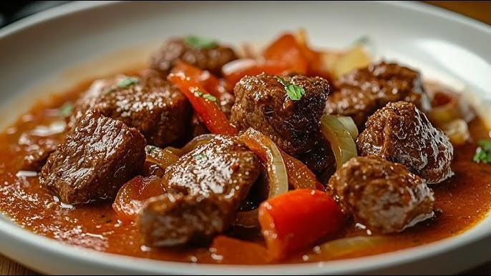

Jahni me mish, a robust stew of meat and onions, is a classic dish that highlights the heartiness and simplicity of Albanian home cooking. Often enjoyed in cooler seasons, it’s associated with rural communities where onions, a staple crop, and readily available meat—be it lamb, beef, or even goat—provide a warming, nourishing meal. Historical references to onion-based stews appear in early 20th-century domestic guides and travelers’ accounts, suggesting that variations of this dish have comforted Albanian families for generations. Its preparation epitomizes the Balkan culinary philosophy of coaxing big flavor from a few humble ingredients.

**Why It’s Beloved:**

Jahni me mish boasts tender morsels of meat simmered with plenty of onions until they turn sweet, soft, and richly flavorful. The onions mellow and thicken the stew’s sauce, creating a luxuriously savory broth that begs to be sopped up with crusty bread. This is comfort food at its core—served at family tables on ordinary nights and special gatherings alike. Its balanced simplicity makes it universally appealing, transcending regional boundaries within Albania.

**Ingredient Adjustments & Personal Touches:**

Traditionally, the dish is made with lamb or beef, but feel free to choose the meat you prefer. Some cooks add a splash of vinegar or lemon juice to brighten the flavor, while others incorporate a pinch of cinnamon, paprika, or dried herbs. For a richer sauce, a small spoonful of tomato paste can be stirred in. Adjust seasoning to taste, keeping in mind that the onions naturally lend sweetness and depth to the stew.

**Serves:** About 6-8

**Time:** Approximately 2 hours (including simmering)

**Ingredients:**

* 1-1.5 kg (2-3 lbs) lamb or beef, cut into medium chunks
* 2-3 tbsp olive oil or butter
* 3-4 large onions, thinly sliced or roughly chopped
* Salt and pepper to taste
* Optional additions: 1-2 garlic cloves (minced), a spoonful of tomato paste, a pinch of paprika, a bay leaf, or a splash of vinegar/lemon juice

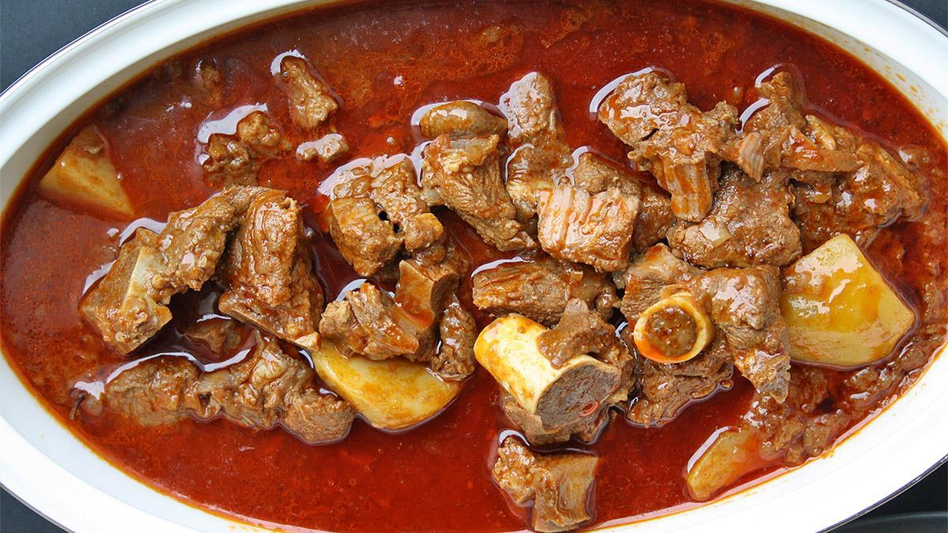

**Method:**

1. **Brown the Meat:** In a large, heavy-bottomed pot over medium-high heat, warm the olive oil or butter. Add the meat in batches (to avoid overcrowding) and brown on all sides to develop flavor. Season lightly with salt and pepper as you go. Remove the browned meat and set aside.
2. **Cook the Onions:** Add the onions (and garlic if using) to the pot, reducing the heat to medium. Stir gently, scraping up any browned bits from the bottom. Cook until the onions soften and turn translucent, about 8-10 minutes. If using paprika or tomato paste, stir it in now.
3. **Simmer the Stew:** Return the browned meat and its juices to the pot. Pour in enough hot water or stock to just cover the ingredients. If you’re adding a bay leaf or a splash of vinegar/lemon juice, do so now. Bring to a gentle simmer, then reduce the heat to low, cover, and let it cook slowly for about 1-1½ hours, or until the meat is tender and the flavors have melded. Taste and adjust seasoning with salt, pepper, or a hint more vinegar if desired.
4. **Thicken & Serve:** As the stew simmers, the onions will break down, thickening the broth naturally. If you prefer a thicker sauce, cook uncovered for the last 10-15 minutes to reduce the liquid. Remove the bay leaf (if used). Ladle the stew into bowls and serve hot, accompanied by bread, rice, or a simple salad.

**Your Adaptations:**

This dish invites subtle variations. Alter the ratio of onions to meat for a sweeter, more onion-forward flavor, or add seasonal vegetables like a handful of green beans or diced carrots. Experiment with a splash of red wine for complexity, or drizzle a bit of olive oil at the end for richness. In each adaptation, jahni me mish remains a timeless Albanian comfort—hearty, fragrant, and deeply satisfying.

# Stuffed Eggplants with Meat (Patëllxhanë të mbushur me mish)

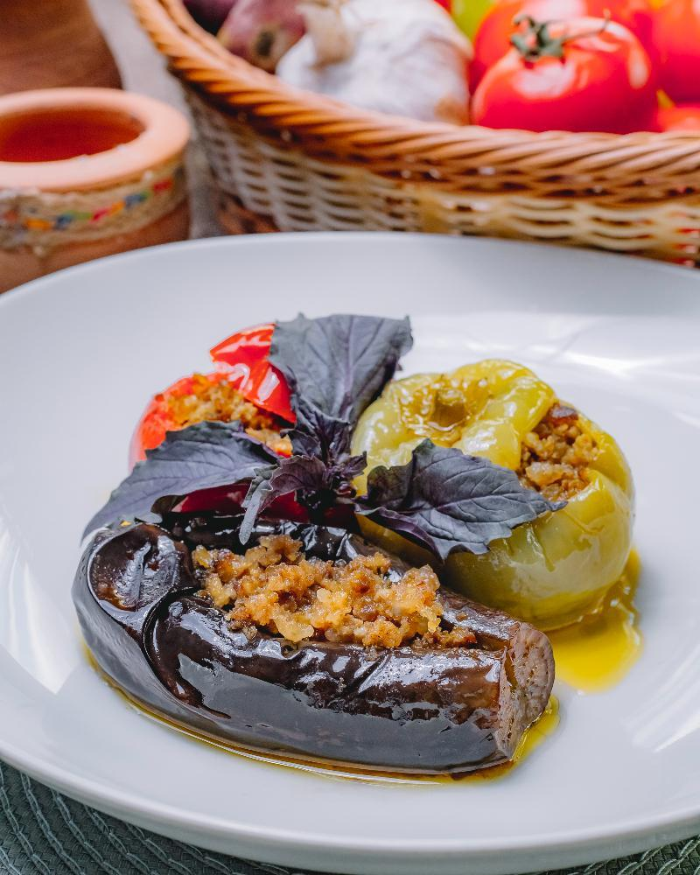

Stuffed eggplants are common throughout the Balkans and the broader Mediterranean, reflecting a culinary tradition that values seasonal vegetables and creative fillings. In Albania, this dish is particularly enjoyed in central and southern regions, where aubergines (eggplants) thrive under the warm sun. Family recipe notebooks and oral traditions mention variations dating back to the early 20th century or earlier, often inspired by Ottoman influences. Patëllxhanë të mbushur me mish embodies the Albanian ethos of transforming humble ingredients—garden-fresh eggplants and flavorful ground meat—into a dish fit for family gatherings or special occasions.

**Why It’s Beloved:**

Tender eggplant halves, hollowed out and filled with a savory mixture of ground meat, onions, herbs, and sometimes a touch of tomato, capture both comfort and subtle elegance. As the eggplants bake, their flesh softens, melding with the aromatic filling. The result is a fragrant, hearty dish that pairs beautifully with yogurt, salads, or a side of rice. For many Albanians, this comforting meal triggers fond memories of home kitchens, laughter-filled family meals, and seasonal abundance.

**Ingredient Adjustments & Personal Touches:**

While ground beef or lamb is typical, feel free to use a mixture of meats or even ground turkey for a lighter version. Consider adding a spoonful of tomato paste or fresh diced tomatoes for acidity and color. For extra aromatic depth, stir in chopped parsley, dill, or mint. A bit of crumbled white cheese on top before baking can provide a pleasant salty tang. The ratio of spices, herbs, and vegetables can be fine-tuned to your family’s tastes—more herbs for freshness, a pinch of paprika for warmth, or a spoonful of yogurt stirred into the filling for creaminess.

**Serves:** About 4-6

**Time:** Approximately 1.5-2 hours (including baking)

**Ingredients:**

* 4-6 medium eggplants
* 400-500 g (about 1 lb) ground beef or lamb
* 1 large onion, finely chopped
* 2-3 garlic cloves, minced (optional)
* 2-3 tbsp olive oil
* 1-2 tbsp tomato paste or 1-2 ripe tomatoes, diced (optional)
* Salt and pepper to taste
* A handful of chopped fresh parsley (optional)
* A pinch of paprika or dried oregano (optional)
* Water or mild stock for baking

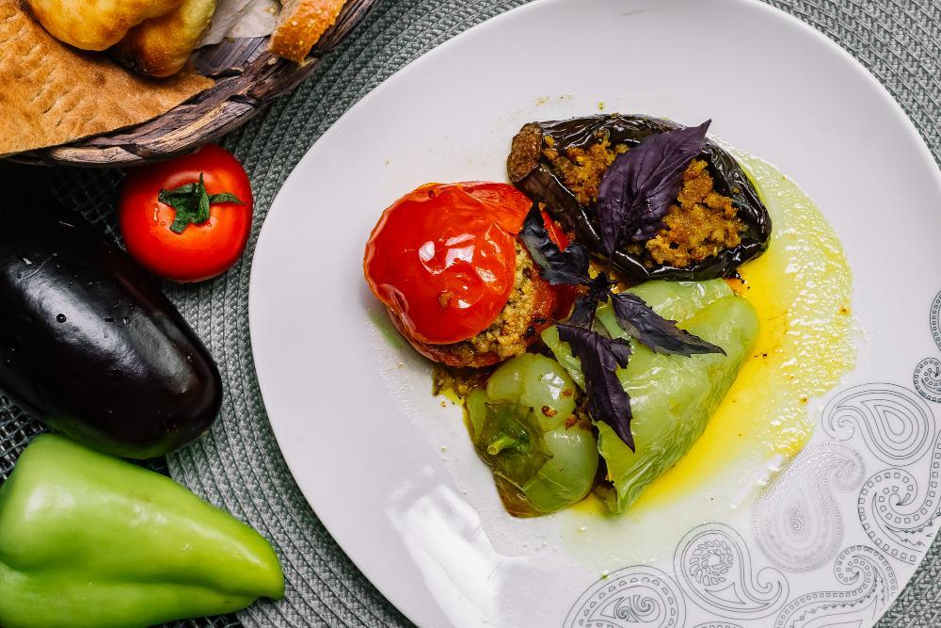

**Method:**

1. **Prepare the Eggplants:** Preheat your oven to 180°C (350°F). Wash the eggplants and slice them in half lengthwise. Using a small spoon, carefully scoop out some of the pulp to create hollow “boats,” leaving about 1 cm (½ inch) of flesh intact. Chop the removed pulp into small pieces and set aside. Lightly salt the hollowed eggplants and set them cut-side down on paper towels for about 15-20 minutes to draw out moisture.
2. **Sauté the Filling:** In a skillet over medium heat, warm the olive oil. Add the chopped onion and sauté until translucent. Stir in the garlic, if using, and cook briefly. Add the ground meat, breaking it up with a spoon until it’s browned and no longer pink. Mix in the chopped eggplant pulp, tomato paste or diced tomatoes (if using), and season with salt, pepper, and any desired paprika or oregano. Cook until the mixture is well combined and slightly thickened. Stir in parsley or other fresh herbs, then taste and adjust seasonings.
3. **Stuff the Eggplants:** Pat the eggplant halves dry and arrange them in a baking dish. Spoon the meat mixture into each hollowed eggplant half, pressing gently to fill them well. If desired, top with crumbled white cheese or a drizzle of olive oil for extra richness.
4. **Bake:** Pour a bit of water or mild stock into the baking dish—just enough to come about 1 cm (½ inch) up the sides of the eggplants. This moisture helps them cook evenly. Cover the dish with foil and bake for about 30-40 minutes. Remove the foil and continue baking for another 15-20 minutes or until the eggplants are tender and the filling is browned and fragrant. Cooking times vary depending on eggplant size, so test with a fork for doneness.
5. **Rest & Serve:** Allow the stuffed eggplants to rest for a few minutes before serving. Accompany them with yogurt or a simple cucumber-tomato salad for a fresh contrast. They’re excellent served warm, but also hold their flavor well at room temperature.

**Your Adaptations:**

Feel free to adjust the vegetable-to-meat ratio, use different herbs, or add a handful of rice or bulgur to the filling for more texture. You can even experiment with a vegetarian version by substituting the meat with lentils or mushrooms. Patëllxhanë të mbushur me mish welcomes your personal touch, ensuring each generation can reinvent this classic while staying true to its Albanian roots.

# Peas and Meat Stew (Bizele me mish)

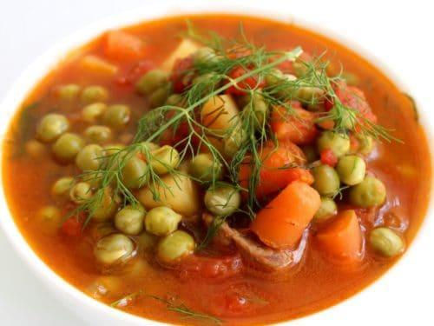

Bizele me mish is a comforting Albanian stew that highlights peas simmered with tender pieces of meat in a savory, aromatic broth. While peas have been a cherished springtime crop in Albanian gardens for centuries, written references to pea stews appear in family recipe collections and local cookbooks from the early 20th century, indicating their longstanding presence at the dinner table. This dish is popular throughout the country, bridging rural and urban palates. Its appeal lies in the simplicity and adaptability of blending fresh (or even frozen) peas with hearty meat, resulting in a stew that is as nourishing as it is flavorful.

**Why It’s Beloved:**

Bizele me mish is the kind of everyday meal that brings families together. The natural sweetness of peas melds beautifully with savory, slow-cooked meat—usually lamb, beef, or veal. The result is a balanced, warming stew that can be served year-round but is especially delightful when fresh peas are abundant. Accompanied by bread, rice, or a simple salad, it evokes the warmth and familiarity of home cooking. For many Albanians, it’s a timeless dish that evokes memories of grandparents and family gatherings.

**Ingredient Adjustments & Personal Touches:**

Traditional versions rely on minimal seasonings—salt, pepper, maybe a touch of onion or garlic—to let the peas and meat shine. Feel free to add depth with a spoonful of tomato paste, a dash of paprika, or fresh herbs like parsley or dill. You can also use chicken for a lighter dish or lean towards lamb for a richer flavor. Adjust the thickness of the broth by adding more or less water, or consider stirring in a spoonful of yogurt or a drizzle of olive oil at the end for a subtle twist. This stew welcomes small tweaks that reflect personal taste and seasonal availability.

**Serves:** About 6-8

**Time:** Approximately 1.5 hours (including simmering)

**Ingredients:**

* 500-700 g (1-1½ lbs) lamb, beef, or veal, cut into bite-sized pieces
* 2-3 tbsp olive oil or butter
* 1 large onion, finely chopped
* 1-2 garlic cloves, minced (optional)
* 500-600 g (about 1 lb) peas (fresh or frozen)
* Salt and pepper to taste
* Optional additions: 1-2 tbsp tomato paste, a pinch of paprika, fresh herbs (parsley, dill)
* Water or stock to cover

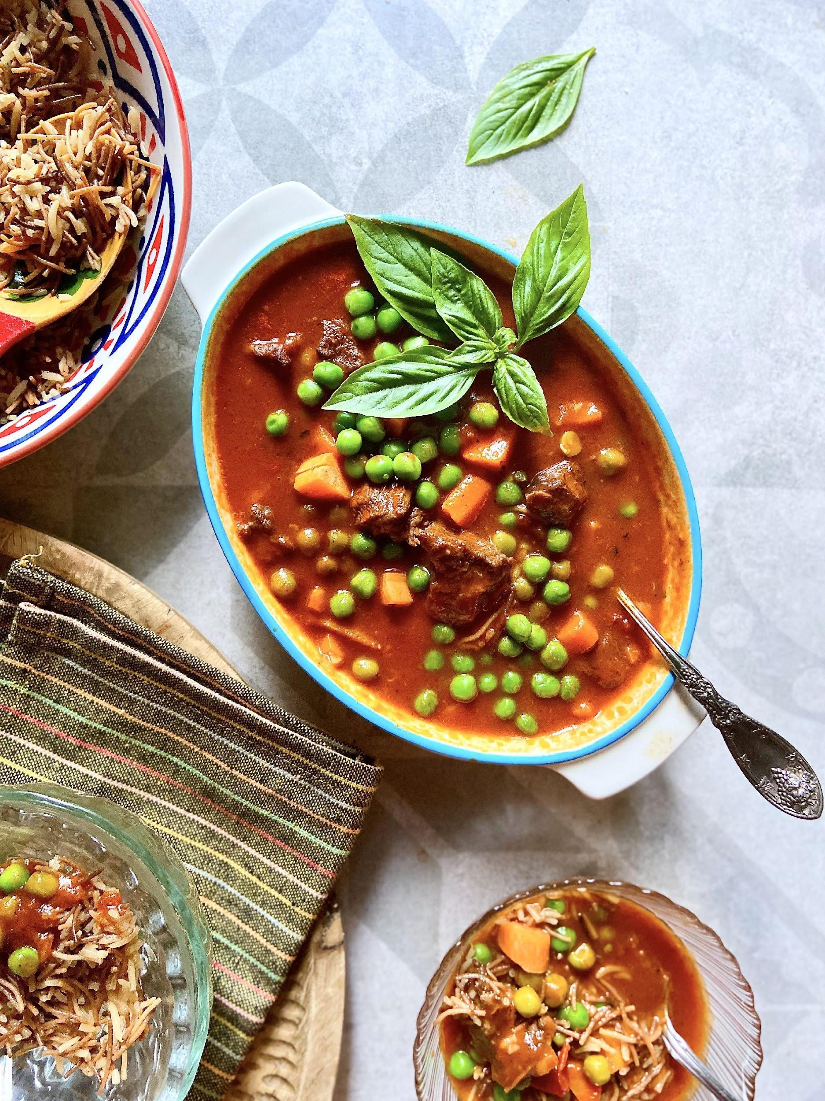

**Method:**

1. **Brown the Meat:** In a large, heavy-bottomed pot, warm the olive oil or butter over medium-high heat. Add the meat in batches to avoid crowding, browning it on all sides. Season lightly with salt and pepper. Remove the browned meat and set it aside.
2. **Build the Base:** Reduce the heat to medium and add the chopped onion. Sauté until it becomes translucent and soft. Stir in the garlic, if using, and cook briefly. If you’re adding tomato paste or paprika, stir it in now to develop flavor.
3. **Simmer the Stew:** Return the browned meat and its juices to the pot. Pour in enough hot water or stock to just cover the meat. Bring to a gentle simmer, then reduce the heat, cover, and let it cook for about 45-60 minutes or until the meat is beginning to tenderize. Skim any foam if it forms.
4. **Add the Peas:** Stir in the peas. If using fresh peas, add them a bit earlier to ensure they soften; if using frozen, add them closer to the end. Simmer uncovered or partially covered for another 15-20 minutes, or until the peas are tender and the flavors have melded. Taste and adjust seasoning with salt, pepper, and fresh herbs.
5. **Serve:** Ladle the stew into bowls and serve hot. Accompany with warm bread, cornbread, or rice for soaking up the flavorful broth. A side salad or pickled vegetables can provide a bright, tangy contrast.

**Your Adaptations:**

Experiment by adding diced carrots or potatoes for extra heartiness, or a bay leaf for gentle aroma. You might even finish with a squeeze of lemon or stir in a spoonful of yogurt for a tangy edge. Over time, these small tweaks allow you to shape Bizele me mish into a family favorite that captures the essence of Albanian comfort cooking, while still reflecting your personal culinary signature.

# Grilled Sausages Qebapa

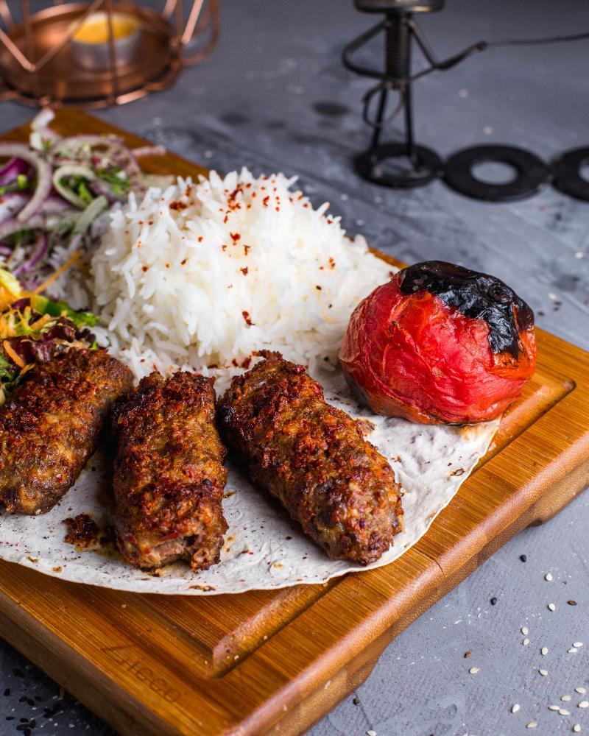

Qebapa (also spelled qebap or qyfte depending on the region) are small, skinless sausages enjoyed throughout the Balkans, with local variations found in Albania, Kosovo, North Macedonia, Bosnia and Herzegovina, and beyond. Albanian qebapa likely trace their roots to the Ottoman era, when methods of preparing minced meat—shaped, seasoned, and grilled—spread widely across Southeastern Europe. Historically, these savory morsels were street food staples, sold by vendors using portable grills, and a favorite for travelers and locals alike. They are still a popular choice at family gatherings, roadside restaurants, and city festivals, symbolizing both tradition and shared culinary heritage.

**Why They’re Beloved:**

Qebapa are beloved for their simplicity and intense meaty flavor. Shaped from a mixture of ground meats (often beef, lamb, or a combination), seasoned with salt, pepper, and occasionally mild spices, they’re grilled until smoky and caramelized on the outside while remaining juicy within. They’re commonly served in warm bread with onions, yogurt sauce, ajvar (a roasted pepper spread), or a side of pickled vegetables. This unassuming dish brings people together around the grill, evoking memories of summer picnics, family reunions, and the universal pleasure of well-seasoned, grilled meat.

**Ingredient Adjustments & Personal Touches:**

Traditional qebapa rely on straightforward seasoning—salt, pepper, maybe a pinch of paprika, and sometimes a bit of garlic or onion juice. Feel free to experiment with the meat blend and ratios. Pure beef is common, but a mix of beef and lamb adds complexity. Some cooks include a spoonful of sparkling water or yogurt to achieve a fluffier texture. Adjust the level of salt and spice to your liking and consider adding fresh parsley or dried herbs for a personal twist. The key is to keep the seasoning subtle, allowing the grilled flavor and meat quality to shine.

**Serves:** About 4-6 (makes roughly 20 small qebapa)

**Time:** About 1 hour (including resting time for the mixture)

**Ingredients:**

* 500 g (about 1 lb) ground beef or a mixture of beef and lamb (about 70% beef, 30% lamb is common)
* Salt and pepper to taste (start with about 1 tsp salt and ½ tsp pepper)
* Optional seasonings: a pinch of paprika, a splash of sparkling water or 1-2 tbsp plain yogurt, 1-2 cloves garlic crushed to a paste, or a few tablespoons of finely grated onion
* A little oil for greasing the grill or your hands

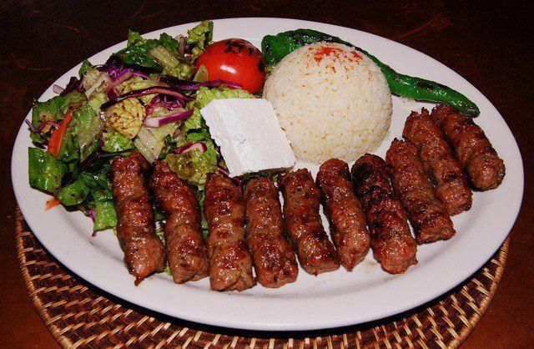

**Method:**

1. **Mix the Meat:** In a large bowl, combine the ground meat with salt, pepper, and any optional seasonings. Mix gently but thoroughly with your hands. Avoid overmixing, as it can make the texture dense. If using sparkling water or yogurt, stir it in for extra juiciness.
2. **Shape the Qebapa:** Cover the bowl and let the mixture rest in the refrigerator for at least 30 minutes (or up to a few hours) to allow the flavors to meld and the mixture to firm up. With lightly oiled hands, shape the meat into small, finger-length sausages, about 7-8 cm (3 inches) long and about 1-2 cm (½-¾ inch) thick. They should be compact but not overly pressed.
3. **Grill to Perfection:** Preheat your grill to medium-high heat. Lightly oil the grates. Grill the qebapa for about 3-5 minutes per side, turning once or twice, until nicely browned and cooked through. They should be slightly springy to the touch when done. If you don’t have a grill, a grill pan or a broiler can work in a pinch.
4. **Rest & Serve:** Let the qebapa rest for a few minutes off the heat before serving. Present them with warm flatbread or pita, sliced onions, and a dollop of yogurt or sour cream. Ajvar, pickled peppers, or fresh salads also pair beautifully, adding brightness and texture to the meal.

**Your Adaptations:**

Feel free to play with the flavor profile—add a tiny pinch of cumin or a hint of chili flakes if you prefer. Experiment with different meat ratios, or try using ground lamb entirely for a richer taste. Serve them as part of a mezze spread, or enjoy them as a simple weeknight dinner. Qebapa’s charm lies in its versatility and the way it connects you to a broader Balkan culinary tapestry, one delicious bite at a time.

# Onion and Leek Stew with Meat (Jahni me presh)

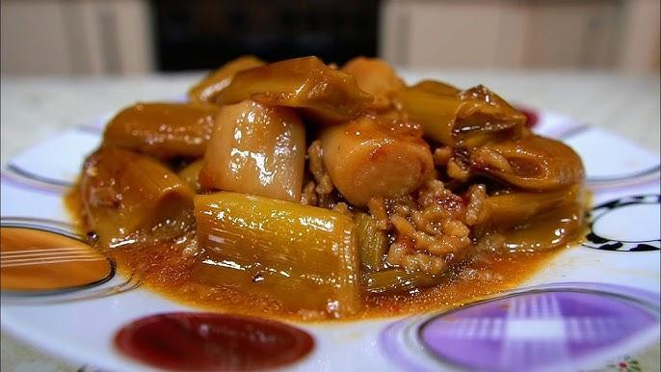

Jahni me presh is a rustic Albanian stew that prominently features leeks—“presh” in Albanian—along with hearty pieces of meat. Its roots lie in the agricultural traditions of Albania, where leeks have long been a reliable, cold-hardy crop. Historically, families in mountainous and hilly regions, particularly in the north and center of the country, relied on such simple, warming dishes to get them through colder seasons. Early references can be found in household recipe collections and oral histories passed down over generations, indicating that this combination of leeks, onions, and meat has been comforting Albanian families for well over a century.

**Why It’s Beloved:**

The sweetness of cooked leeks and onions melds beautifully with tender chunks of meat, resulting in a stew that’s both nourishing and aromatic. The flavors are gentle but deeply satisfying, offering a sense of warmth and simplicity that many associate with home cooking. Served with bread, rice, or polenta, jahni me presh invites diners to slow down, savor each spoonful, and appreciate the value of seasonal produce and honest flavors.

**Ingredient Adjustments & Personal Touches:**

Traditionally made with lamb or beef, this stew can easily adapt to other proteins. Consider veal or even goat if that’s what you have on hand. Some cooks add a spoonful of tomato paste or diced tomatoes for a hint of acidity, while others keep the flavor profile minimal, allowing the leeks to shine. Fresh herbs like parsley or dill can lend brightness, and a splash of lemon juice at the end can lift the dish. Adjust seasoning and consistency based on your family’s tastes—thicker and heartier for cold evenings, or lighter and brothy if you prefer a more delicate soup-like consistency.

**Serves:** About 6-8

**Time:** Approximately 1.5-2 hours (including simmering)

**Ingredients:**

* 1-1.5 kg (2-3 lbs) lamb or beef, cut into medium chunks
* 2-3 tbsp olive oil or butter
* 1 large onion, chopped
* 3-4 medium leeks (white and light green parts), sliced into rounds and rinsed well
* Salt and pepper to taste
* Optional additions: 1 tbsp tomato paste or a handful of diced tomatoes, a bay leaf, fresh parsley or dill, a squeeze of lemon juice at the end
* Water or mild stock to cover

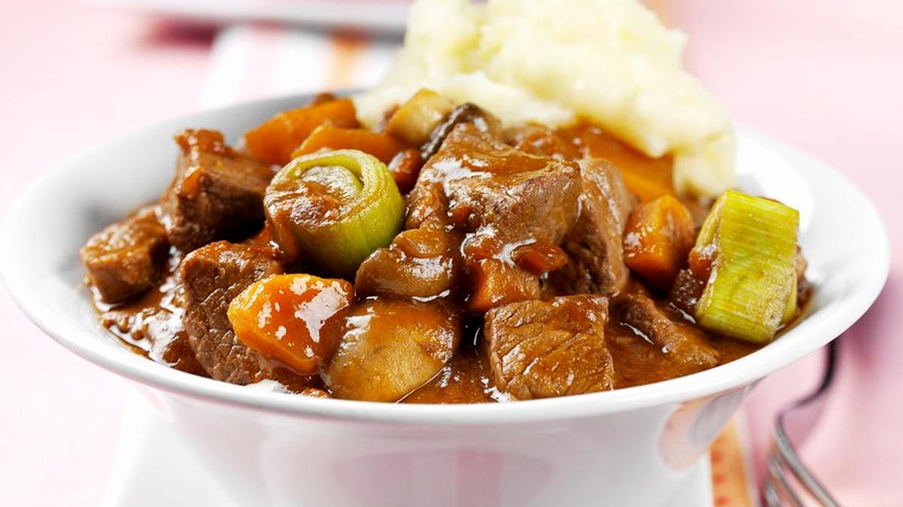

**Method:**

1. **Brown the Meat:** In a large, heavy-bottomed pot, heat the olive oil or butter over medium-high heat. Add the meat in batches so as not to overcrowd, browning it on all sides. Season lightly with salt and pepper. Remove the browned meat and set aside.
2. **Sauté the Onions & Leeks:** Reduce the heat to medium and add the onion. Sauté until it turns translucent. Add the sliced leeks and continue cooking until they begin to soften and release their aroma, about 5-7 minutes. If using tomato paste, stir it in now and cook briefly to develop its flavor.
3. **Combine & Simmer:** Return the browned meat to the pot. Pour in enough water or mild stock to just cover the ingredients. If you’d like to add a bay leaf or diced tomatoes, do so now. Bring the stew to a gentle simmer, then reduce the heat to low, cover, and cook for about 1-1½ hours, or until the meat is tender and the flavors have melded. Skim off any foam that rises to the surface. Adjust salt and pepper to taste as you go.
4. **Finish the Dish:** If desired, stir in some chopped parsley or dill at the end for a fresh note. A squeeze of lemon juice can brighten the flavors. Taste and adjust seasonings. For a thicker consistency, let the stew simmer uncovered for a few minutes to reduce the liquid.
5. **Serve:** Ladle the stew into bowls and serve hot. Accompany it with crusty bread, polenta, or a simple side salad. Its gentle, comforting flavors make jahni me presh a satisfying main course, perfect for enjoying around the family table.

**Your Adaptations:**

Feel free to explore different herbs, add a subtle spice like paprika, or enrich the broth with a bit of butter or yogurt near the end. Jahni me presh invites you to celebrate the humble leek—transforming it into a fragrant, hearty meal that bridges Albania’s pastoral past with your family’s present-day tastes.

# Meat Cooked with Walnuts (Mish me arra)

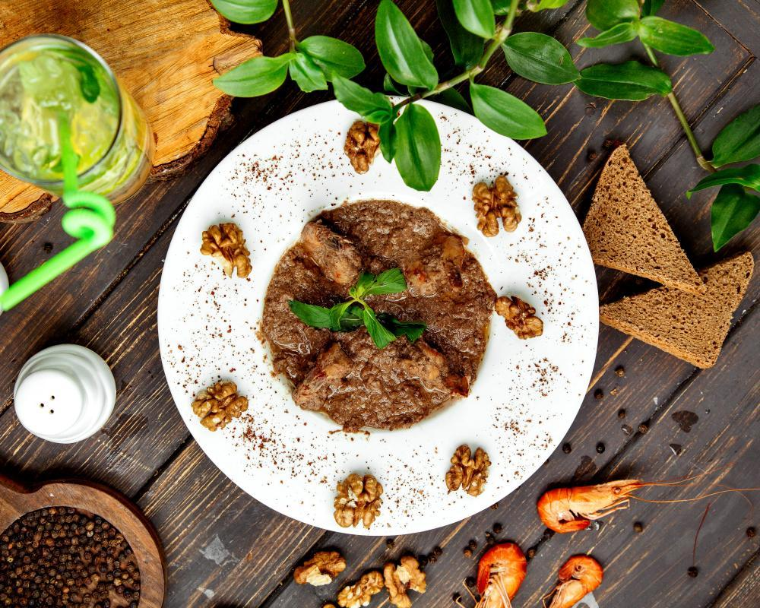

Mish me arra is a distinctive Albanian dish that showcases the country’s long-standing appreciation for nuts—particularly walnuts—as a key flavoring element in savory cooking. Walnuts have historically been abundant in certain regions of Albania, such as the southeastern areas and mountainous parts where walnut trees thrive. While direct references may not be found in older written sources, the dish is well-known among families who have passed down recipes orally. The inclusion of walnuts alongside meat reflects an Ottoman-era influence, as well as the Balkan tradition of pairing rich proteins with earthy, aromatic nuts.

**Why It’s Beloved:**

Mish me arra offers a delightful interplay of textures and flavors. The tender chunks of meat—often lamb or beef—slowly simmer with onions, herbs, and warm spices until they become succulent. The walnuts, ground or finely chopped, lend a creamy, nutty depth that enriches the dish’s overall complexity. Served with bread, rice, or a simple salad, mish me arra feels both comforting and slightly exotic, a special meal often reserved for gatherings or to impress guests with something distinctively Albanian.

**Ingredient Adjustments & Personal Touches:**

Lamb is common, but beef or veal can work equally well. Some cooks add a hint of cinnamon, allspice, or paprika to complement the walnuts. A splash of lemon juice or vinegar toward the end can brighten the stew. Feel free to stir in a small spoonful of yogurt for creaminess, or increase the herb content by adding parsley or dill. Adjust the thickness of the sauce by simmering uncovered to reduce it or by adding a bit more liquid for a stew-like consistency.

**Serves:** About 6-8

**Time:** Approximately 1.5-2 hours (including simmering)

**Ingredients:**

* 1-1.5 kg (2-3 lbs) lamb, beef, or veal, cut into medium chunks
* 2-3 tbsp olive oil or butter
* 1 large onion, finely chopped
* 2-3 garlic cloves, minced (optional)
* 100-150 g (about 1-1¼ cups) walnuts, ground or very finely chopped
* Salt and pepper to taste
* Optional spices: a pinch of cinnamon or allspice, paprika
* Optional herbs: parsley or dill, chopped
* Water or mild stock to cover
* Optional: lemon juice or vinegar for brightness, a spoonful of yogurt for richness

**Method:**

1. **Brown the Meat:** Warm the olive oil or butter in a large, heavy-bottomed pot over medium-high heat. Add the meat in batches, browning it on all sides to develop flavor. Season lightly with salt and pepper. Remove the browned meat and set aside.
2. **Sauté the Onion & Aromatics:** Reduce the heat to medium and add the chopped onion. Cook until softened and translucent. Stir in the garlic if using, along with any chosen spices (cinnamon, allspice, or paprika). Cook briefly to release their aromas.
3. **Combine & Simmer:** Return the browned meat to the pot. Pour in enough water or stock to just cover the ingredients. Stir in the ground walnuts, allowing them to disperse and thicken the sauce as it cooks. Bring to a gentle simmer, then reduce the heat to low, cover, and let it cook for about 1-1½ hours, or until the meat is tender and the flavors have melded. Skim off any foam that may form.
4. **Adjust Flavor & Texture:** Taste the sauce and adjust the seasoning with salt, pepper, or additional spices. If you prefer a tangy note, add a splash of lemon juice or vinegar. For extra creaminess, stir in a spoonful of yogurt. If the sauce is too thin, simmer uncovered for a bit longer to reduce and thicken. Stir in fresh herbs for brightness if desired.
5. **Serve:** Ladle the meat and walnut sauce over plates of warm bread, rice, or potatoes. The rich, nutty flavors pair beautifully with a crisp salad or pickled vegetables. Serve hot, allowing guests to savor the comforting and aromatic depth of this centuries-old culinary tradition.

**Your Adaptations:**

Feel free to customize the dish according to your family’s palate. Adjust spices, add more herbs, or experiment with a different meat cut. Mish me arra’s versatility ensures it can evolve with each cook’s preferences, while retaining its heart: the harmonious union of tender meat and richly flavored walnuts.

# Baked Ohrid Trout (Koran i pjekur)

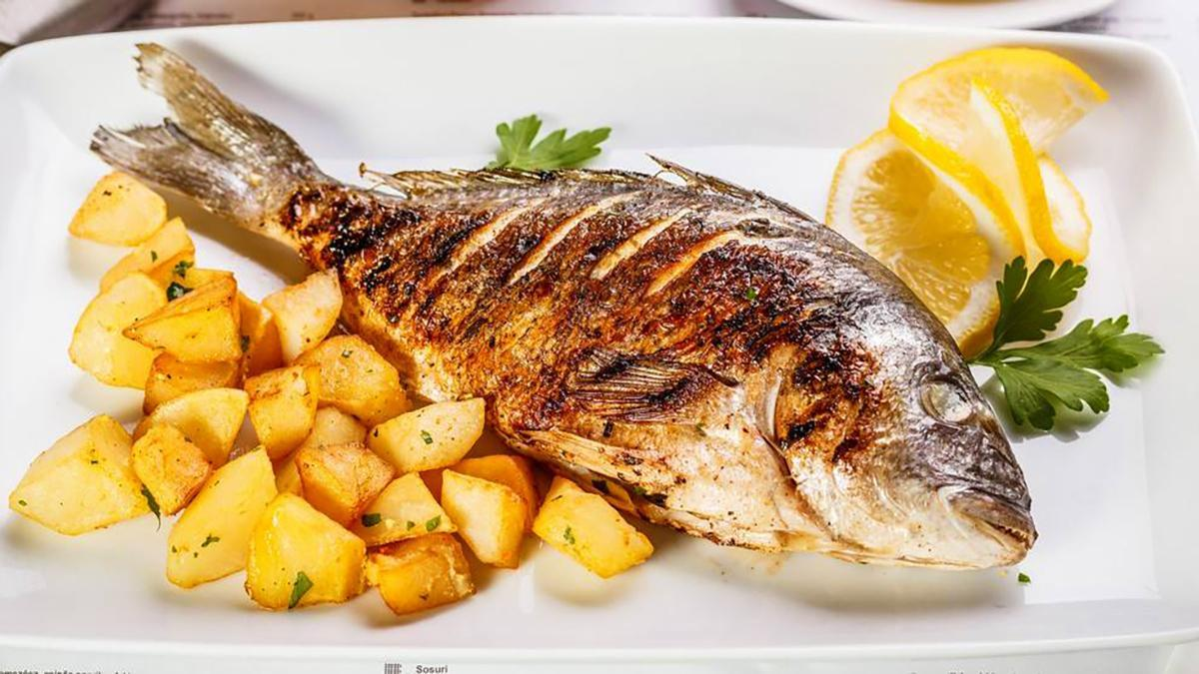

Koran, the famed trout of Lake Ohrid—shared by Albania and North Macedonia—has long been considered a delicacy. The pristine waters of Lake Ohrid, one of Europe’s oldest and deepest lakes, are home to this unique trout species, prized for its firm texture and delicate flavor. Historically, koran was reserved for special occasions or served to honored guests, and even in the early 20th century, travelers and diplomats wrote about this coveted fish. Today, Koran i pjekur remains a culinary jewel, connecting diners to centuries of lake-side tradition and the natural riches of this alpine region.

**Why It’s Beloved:**

With its naturally mild, buttery taste, Ohrid trout needs little adornment. Baked with simple seasonings—olive oil, lemon, herbs—it emerges tender and aromatic, its flesh easily flaking off the bone. Served with minimal fuss, Koran i pjekur allows the true character of the fish to shine through. This dish symbolizes the elegance of simplicity, a respect for local resources, and the timeless appeal of fresh, well-sourced ingredients.

**Ingredient Adjustments & Personal Touches:**

While the classic approach involves only salt, pepper, lemon, and olive oil, feel free to introduce subtle herb accents. Parsley, dill, or a sprig of thyme can highlight the fish’s delicate flavor. A few cherry tomatoes or sliced shallots baked alongside can add gentle sweetness. Consider a drizzle of white wine for a light, aromatic sauce. The key is restraint—use just enough embellishment to enhance, not overshadow, the natural taste of koran.

**Serves:** About 4-6

**Time:** Approximately 45-60 minutes (including baking)

**Ingredients:**

* 1 whole Ohrid trout (koran), about 1-1.5 kg (2-3 lbs), cleaned and scaled
* 2-3 tbsp olive oil
* 1-2 lemons (juice of half a lemon for seasoning + slices for garnish)
* Salt and pepper to taste
* A handful of fresh parsley, dill, or thyme (optional)
* Optional additions: a splash of white wine, a handful of cherry tomatoes, thinly sliced shallots

**Method:**

1. **Preheat & Prep:** Preheat your oven to 180°C (350°F). Rinse the trout and pat it dry inside and out. Lightly season the cavity and skin with salt and pepper.
2. **Flavor the Fish:** Drizzle the inside of the cavity with a bit of olive oil and a squeeze of fresh lemon juice. Tuck in a few herb sprigs if using. If you’d like to add cherry tomatoes or shallots, place them in the baking dish around the fish. Drizzle the fish and vegetables with the remaining olive oil. If using white wine, pour a small splash around the sides to create a light braising liquid.
3. **Bake Gently:** Place the trout in a baking dish large enough to hold it comfortably without bending. Cover loosely with foil and bake for about 20-30 minutes. Remove the foil and continue baking for another 10-15 minutes, or until the flesh flakes easily with a fork. Cooking times vary based on the fish’s size and thickness, so check periodically to avoid overcooking.
4. **Rest & Garnish:** Once baked, let the trout rest for a few minutes. Drizzle with more lemon juice and sprinkle with chopped fresh herbs if desired. Taste and adjust seasoning. The fish should be moist, tender, and subtly perfumed by the herbs and lemon.
5. **Serve:** Transfer the trout to a serving platter and spoon over any pan juices. Serve hot, accompanied by simple sides like boiled potatoes, sautéed greens, or a crisp salad. Good bread for sopping up the juices is always welcome, as is a glass of dry white wine.

**Your Adaptations:**

Though Koran i pjekur is best in its authentic, minimalistic form, you can introduce slight variations. Try adding a pat of butter or a drizzle of cream for richness, or toss in a few capers for brininess. However you adjust it, remember that this dish’s soul lies in its simplicity—honoring the pure flavor of a lake’s treasured gift.

# Fish Casserole (Tava e Peshkut)

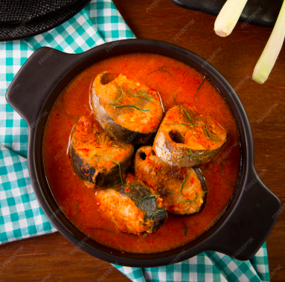

Tava e Peshkut is a traditional Albanian casserole centered around fresh fish, often sourced from the country’s lakes, rivers, or coastal waters. Regions like Shkodër, near Lake Shkodra, and areas along the Ionian and Adriatic coasts have a longstanding tradition of preparing fish in simple yet flavorful ways. Historical culinary notes and family recipe collections from the early 20th century reference baked fish dishes that incorporate local herbs, tomatoes, and olive oil. Over time, as markets offered a wider variety of fish, Albanians adopted this dish countrywide, turning to it for both special occasions and wholesome family dinners.

**Why It’s Beloved:**

The allure of Tava e Peshkut lies in its simplicity. Tender fish fillets or whole fish, gently baked with onions, tomatoes, and aromatic herbs, yield delicate flavors that pay homage to Albania’s natural bounty. The dish typically features a light sauce—often enriched with olive oil, lemon juice, and mild spices—that accentuates the freshness of the fish rather than overpowering it. Served with crusty bread, rice, or simple salads, it represents the Mediterranean spirit embedded in Albanian cuisine: fresh, bright, and nourishing.

**Ingredient Adjustments & Personal Touches:**

Commonly used fish include carp, trout, or sea bream, but you can use any firm, mild fish available. Adjust the herbs to your taste—parsley and dill are classic, though basil or oregano can add a new dimension. A splash of white wine can bring gentle acidity, while a few olives or capers introduce briny complexity. The balance of tomato to onion is flexible; some prefer a more tomato-forward sauce, while others highlight sweet caramelized onions. Feel free to add a pinch of chili flakes for subtle heat, or garnish with fresh lemon zest before serving.

**Serves:** About 4-6

**Time:** Approximately 1-1.5 hours (including baking)

**Ingredients:**

* 1-1.5 kg (2-3 lbs) whole fish (like trout, carp, sea bream) or fillets
* 2-3 tbsp olive oil
* 1 large onion, thinly sliced
* 2-3 garlic cloves, minced (optional)
* 2-3 ripe tomatoes, chopped (or 1-2 tbsp tomato paste diluted in water)
* Salt and pepper to taste
* A handful of fresh parsley or dill, chopped
* Optional additions: a splash of white wine, a few olives or capers, a pinch of chili flakes, lemon slices or zest

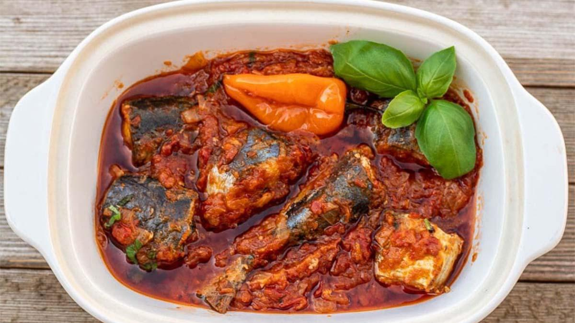

**Method:**

1. **Prepare the Fish:** Rinse and pat the fish dry. If using a whole fish, season the cavity with salt and pepper. Season the outside of the fish or fillets with salt and pepper as well. Set aside while you prepare the base.
2. **Build the Aromatic Base:** Preheat your oven to 180°C (350°F). In a large oven-safe casserole dish, add the olive oil, sliced onion, and garlic (if using). Scatter the chopped tomatoes over the onions. Season lightly with salt and pepper. If using tomato paste, stir it into a little warm water and pour over the onions and tomatoes. If you’d like more complexity, add a splash of white wine, some olives, or a pinch of chili flakes now.
3. **Add the Fish:** Place the seasoned fish or fillets on top of the onion-tomato mixture. Drizzle a bit more olive oil over the fish. If using whole fish, you can tuck herbs and lemon slices inside the cavity. Sprinkle chopped parsley or dill over the top.
4. **Bake:** Cover the dish loosely with foil and bake for about 20-30 minutes, depending on the thickness of the fish. Remove the foil and continue baking for another 10-15 minutes, or until the fish flakes easily with a fork and the vegetables have melded into a light sauce. If the dish looks dry at any point, add a splash of water, stock, or white wine.
5. **Rest & Serve:** Let the casserole rest for a few minutes before serving. Carefully transfer the fish to a platter, spooning the onions, tomatoes, and pan juices over it. Serve hot, accompanied by crusty bread, rice, or a fresh salad. A squeeze of lemon juice just before serving can brighten the flavors even more.

**Your Adaptations:**

Feel free to experiment with different herbs, or add a handful of cherry tomatoes, sliced bell peppers, or thinly sliced potatoes for a heartier meal. Tava e Peshkut is a versatile template—start with a fresh, mild fish and let your personal preferences guide the seasoning. Over time, you’ll discover your own signature version of this Albanian classic.

# Fish Soup with Dill (Supë Peshku Me Kopër)

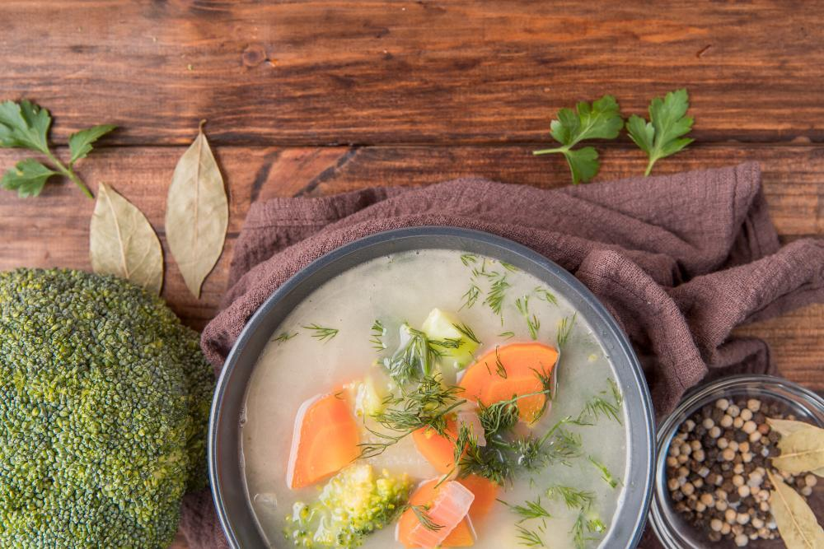

Fish soups hold a gentle yet important place in Albanian coastal and lakeside cuisines. Supë Peshku Me Kopër (Fish Soup with Dill) reflects the country’s Mediterranean influences, where fresh herbs, vegetables, and delicate broths showcase the natural sweetness of local fish. While exact historical references are harder to pinpoint, fish soups have long featured in the culinary traditions of Albanian port towns and lakeside villages—simple, nourishing dishes prepared with the catch of the day. Dill, known as “kopër,” imparts a fresh, distinctive aroma that sets this soup apart from other Balkan fish broths.

**Why It’s Beloved:**

This soup is cherished for its lightness, fragrant herbaceousness, and comforting warmth. Gently poached fish imparts a subtle flavor to the broth, while carrots, celery, onions, and garlic layer in natural sweetness and depth. The addition of dill brightens the entire dish, making it feel as fresh as a seaside breeze. Served with bread or a simple salad, it can be a soothing starter or a satisfying main—particularly appealing when you crave something wholesome yet elegant.

**Ingredient Adjustments & Personal Touches:**

You can use various mild white fish fillets—such as cod, sea bass, or trout—or even a firm-fleshed fish like carp if that’s what’s available. If you prefer a richer broth, simmer the fish heads and bones separately to create a homemade stock before adding the vegetables and fillets. A splash of white wine or a squeeze of lemon can add brightness, while a spoonful of rice or orzo makes it heartier. Adjust the amount of dill to your liking, or consider adding a handful of fresh parsley or a pinch of chili flakes for gentle heat.

**Serves:** About 4-6

**Time:** Approximately 45-60 minutes

**Ingredients:**

* 500-700 g (1-1½ lbs) mild white fish fillets or steaks (cod, trout, sea bass, or similar)
* 2-3 tbsp olive oil
* 1 large onion, finely chopped
* 2-3 garlic cloves, minced
* 2 carrots, sliced into rounds
* 2 celery stalks, sliced
* 1-1.5 L (4-6 cups) water or fish stock
* A generous handful of fresh dill, chopped (adjust to taste)
* Salt and pepper to taste
* Optional additions: a splash of white wine, a squeeze of lemon juice, a handful of parsley, a pinch of chili flakes, a small handful of rice or orzo

**Method:**

1. **Sauté the Aromatics:** In a large pot over medium heat, warm the olive oil. Add the chopped onion and sauté until it softens and becomes translucent. Stir in the garlic, carrots, and celery, cooking for another 3-4 minutes until the vegetables start to soften and become aromatic.
2. **Add Liquid & Simmer:** Pour in the water or fish stock. If using white wine, add a small splash now. Season lightly with salt and pepper. Bring the soup to a gentle simmer and cook for about 10-15 minutes, or until the vegetables are just tender. If adding rice or orzo, stir it in now and let it cook until nearly done, following package times.
3. **Add the Fish:** Gently add the fish fillets or pieces to the simmering broth. Poach for about 5-8 minutes, or until the fish is opaque and flakes easily with a fork. Taste and adjust seasoning with more salt, pepper, or a squeeze of lemon juice for brightness.
4. **Finish with Dill:** Stir in the chopped dill, letting its fragrance infuse the soup. If you’d like, add a handful of chopped parsley or a pinch of chili flakes for depth and subtle warmth. Taste once more and adjust seasonings as needed.
5. **Serve:** Ladle the hot fish soup into bowls. Serve it warm, accompanied by crusty bread or a simple green salad. The soup’s delicate flavors and fresh dill aroma create a soothing, nourishing bowl that invites you to savor every spoonful.

**Your Adaptations:**

Feel free to experiment with the vegetables—add a diced potato for extra heartiness or a handful of cherry tomatoes for sweetness. You might stir in a spoonful of yogurt at the end for creaminess or top each bowl with a drizzle of olive oil. Supë Peshku Me Kopër is a versatile canvas, allowing you to celebrate Albania’s coastal inspirations while making it your own.

# Stuffed Eggplant in Olive Oil (Imam Bajalldi)

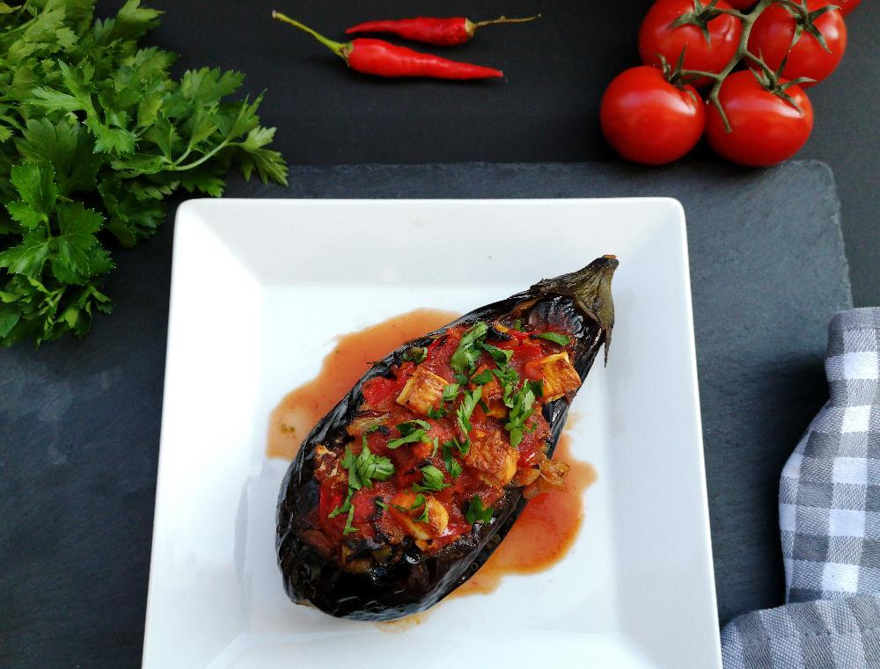

Imam Bajalldi (often spelled Imam Bayildi outside Albania) is a dish deeply rooted in the Ottoman culinary tradition, enjoyed throughout the Balkans and the Eastern Mediterranean. In Albania, it’s known and cherished as a quintessential summer dish, especially in regions where eggplants thrive under the warm sun. Oral histories and old family recipe collections note the long-standing presence of this aromatic, vegetarian specialty. The name, poetically translated to “the imam fainted,” is linked to a legend where the rich aroma and taste of the dish supposedly caused an imam (Muslim cleric) to swoon. The Albanian version often relies on high-quality olive oil and fresh, local produce, staying true to the dish’s heritage of simplicity and abundance.

**Why It’s Beloved:**

Imam Bajalldi epitomizes the magic of simple, plant-based cooking. Sweet onions and ripe tomatoes, gently simmered in plenty of olive oil, are stuffed into tender eggplants. Slow cooking transforms these humble ingredients into a silky, flavorful, and fragrant dish. Served warm or at room temperature, it’s light yet satisfying—a summer comfort food that’s equally at home on a family table or at a festive gathering. For many Albanians, it evokes memories of bountiful gardens, long sunny afternoons, and the pleasure of sharing seasonal meals with loved ones.

**Ingredient Adjustments & Personal Touches:**

While the classic version relies on onions, tomatoes, garlic, and olive oil, feel free to customize. Add a few strips of bell pepper for sweetness, or a pinch of paprika for warmth. Some cooks include a touch of sugar to balance acidity or a handful of fresh herbs like parsley or dill for brightness. It’s a forgiving dish, encouraging you to adjust the seasoning, oil quantity, and even the ratio of onions to tomatoes based on personal taste. The goal is a richly flavored, tender filling that complements the eggplants’ mild flesh.

**Serves:** About 4-6

**Time:** Approximately 1.5-2 hours (including prep and baking)

**Ingredients:**

* 4-6 small to medium eggplants
* 3-4 onions, thinly sliced into half-moons
* 2-3 ripe tomatoes, chopped (or 1-2 tbsp tomato paste diluted in water)
* 2-3 garlic cloves, minced (optional)
* 100-150 ml (about ½ cup or more) high-quality olive oil (adjust to taste)
* Salt and pepper to taste
* A pinch of sugar (optional, to balance acidity)
* Optional additions: a handful of chopped parsley, dill, or a pinch of paprika

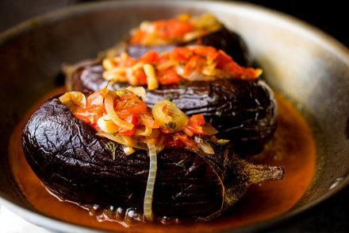

**Method:**

1. **Prepare the Eggplants:**
2. Rinse the eggplants and remove the stems. Peel off a few lengthwise strips of skin, creating a striped pattern. This helps the flavors penetrate and the eggplants cook evenly. Slice each eggplant lengthwise to create a pocket without cutting all the way through. Lightly salt the eggplants and set them aside for about 20-30 minutes to draw out moisture and bitterness. Pat them dry.
3. **Cook the Filling:**
4. In a large skillet over medium heat, warm a generous portion of the olive oil. Add the sliced onions and sauté until they begin to soften. Stir in the garlic (if using), followed by the chopped tomatoes. Season with salt, pepper, and, if desired, a pinch of sugar to highlight the tomatoes’ natural sweetness. Cook until the mixture is soft, fragrant, and slightly saucy. If using herbs or paprika, stir them in now. Taste and adjust seasoning.
5. **Stuff the Eggplants:**
6. Preheat the oven to 180°C (350°F). Arrange the prepared eggplants in a baking dish. Carefully open each eggplant “pocket” and spoon in the onion-tomato filling, dividing it evenly. Drizzle the remaining olive oil over and around the eggplants. Add a splash of water to the dish to create steam and help the eggplants become tender.
7. **Bake Slowly:**
8. Cover the dish loosely with foil and bake for about 30-40 minutes. Remove the foil and continue baking for an additional 20-30 minutes, or until the eggplants are very tender and the filling is rich and aromatic. Baste the eggplants occasionally with the pan juices, adding a bit more water or olive oil if they seem dry. They should be silky, not dry.
9. **Rest & Serve:**
10. Let the Imam Bajalldi cool for at least 10 minutes before serving. It’s traditionally enjoyed warm or at room temperature, allowing the flavors to meld and intensify. Serve with crusty bread, a fresh salad, or a side of yogurt. Its gentle sweetness and smooth texture pair beautifully with simple accompaniments.

**Your Adaptations:**

Feel free to add a few strips of bell pepper to the onion-tomato mixture, or a spoonful of capers for a briny note. Experiment with different herbs, or try a mix of red and yellow onions for complexity. Imam Bajalldi gracefully adapts to your personal preferences, ensuring that each cook can find their own perfect balance in this time-honored Albanian-Ottoman classic.

# Stuffed Peppers with Ground “Beef” (Speca të mbushur me mish)

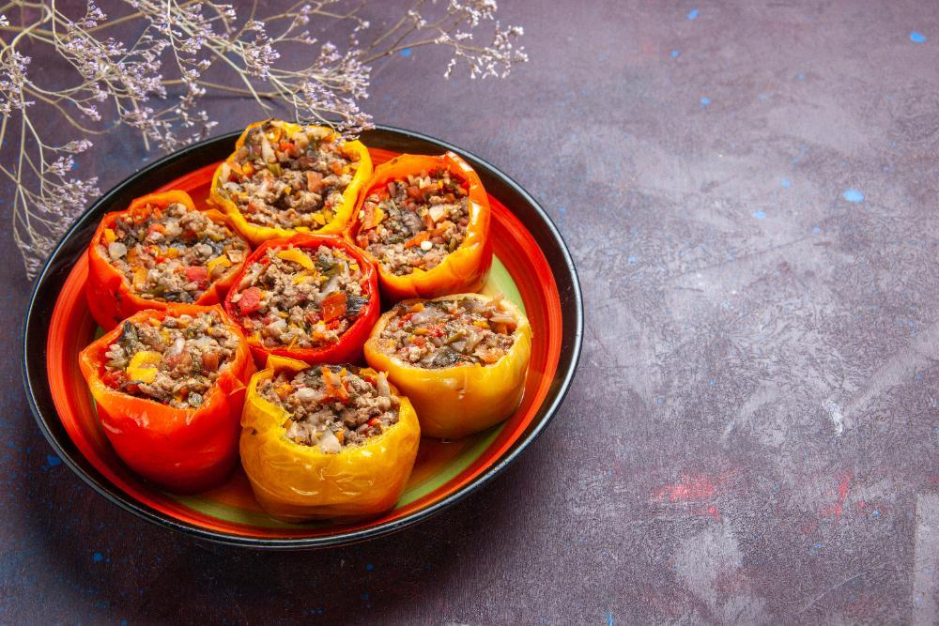

Stuffed peppers—“Speca të mbushur”—are a cherished part of Albanian home cooking. Traditionally prepared with ground meat (mish), rice, onions, and sometimes herbs or tomatoes, they are baked until the peppers become tender and their filling flavorful and comforting. This vegetarian adaptation pays homage to the classic dish while embracing modern dietary choices. It replaces ground beef with a hearty plant-based mixture that still provides protein, texture, and savory depth. Although this isn’t the traditional version, it captures the spirit of family meals and seasonal abundance that Albanian cuisine represents.

**Why It’s Beloved (and Why This Veggie Version Works):**

Stuffed peppers are beloved for their comforting mix of tender peppers and savory, aromatic filling. The dish brings warmth, color, and balanced flavors to the table. By choosing a vegetarian alternative, you can still enjoy the sweet earthiness of roasted peppers and the delightful seasoning of the filling—just without meat. Use plant-based “ground beef” products available on the market, or opt for a mixture of lentils, mushrooms, and walnuts to create a similarly hearty, umami-rich filling. The result is a comforting, protein-packed vegetarian entree that everyone can enjoy.

**Ingredient Adjustments & Personal Touches:**

While the classic recipe often includes ground beef, you can use a commercial plant-based ground meat substitute or create your own blend of finely chopped mushrooms and cooked lentils. Add minced onion, garlic, and herbs like parsley or dill. A spoonful of tomato paste and a handful of rice or bulgur helps bind the mixture. Feel free to incorporate grated carrots or zucchini for extra vegetables. Spice it up with paprika or chili flakes, or keep it mild and aromatic with just salt, pepper, and herbs. A drizzle of olive oil and a bit of broth at the bottom of the baking dish ensure tender, juicy peppers.

**Serves:** About 4-6

**Time:** Approximately 1.5 hours (including baking)

**Ingredients:**

* 8-10 medium bell peppers (red, green, or a mix), tops sliced off and seeds removed
* 300-400 g (about 2 cups) plant-based ground “meat” (or a mixture of 1 cup cooked lentils + 1 cup finely chopped mushrooms + ½ cup chopped walnuts)
* 1 medium onion, finely chopped
* 2-3 garlic cloves, minced
* 2-3 tbsp olive oil
* 1-2 tbsp tomato paste
* ½ cup rice or bulgur (rinsed)
* A handful of fresh parsley or dill, chopped
* Salt and pepper to taste
* Optional spices: a pinch of paprika or chili flakes
* Optional additions: grated carrot or zucchini for extra moisture and veggies
* Vegetable broth or water for baking (about 1-2 cups)

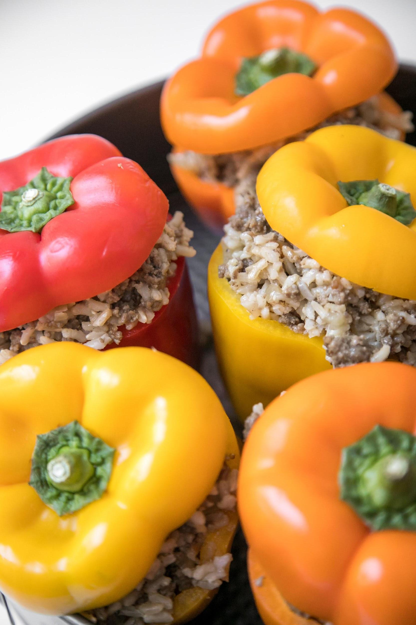

**Method:**

1. **Prepare the Filling:**

In a large skillet over medium heat, warm the olive oil. Add the chopped onion and sauté until softened. Stir in the garlic and cook another minute, then add the plant-based ground “meat” or your lentil-mushroom-walnut mixture. Cook, stirring frequently, until the mixture begins to brown and develop flavor. Stir in the tomato paste, rice or bulgur, and any grated vegetables if using. Season generously with salt, pepper, and any optional spices. Add a splash of water or broth if needed to help the ingredients come together. Cook for a few minutes, then remove from heat and stir in the fresh herbs.

1. **Stuff the Peppers:**

Preheat your oven to 180°C (350°F). Lightly oil a baking dish large enough to hold all the peppers snugly. Spoon the filling into each hollowed pepper, packing it gently but not too tightly (the grains will expand as they cook). Place the filled peppers upright in the baking dish. If desired, replace the pepper tops as “lids” for a charming presentation.

1. **Bake Gently:**

Pour enough vegetable broth or water into the dish to come about 1-2 cm (½ inch) up the sides of the peppers. Drizzle a little olive oil over the peppers. Cover the dish with foil and bake for about 30-40 minutes. Remove the foil and continue baking for another 20-30 minutes, or until the peppers are tender and the filling is cooked through (taste a grain of rice or bulgur to ensure doneness). If the dish looks dry at any point, add a bit more broth.

1. **Rest & Serve:**

Let the peppers sit for at least 10 minutes before serving to allow the flavors to meld and the filling to set. Serve them warm, with a side salad or yogurt sauce. They’re delicious as a main course or as part of a larger vegetarian spread.

**Your Adaptations:**

Experiment with different herbs (mint, dill, parsley) or add a spoonful of yogurt or labneh on top for creaminess. Include chopped olives or sun-dried tomatoes for depth. This vegetarian rendition of Speca të mbushur me mish captures the cozy satisfaction of the original, while welcoming a wide range of modern palates and dietary choices to the table.

# Oven-Baked Beans (Fasule pllaqi)

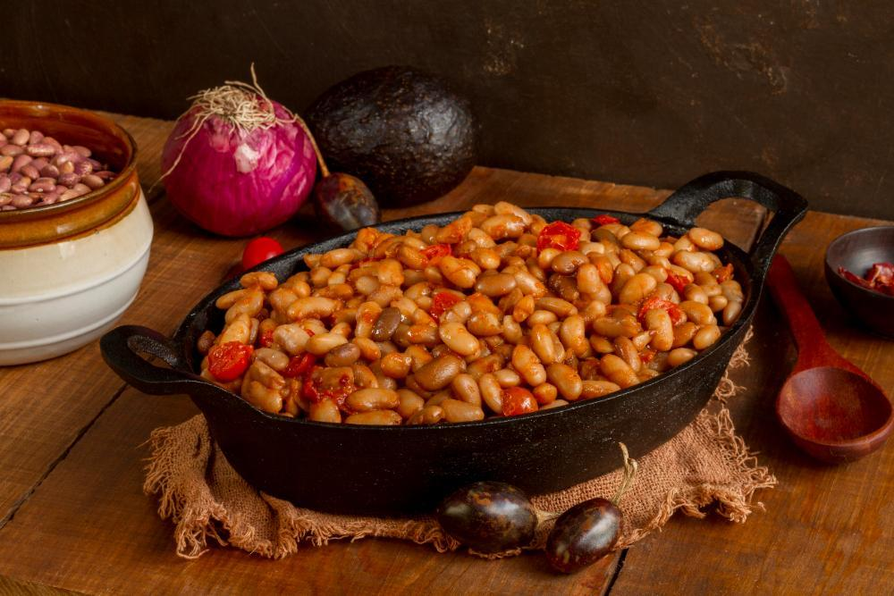

Fasule pllaqi is a cherished Albanian dish that exemplifies the region’s resourcefulness and love of legumes. Historically, beans have been a dietary staple in Albania’s rural communities, providing affordable, nourishing meals that could sustain families through long winters and demanding agricultural work. Over time, fasule pllaqi became a symbol of comfort and simplicity, often appearing at family gatherings or holiday tables. This dish’s origins likely stretch back to Ottoman times, as the Balkan culinary world often features baked bean casseroles and slow-simmered legume stews. Today, fasule pllaqi remains beloved for its ability to transform humble beans into a rich, hearty, and deeply satisfying meal.

**Why It’s Beloved:**

At its core, fasule pllaqi is about coaxing deep flavor out of simple ingredients. Tender white beans, sweet onions, garlic, and a touch of tomato combine and then bake slowly to produce a thick, velvety casserole that’s both comforting and filling. The slow baking process allows the flavors to meld, resulting in a dish that’s as warming on a cold day as it is welcome at a festive spread. Served with crusty bread, pickled vegetables, or a fresh salad, it’s both a reliable everyday meal and a nostalgic treat that connects families to their culinary heritage.

**Ingredient Adjustments & Personal Touches:**

While traditional fasule pllaqi is fairly minimalistic—just beans, onions, garlic, oil, and a hint of tomato—there’s room to adapt. Some cooks add a spoonful of paprika or dried herbs like oregano for complexity. A drizzle of olive oil before baking can enrich the flavor, while a small pinch of sugar can balance the tomato’s acidity. If you prefer a richer texture, stir in a knob of butter at the end. Vegetarian by nature, this dish also pairs well with salty cheese, yogurt, or grilled sausages on the side for those who want to add more protein.

**Serves:** About 6-8

**Time:** Approximately 2-3 hours (including soaking and baking)

**Ingredients:**

* 500 g (about 2½ cups) dried white beans (e.g., cannellini or navy beans), soaked overnight
* 2-3 tbsp olive oil or vegetable oil
* 2 medium onions, finely chopped
* 2-3 garlic cloves, minced
* 1-2 tbsp tomato paste or 1 cup chopped tomatoes
* Salt and pepper to taste
* Optional additions: a pinch of paprika, dried oregano, or a small pinch of sugar

**Method:**

1. **Soak & Pre-cook the Beans:**

After soaking the beans overnight, drain and rinse them. Place them in a large pot and cover with fresh water. Bring to a gentle boil, then reduce heat and simmer until the beans are just tender, about 45-60 minutes. Skim any foam that forms. Drain the beans, reserving some of the cooking liquid.

1. **Build the Flavor Base:**

Preheat your oven to 180°C (350°F). In a large, oven-safe casserole dish or Dutch oven, warm the olive oil over medium heat. Add the chopped onions and sauté until softened and golden. Stir in the garlic and cook another minute, being careful not to burn it. Add the tomato paste or chopped tomatoes, stirring to combine. Season with salt, pepper, and any optional herbs or spices.

1. **Combine & Bake:**

Add the drained beans to the dish, gently folding them into the onion-tomato mixture. Pour in enough reserved bean cooking liquid (or hot water) to barely cover them. Taste and adjust seasoning. Cover the dish with a lid or foil and place in the preheated oven.

1. **Slow Baking:**

Bake for about 45-60 minutes, checking occasionally. If the mixture appears dry, add a little more water. Remove the lid or foil for the final 15-20 minutes of baking to allow the top to develop a light crust and the flavors to deepen. The beans should be meltingly tender and the sauce thick and rich.

1. **Rest & Serve:**

Let the fasule pllaqi rest for about 10 minutes before serving. Drizzle with a bit of olive oil if you like, and serve with fresh bread, pickled vegetables, or a crisp salad. It’s also delicious the next day as the flavors continue to meld.

**Your Adaptations:**

Fasule pllaqi welcomes subtle variations. Add a bay leaf during baking for aroma, or toss in a handful of fresh parsley at the end for brightness. Adjust the thickness of the sauce by adding or reducing liquid during baking. Over time, you’ll find the perfect balance for your family’s taste, ensuring this time-honored Albanian classic remains a comforting presence at your table.

# Baked Okra (Bamje të furrës)

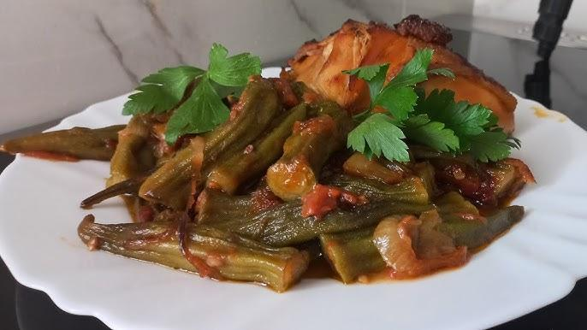

Bamje (okra) have a long history in Albanian cuisine, their presence tied to the country’s agrarian traditions and Ottoman-influenced culinary culture. Historically grown in warmer regions of Albania, okra provided a nutritious, vegetable-based staple. While okra is often simmered in stews and sauces, baking them (“të furrës” indicates “from the oven”) is another time-honored approach. Early 20th-century family recipe collections and oral histories mention okra dishes served at family gatherings, illustrating the vegetable’s embeddedness in the Albanian food landscape. Baking okra highlights their natural flavor, yielding a dish that is light, nourishing, and comforting.

**Why It’s Beloved:**

Baked okra emphasizes simplicity. A good drizzle of olive oil, aromatics like onion and garlic, and perhaps a hint of tomato bring out okra’s natural sweetness and subtle earthiness. The oven’s gentle heat helps reduce okra’s characteristic “slime,” resulting in a tender texture and mellow taste. Enjoyed as a side dish or a light vegetarian main, bamje të furrës pairs beautifully with bread, cheeses, or grilled meats. For many Albanians, it recalls garden harvests, shared meals, and an uncomplicated joy in making the most of seasonal produce.

**Ingredient Adjustments & Personal Touches:**

While the classic version may feature just okra, onion, oil, and sometimes tomato, feel free to adjust. Add a sprinkle of fresh herbs (dill, parsley, or oregano) to brighten the flavors. For a richer sauce, stir in a spoonful of tomato paste and a bit of water or vegetable stock. If you prefer a livelier taste, include a squeeze of lemon juice or a pinch of chili flakes. The key is to enhance okra’s natural qualities without overshadowing them.

**Serves:** About 4-6

**Time:** Approximately 1 hour (including baking)

**Ingredients:**

* 500-700 g (1–1½ lbs) fresh okra, trimmed (remove tough stems and tips)
* 2-3 tbsp olive oil
* 1 large onion, thinly sliced
* 2-3 garlic cloves, minced (optional)
* 1-2 ripe tomatoes, chopped (or 1-2 tbsp tomato paste diluted in water)
* Salt and pepper to taste
* Optional: a handful of fresh herbs (dill, parsley, or oregano), a squeeze of lemon juice, a pinch of paprika or chili flakes

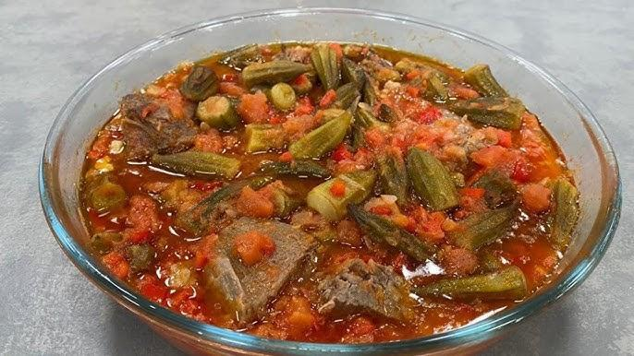

**Method:**

1. **Preheat & Prep:**

Preheat your oven to 180°C (350°F). Rinse the okra and pat them dry. If desired, briefly blanch the okra in boiling water for 1-2 minutes, then drain—this can help reduce the sliminess. Pat dry again.

1. **Layer the Vegetables:**

In a baking dish, drizzle a bit of olive oil. Add the sliced onion, spreading it out as a base. Scatter the okra over the onions. If using garlic, sprinkle it evenly over the top. Add the chopped tomatoes or drizzle the diluted tomato paste mixture over the vegetables. Season generously with salt and pepper, and any optional spices or herbs.

1. **Add Liquid & Oil:**

Drizzle the remaining olive oil over everything. If you’re using tomato paste, add a small amount of water or stock—just enough to keep the dish moist without making it soupy. If adding lemon juice or a touch of paprika, do so now.

1. **Bake Gently:**

Cover the dish with foil and bake for about 30 minutes. Remove the foil and continue baking for another 15-20 minutes or until the okra are tender and the flavors have mingled. If it looks dry, add a splash more water. You want the okra to be fully cooked but not mushy, and the onions and tomatoes to form a light sauce.

1. **Rest & Serve:**

Let the dish rest for a few minutes after removing it from the oven. Taste and adjust seasoning. Serve warm as a side dish or a light vegetarian main, accompanied by crusty bread, feta cheese, yogurt, or a fresh salad.

**Your Adaptations:**

Feel free to experiment with adding diced bell peppers for sweetness or a handful of chickpeas for extra heartiness. Bamje të furrës invites you to celebrate the natural goodness of okra, finding that perfect balance of flavors and textures that speaks to Albania’s culinary heritage and your personal palate.

# Sheqerpare (Sugar-Syrup Soaked Cookies)

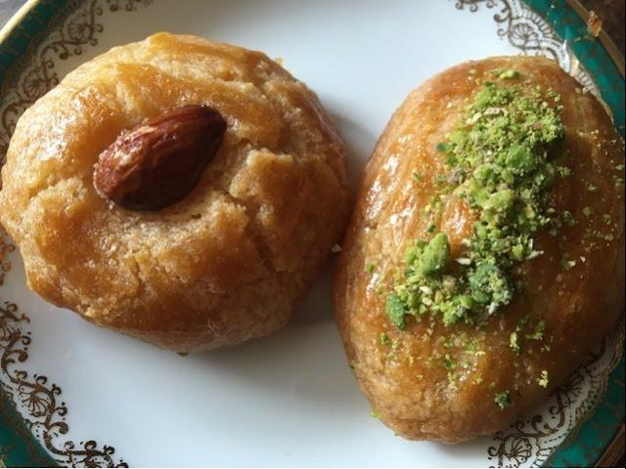

Sheqerpare are a traditional Albanian sweet that reflect the broader Balkan and Ottoman dessert-making heritage, where soaked pastries and confections hold a special place on the table. Historically served at holidays, weddings, and religious festivities, these tender, buttery cookies soaked in sugar syrup epitomize Albanian hospitality—sweet, comforting, and meant to be shared. Generations of families have handed down recipes for sheqerpare, ensuring that each bite preserves culinary traditions that span centuries.

**Why They’re Beloved:**

Simple yet indulgent, sheqerpare are known for their delicate crumb and fragrant syrup. When baked, the cookies become lightly golden, and once drenched in warm sugar syrup, they turn moist and melt-in-your-mouth tender. Served with coffee, tea, or a glass of cold water, they’re a symbol of warmth and celebration, evoking memories of family gatherings, laughter, and holidays filled with sweetness.

**Ingredient Adjustments & Personal Touches:**

While the classic version calls for butter, flour, sugar, and eggs, feel free to add a hint of vanilla or a pinch of lemon zest for subtle complexity. Some cooks include a small measure of ground almonds or use semolina flour for a slightly grainier texture. The syrup can be infused with lemon peel, cinnamon, or even rosewater. The core principle remains: a beautifully baked cookie brought to life by fragrant syrup.

**Makes:** About 20-24 cookies

**Time:** Approximately 1.5 hours (including baking and soaking)

**Ingredients (Cookies):**

* 250 g (about 1 cup) unsalted butter, softened
* 100 g (about ½ cup) sugar
* 2 eggs (room temperature)
* 1 tsp vanilla extract (optional)
* 350-400 g (about 2½-3 cups) all-purpose flour (adjust as needed for a soft, pliable dough)
* 1 tsp baking powder
* A pinch of salt

**Ingredients (Syrup):**

* 500 ml (2 cups) water
* 400 g (about 2 cups) sugar
* A thin slice of lemon peel or a squeeze of lemon juice (optional)

**Method:**

1. **Prepare the Dough:**

In a mixing bowl, cream the softened butter and sugar until light and fluffy. Beat in the eggs one at a time, then add the vanilla if using. In a separate bowl, combine the flour, baking powder, and salt. Gradually add the dry ingredients to the butter mixture, mixing until a soft, pliable dough forms. The dough should hold its shape but remain slightly soft. If it’s too sticky, add a little more flour.

1. **Shape the Cookies:**

Preheat your oven to 180°C (350°F). Line a baking sheet with parchment paper. Pinch off small portions of dough (about a tablespoon each) and roll them into oval or round shapes. Lightly flatten each cookie and place them on the sheet, leaving some space between them. For a traditional look, you can press lightly on top of each cookie with a fork to create decorative ridges.

1. **Bake:**

Bake the cookies for about 20-25 minutes or until they turn lightly golden. Baking times vary by oven and cookie size, so keep an eye on them. They should remain pale, not deeply browned.

1. **Make the Syrup:**

While the cookies bake, prepare the syrup. In a saucepan, combine the water and sugar. Bring to a boil over medium heat, stirring to help dissolve the sugar. Add the lemon peel or juice if desired. Reduce the heat and simmer for about 10 minutes. The syrup should be clear and slightly thickened but still pourable. Remove from heat and keep warm.

1. **Soak the Cookies:**

When the cookies come out of the oven, let them cool for just a couple of minutes, then pour the warm syrup over them while they’re still warm but not piping hot. The cookies will absorb the syrup as they rest. For the best texture, let them sit in the syrup for at least an hour before serving. You can occasionally spoon some syrup over them to ensure even absorption.

1. **Serve:**

Transfer the soaked cookies to a serving platter. Sheqerpare are best enjoyed at room temperature, allowing the syrup to fully infuse. Serve with coffee or tea, or as a sweet treat after a meal. They will keep for several days in an airtight container, growing even more tender and aromatic over time.

**Your Adaptations:**

Experiment with a pinch of ground almonds in the dough or a dash of cardamom in the syrup. Adjust sweetness to your preference by adding less sugar to the syrup or including a bit of honey. Sheqerpare are a canvas for your creativity, yet they remain anchored by the centuries-old tradition of Albanian sweet treats—always comforting, always welcoming.

# Bakllava (Layered Filo Pastry Walnuts & Syrup)

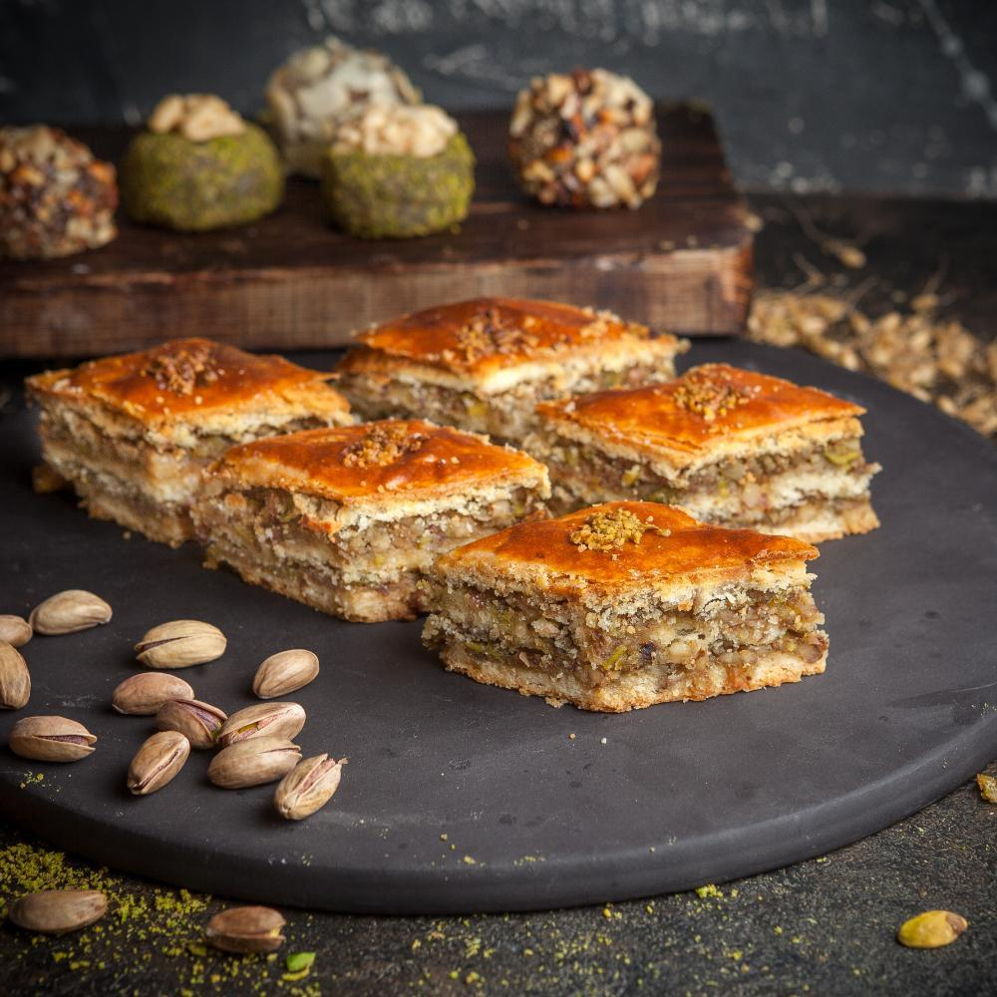

Bakllava is a dessert deeply ingrained in Albanian culinary tradition, though it’s also found across the Balkans, Turkey, the Middle East, and the Mediterranean region. With roots reaching back to the Ottoman Empire, bakllava’s spread and enduring popularity reflect centuries of trade, cultural exchange, and festivity. In Albania, bakllava is often prepared for special occasions and holidays, most notably New Year’s celebrations, symbolizing abundance and sweetness for the coming year. Families pass down their unique recipes, each varying slightly in nut mixtures, layering techniques, or syrup infusions, but the result is always a luxurious, sticky-sweet treat.

**Why It’s Beloved:**

Bakllava’s appeal lies in the interplay of textures and flavors: whisper-thin layers of crisp filo pastry, finely ground walnuts, and a fragrant syrup that soaks through the pastry, creating a luscious, melt-in-your-mouth delight. Served in small, diamond-shaped pieces, bakllava’s richness means a little goes a long way, making it the perfect dessert to share with friends and family. Its preparation, while labor-intensive, is part of the joy, often becoming a communal activity that strengthens bonds and preserves cultural heritage.

**Ingredient Adjustments & Personal Touches:**

While walnuts are classic in Albanian bakllava, feel free to experiment with half walnuts and half pistachios, or add a sprinkle of cinnamon or clove for depth. The syrup can be flavored with lemon peel, orange blossom water, or even a splash of rosewater to add aromatic complexity. Adjust sweetness by varying the sugar-to-water ratio. The artistry of bakllava lies in the details—how thinly you layer the filo, how finely you chop the nuts, and the balance of sweetness and aroma in the syrup.

**Makes:** One large tray (about 30-40 pieces)

**Time:** Approximately 2-3 hours (including layering and baking)

**Ingredients (Bakllava):**

* 500 g (about 1 lb) filo pastry (thin sheets)
* 300-400 g (about 3-4 cups) walnuts, finely chopped
* 200-250 g (about 1 cup) unsalted butter, melted (or a mix of butter and neutral oil)
* 1-2 tbsp sugar (optional, mixed with the walnuts)
* 1 tsp cinnamon (optional)
* A pinch of ground cloves (optional)

**Ingredients (Syrup):**

* 500 ml (2 cups) water
* 400-500 g (2-2½ cups) sugar (adjust to taste)
* 1-2 tbsp lemon juice or a strip of lemon peel
* Optional flavorings: a drizzle of honey, a splash of rosewater or orange blossom water



**Method:**

1. **Prepare the Syrup:**

In a saucepan over medium heat, combine the water and sugar. Stir until the sugar dissolves. Add the lemon peel or juice and any optional flavorings. Bring to a gentle boil and then reduce the heat to low, simmering for about 10-15 minutes until slightly thickened but still pourable. Remove from heat and let it cool completely. Having a cooled syrup is crucial for creating the signature crisp yet syrup-soaked texture.

1. **Preheat & Prep:**

Preheat your oven to 160-170°C (320-340°F). Brush a large rectangular baking pan with melted butter. Unwrap the filo pastry, covering it with a slightly damp cloth to prevent drying out as you work.

1. **Layer the Filo & Nuts:**

Place one sheet of filo in the pan, trimming or folding as needed to fit. Brush it generously with melted butter. Repeat with about a third of the filo sheets, buttering each layer. Spread a layer of chopped walnuts mixed with sugar and spices (if using) over the top. Continue layering another third of the filo sheets, buttering each as you go, then another layer of nuts, and finally top with the remaining filo sheets, each brushed with butter. Reserve a bit more butter for the top layer to ensure a crisp, golden finish.

1. **Score the Bakllava:**

Using a sharp knife, carefully cut the bakllava into diamond or square shapes before baking. This allows the syrup to penetrate evenly later and makes serving easier. Cut through all the layers, being gentle to keep them aligned.

1. **Bake Slowly:**

Place the bakllava in the preheated oven and bake for about 1-1½ hours, or until the top is golden and crisp. Check occasionally to ensure it doesn’t brown too quickly; you can lower the temperature slightly if needed. The slow baking process helps achieve that delicate, flaky texture.

1. **Add the Syrup:**

Once the bakllava is baked and still hot, gradually pour the cooled syrup over the top, ensuring it seeps into the cut lines. You’ll hear a sizzling sound as the syrup meets the pastry. Let the bakllava rest for at least a few hours, ideally overnight, so the syrup can fully absorb, creating a perfect balance between crisp pastry and sweet, tender filling.

1. **Serve:**

Gently lift out a piece and place it on a serving plate. Bakllava keeps well for several days at room temperature, and its flavor often improves after resting. Serve with strong coffee, tea, or a small glass of raki, enjoying the richness and history woven into each bite.

# Kadaif (Shredded Pastry with Syrup)

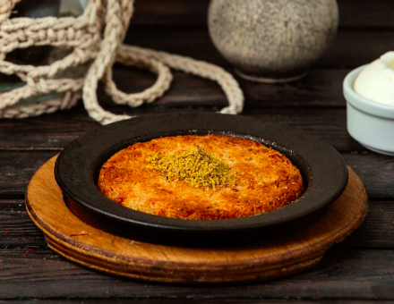

Kadaif is a traditional dessert with deep roots in the Ottoman Empire, enjoyed across the Balkans, the Middle East, and the Mediterranean. In Albania, it is a beloved sweet, often prepared for festive occasions, celebrations, and holidays. The delicate shredded pastry (called “kataifi” or “kadaifi”) is layered or rolled with nuts, then baked until golden and drenched in fragrant syrup. The result is a dessert that balances crispness and moistness, sweetness and nuttiness—perfect with coffee, tea, or as a centerpiece for special meals.

**Why It’s Beloved:**

Kadaif is celebrated for its unique texture: crunchy, golden threads of pastry softened by syrup but retaining a delicate crispiness. The filling—usually walnuts, though pistachios or almonds are also used—adds a nutty depth, while the syrup binds everything together with sweetness and a touch of fragrance. Easy to portion and serve, kadaif is as practical as it is indulgent, making it a favorite for gatherings and shared meals.

**Ingredient Adjustments & Personal Touches:**

While walnuts are the traditional filling in Albania, you can experiment with pistachios or almonds for a different flavor profile. The syrup is typically flavored with lemon juice, but you can add orange blossom water, rosewater, or a cinnamon stick for aromatic variation. Some cooks mix in a small amount of sugar or honey with the nuts to enhance their sweetness. Whether you prefer it richer or lighter, kadaif is endlessly adaptable to your tastes.

**Makes:** One large tray (about 20-24 servings)

**Time:** Approximately 2 hours (including baking and syrup preparation)

**Ingredients (Kadaif):**

* 500 g (about 1 lb) kadaif pastry (shredded filo pastry)
* 200-250 g (1-1½ cups) walnuts, finely chopped (or pistachios, almonds, or a mix)
* 200-250 g (1 cup) unsalted butter, melted

**Ingredients (Syrup):**

* 500 ml (2 cups) water
* 400 g (2 cups) sugar (adjust to taste)
* 1-2 tbsp lemon juice or a strip of lemon peel
* Optional: a splash of rosewater, orange blossom water, or a cinnamon stick for fragrance

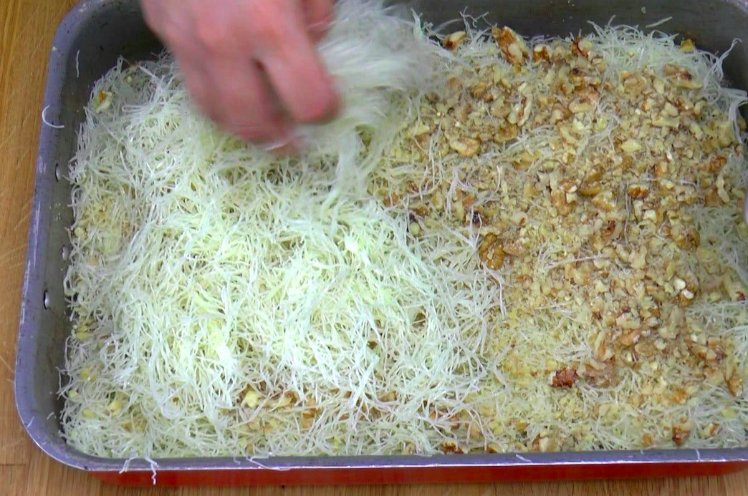

**Method:**

1. **Prepare the Syrup:**

In a saucepan, combine the water and sugar. Heat over medium heat, stirring until the sugar dissolves. Add the lemon juice or peel, and any optional flavorings like rosewater or a cinnamon stick. Bring to a gentle boil, then reduce the heat and simmer for about 10-15 minutes, until the syrup slightly thickens. Remove from heat and let it cool completely.

1. **Preheat the Oven & Prepare the Tray:**

Preheat your oven to 180°C (350°F). Brush a large baking tray with melted butter to prevent sticking.

1. **Layer the Kadaif:**

Divide the shredded kadaif pastry into two equal portions. Spread half the pastry evenly over the bottom of the baking tray, gently pressing it down. Drizzle with melted butter, ensuring the entire layer is moistened. Spread the chopped walnuts (or your chosen nuts) evenly over this layer. Cover the nuts with the remaining kadaif pastry, spreading it evenly and pressing gently. Drizzle the remaining melted butter over the top, making sure all the pastry is coated for even browning.

1. **Bake:**

Place the tray in the preheated oven and bake for about 40-50 minutes, or until the kadaif is golden brown and crisp. Rotate the tray halfway through baking for even color.

1. **Add the Syrup:**

As soon as the kadaif comes out of the oven, pour the cooled syrup evenly over the hot pastry. The sizzling sound indicates the syrup is being absorbed. Let the kadaif rest for at least 1-2 hours, or overnight if possible, to ensure the syrup fully soaks in and the flavors meld.

1. **Serve:**
2. Cut the kadaif into squares, rectangles, or diamonds, and serve on a platter. It’s perfect with Turkish coffee, tea, or even a glass of raki. Stored in an airtight container, kadaif stays fresh for several days, allowing its flavors to deepen.

**Your Adaptations:**

* Add a pinch of cinnamon or nutmeg to the nut filling for a warm spice note.
* Drizzle the finished dessert with a bit of honey for added sweetness and shine.
* Experiment with layering styles: roll the pastry with nuts for individual portions or create a single layered tray for easier preparation.

Kadaif combines culinary artistry with the joy of sharing sweet traditions. Whether prepared for a celebration or enjoyed as an everyday treat, it embodies the rich flavors and warm hospitality of Albanian and Balkan cuisine.

# Hallve. Sweet Flour-Based Confection

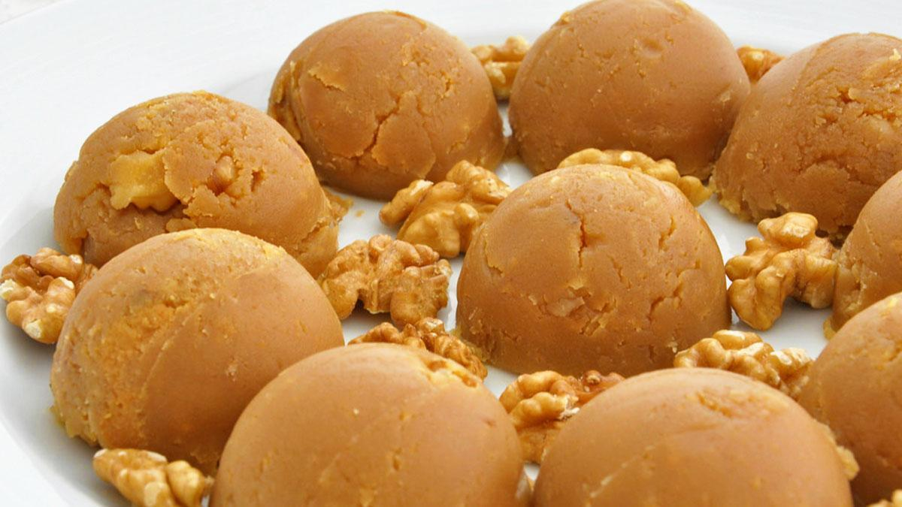

Hallve is a simple yet deeply comforting dessert found across Albania and much of the Balkans, the Middle East, and Mediterranean regions. Its origins are tied to Ottoman culinary traditions, where variations of halva (“hallve” in Albanian) were enjoyed in both humble homes and royal courts. Albanian hallve is traditionally made with flour, butter, sugar, and water, creating a rich, smooth confection. Often prepared during festive occasions, religious holidays, or even as a quick homemade treat, it holds a special place in family kitchens and Albanian food culture.

**Why It’s Beloved:**

Hallve is celebrated for its rich, nutty flavor and melt-in-your-mouth texture. Made from pantry staples, it is an affordable yet indulgent dessert that requires minimal ingredients and no oven. Its preparation often becomes a cherished family activity, especially during Ramadan or after a loved one’s passing, when it is served as a comforting communal dish. The simplicity of hallve allows its deep, roasted flavors to shine, making it both nostalgic and universally appealing.

**Ingredient Adjustments & Personal Touches:**

While the classic recipe features flour, butter, sugar, and water, you can experiment by adding nuts (like almonds or walnuts) for texture or incorporating aromatic spices such as cinnamon or cardamom. Some cooks drizzle honey over the finished hallve for added sweetness, while others use milk instead of water for extra creaminess. Adjust the sugar to your taste, and try garnishing with powdered sugar, chopped nuts, or a sprinkle of cocoa for a modern twist.

**Serves:** About 6-8

**Time:** Approximately 30-40 minutes

**Ingredients:**

* 250 g (2 cups) all-purpose flour
* 125 g (½ cup) unsalted butter
* 200 g (1 cup) sugar (adjust to taste)
* 500 ml (2 cups) water
* Optional: a pinch of cinnamon or cardamom, a handful of chopped nuts for garnish

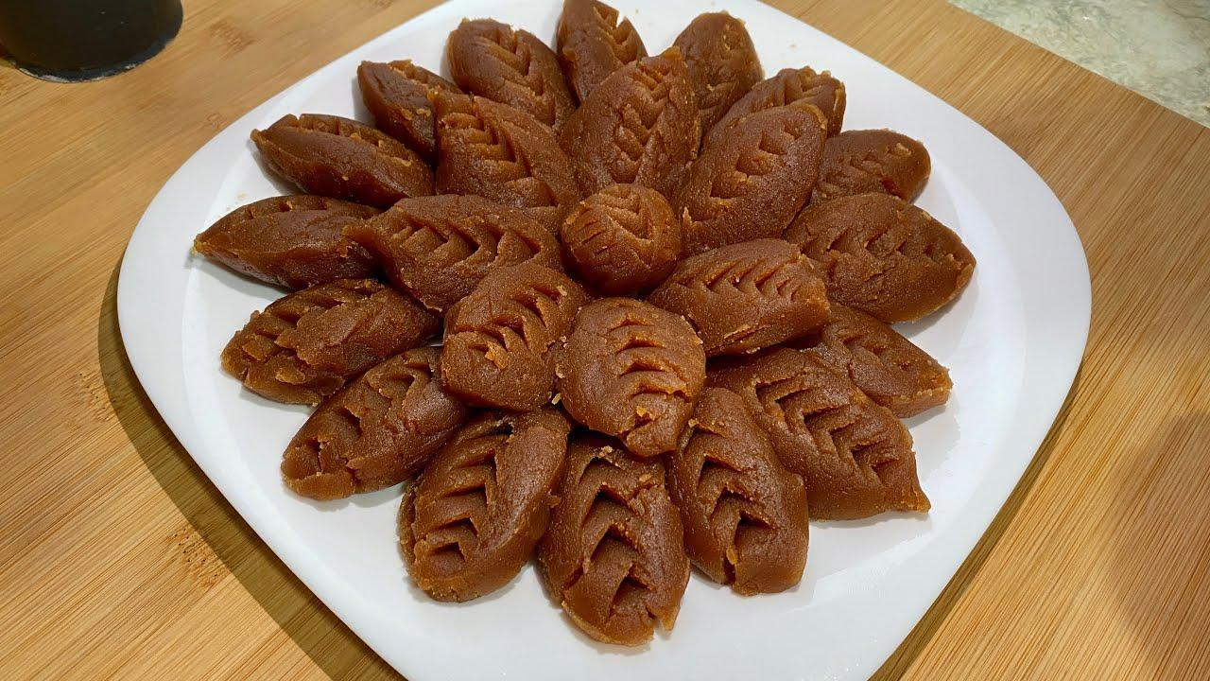

**Method:**

1. **Prepare the Syrup:**

In a saucepan, combine the water and sugar. Heat over medium heat, stirring until the sugar dissolves completely. Once the mixture reaches a gentle boil, reduce the heat to low and let it simmer for 5-10 minutes. Remove from heat and keep warm.

1. **Toast the Flour:**

In a large, heavy-bottomed pan, melt the butter over medium heat. Gradually add the flour, stirring constantly with a wooden spoon or whisk to avoid lumps. Cook the flour and butter mixture for about 15-20 minutes, stirring continuously, until the flour turns a deep golden brown and develops a nutty aroma. Take care not to let it burn.

1. **Incorporate the Syrup:**

Slowly pour the warm syrup into the toasted flour mixture, stirring constantly. Be cautious, as the mixture will bubble and steam. Continue stirring vigorously to combine the syrup evenly with the flour mixture, ensuring a smooth, lump-free consistency. Cook for another 5-7 minutes until the mixture thickens and pulls away from the sides of the pan.

1. **Shape & Serve:**

Transfer the hot hallve mixture to a greased or parchment-lined dish. Smooth the top with a spatula. Allow it to cool for about 20-30 minutes. Once set, cut it into squares, diamonds, or your preferred shape. Garnish with chopped nuts, a sprinkle of cinnamon, or powdered sugar if desired.

1. **Enjoy:**

Serve hallve at room temperature with coffee, tea, or as part of a dessert spread. Its rich, buttery flavor and soft texture make it an irresistible treat that’s perfect for sharing.

**Your Adaptations:**

* For added texture, fold in raisins or chopped nuts during the final mixing stage.
* Use milk instead of water in the syrup for a creamier version.
* Add a splash of vanilla extract or rosewater for a fragrant twist.

Hallve’s versatility ensures it remains a beloved dessert, with each family adding their own touches to this time-honored Albanian confection. Whether prepared for a special occasion or as a nostalgic treat, hallve is always a warm and welcome presence on the table.

# Shëndetli (Honey-Walnut Cake)

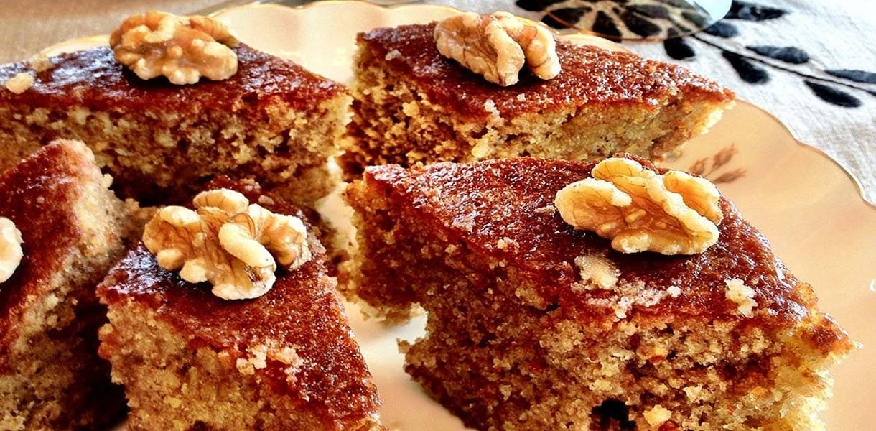

Shëndetli, meaning “healthful” in Albanian, is a traditional honey-walnut cake that exemplifies the warmth and sweetness of Albanian desserts. This dense, moist cake is steeped in syrup, creating a luscious texture that melts in your mouth. It’s often served during celebrations, holidays, or as a generous offering to guests, symbolizing hospitality and the joy of sharing. With roots in Albania’s pastoral culture, where honey and nuts were plentiful, Shëndetli reflects a history of turning simple, wholesome ingredients into something rich and indulgent.

**Why It’s Beloved:**

Shëndetli is cherished for its luxurious combination of honey’s natural sweetness and walnuts’ earthy crunch. The cake itself is rich and hearty, while the syrup adds a soft, moist consistency. Perfect for pairing with coffee or tea, it’s a dessert that brings people together, evoking memories of family meals and festive gatherings. Its name, “healthful,” hints at its nourishing ingredients, making it a timeless favorite in Albanian kitchens.

**Ingredient Adjustments & Personal Touches:**

While honey and walnuts are classic, feel free to add your own twists. Incorporate a hint of cinnamon or nutmeg into the batter for warmth, or garnish the cake with orange zest for brightness. The syrup can be infused with lemon peel, vanilla, or even a splash of brandy for added depth. For a variation in texture, try a mix of finely ground and coarsely chopped walnuts.

**Serves:** About 10-12

**Time:** Approximately 1.5-2 hours

**Ingredients (Cake):**

* 300 g (2½ cups) all-purpose flour
* 150 g (¾ cup) sugar
* 100 g (½ cup) unsalted butter, melted and slightly cooled
* 3 eggs
* 150 g (½ cup) honey
* 200 g (1½ cups) walnuts, finely chopped
* 1 tsp baking soda
* ½ tsp salt

**Ingredients (Syrup):**

* 500 ml (2 cups) water
* 400 g (2 cups) sugar
* 1-2 tbsp honey
* 1 tbsp lemon juice or a strip of lemon peel
* Optional: a splash of vanilla or orange blossom water

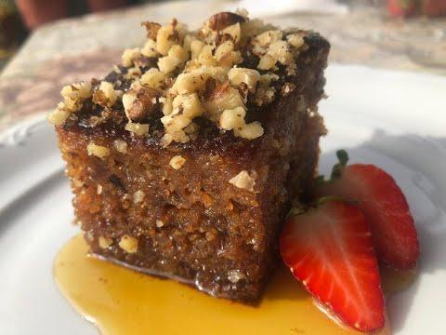

**Method:**

1. **Prepare the Syrup:**

In a saucepan, combine the water and sugar. Heat over medium heat, stirring until the sugar dissolves. Add the honey and lemon juice or peel. Simmer gently for 10-15 minutes, then remove from heat. Let the syrup cool completely.

1. **Make the Cake Batter:**

Preheat your oven to 180°C (350°F). Grease and flour a rectangular or round baking dish.

1. In a large mixing bowl, beat the eggs and sugar until pale and creamy. Stir in the melted butter and honey until well combined. In a separate bowl, sift together the flour, baking soda, and salt. Gradually add the dry ingredients to the wet mixture, stirring gently until a smooth batter forms. Fold in the chopped walnuts.
2. **Bake the Cake:**

Pour the batter into the prepared baking dish, smoothing the top with a spatula. Bake for about 30-40 minutes, or until the cake is golden brown and a toothpick inserted into the center comes out clean. Adjust baking time based on your oven and the size of your pan.

1. **Add the Syrup:**

Once the cake is baked, allow it to cool slightly, then cut it into squares, diamonds, or slices while still warm. Gradually pour the cooled syrup over the cake, ensuring it soaks evenly. Let the cake rest for at least 1-2 hours (or overnight) to absorb the syrup fully.

1. **Serve:**

Garnish with a handful of chopped walnuts, a drizzle of honey, or a sprinkle of cinnamon if desired. Serve at room temperature with coffee, tea, or a glass of raki for a traditional pairing.

**Your Adaptations:**

* Use almond flour for part of the all-purpose flour for a nutty twist.
* Incorporate a handful of raisins into the batter for added sweetness and texture.
* Experiment with syrup flavors, like cardamom, rosewater, or orange zest.

Shëndetli is more than just a dessert—it’s a slice of Albanian tradition, combining the rustic simplicity of its ingredients with the warmth of shared moments around the table.

# Ravani (Semolina Cake Soaked in Syrup)

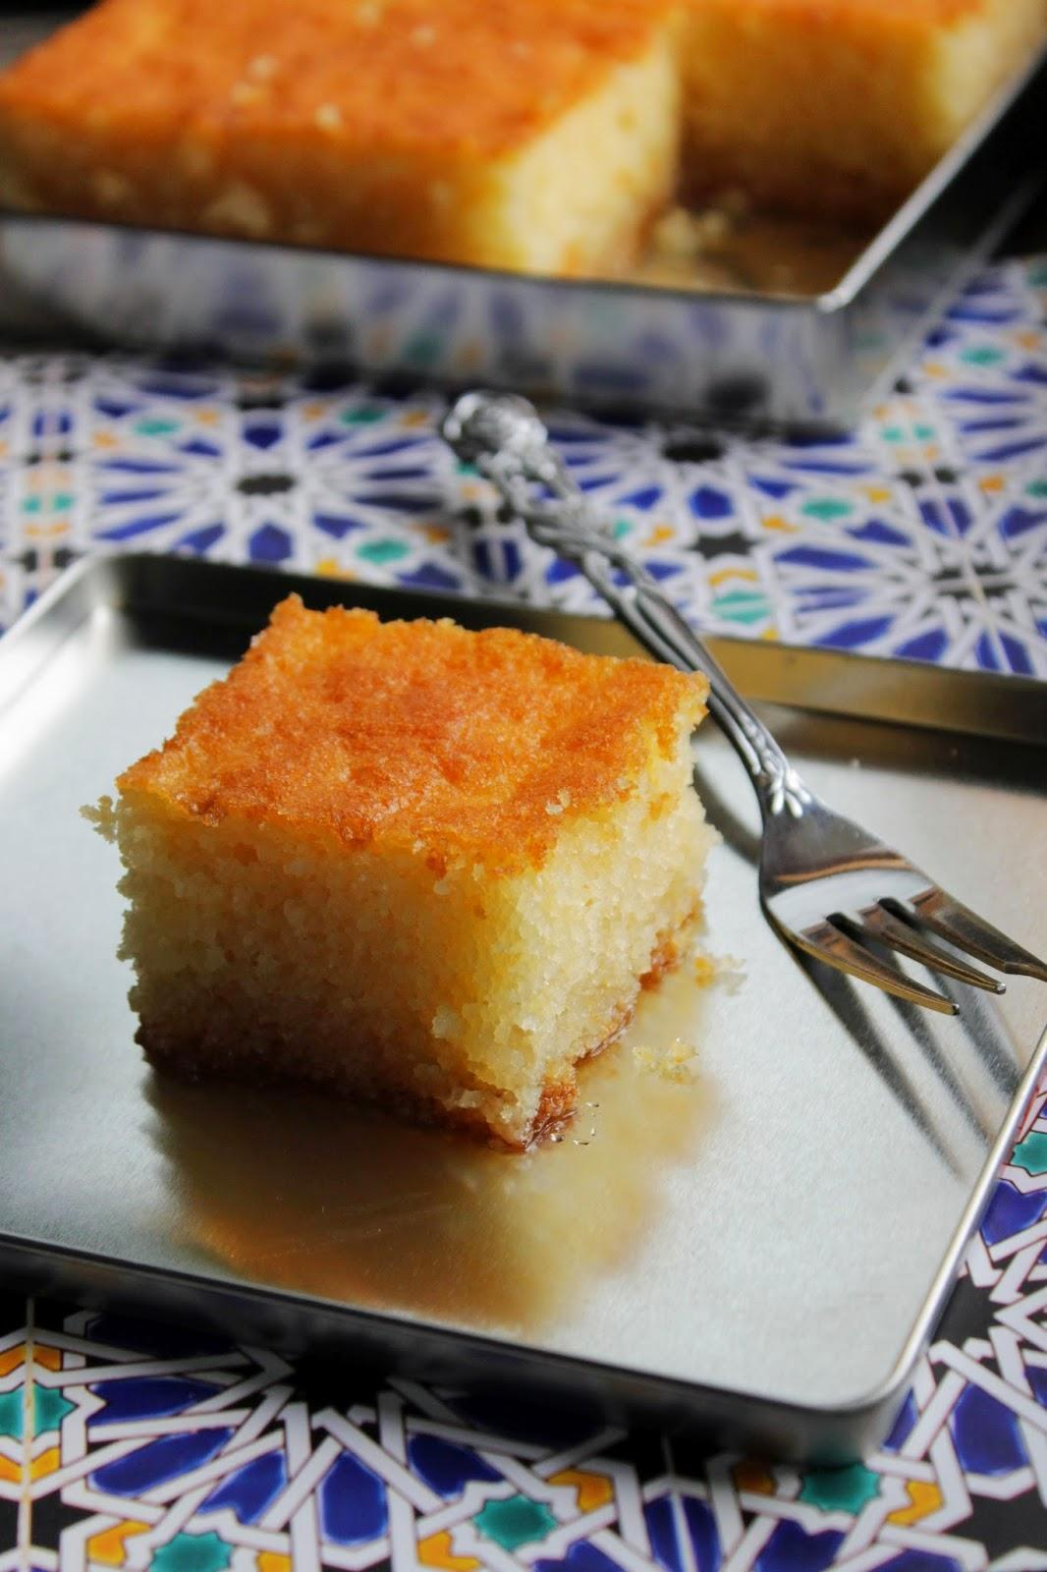

Ravani is a beloved Albanian dessert with roots in the broader Balkan and Middle Eastern culinary traditions. This semolina-based cake, soaked in fragrant syrup, is known for its tender crumb and sweet, moist texture. Ravani is a staple at celebrations, holidays, and family gatherings, symbolizing the sweetness of life and hospitality. Its simplicity, relying on basic pantry ingredients like semolina, sugar, eggs, and yogurt, reflects its humble origins while remaining an elegant treat.

**Why It’s Beloved:**

Ravani’s charm lies in its delicate balance of textures and flavors: the coarseness of semolina, the fluffiness of the cake, and the richness of syrup. Its versatility makes it suitable for festive occasions and everyday enjoyment. Whether served with coffee or as the centerpiece of a dessert spread, Ravani is a crowd-pleaser that bridges generations and cultural boundaries.

**Ingredient Adjustments & Personal Touches:**

Traditional Ravani keeps things simple, but you can add your own flair. Orange or lemon zest in the batter gives a citrusy lift, while a pinch of cinnamon or cardamom in the syrup deepens its aromatic profile. For added texture, sprinkle the top with chopped nuts or shredded coconut. The syrup can also be infused with rosewater, orange blossom water, or even a splash of brandy for a sophisticated twist.

**Serves:** About 10-12

**Time:** Approximately 1.5 hours (including baking and syrup preparation)

**Ingredients (Cake):**

* 200 g (1 cup) semolina (fine or medium)
* 100 g (½ cup) all-purpose flour
* 150 g (¾ cup) sugar
* 2 tsp baking powder
* 3 eggs (room temperature)
* 150 ml (⅔ cup) plain yogurt
* 100 ml (⅓ cup) vegetable oil or melted butter
* 1 tsp vanilla extract (optional)
* Zest of 1 lemon or orange (optional)

**Ingredients (Syrup):**

* 500 ml (2 cups) water
* 400 g (2 cups) sugar
* 1 tbsp lemon juice or a strip of lemon peel
* Optional: 1 tbsp orange blossom water or rosewater for flavor

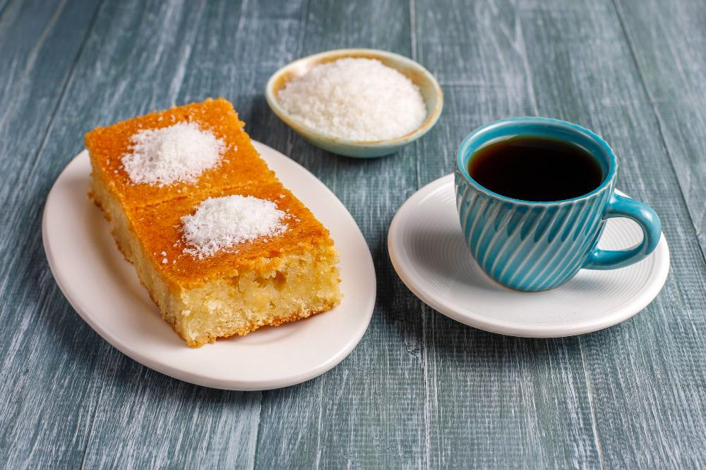

**Method:**

1. **Prepare the Syrup:**

In a saucepan, combine the water, sugar, and lemon juice or peel. Heat over medium heat, stirring until the sugar dissolves. Bring to a gentle boil, then reduce the heat and simmer for about 10 minutes until slightly thickened. If using rosewater or orange blossom water, stir it in after removing the syrup from the heat. Allow the syrup to cool completely.

1. **Preheat the Oven & Prepare the Pan:**

Preheat your oven to 180°C (350°F). Grease a rectangular or round baking dish and dust it lightly with semolina or flour to prevent sticking.

1. **Make the Cake Batter:**

In a mixing bowl, whisk together the eggs and sugar until pale and frothy. Stir in the yogurt, oil or melted butter, and vanilla extract (if using). In a separate bowl, mix the semolina, flour, baking powder, and zest (if using). Gradually fold the dry ingredients into the wet mixture, stirring gently until a smooth batter forms.

1. **Bake the Cake:**

Pour the batter into the prepared baking dish, smoothing the top with a spatula. Bake for about 30-40 minutes, or until the cake is golden brown and a toothpick inserted into the center comes out clean.

1. **Add the Syrup:**

Once the cake is baked, allow it to cool for about 5 minutes. Cut the cake into diamond or square shapes while still warm. Gradually pour the cooled syrup over the cake, ensuring it soaks evenly. Let the cake rest for at least 1-2 hours (or overnight) to absorb the syrup fully.

1. **Serve:**

Garnish with a sprinkle of chopped nuts, shredded coconut, or a dusting of powdered sugar. Serve at room temperature, paired with tea or coffee. Ravani also pairs beautifully with a dollop of whipped cream or a scoop of ice cream for a more indulgent dessert.

**Your Adaptations:**

* Add a layer of finely chopped pistachios or almonds on top before baking for added texture and flavor.
* Replace part of the water in the syrup with orange juice for a citrusy twist.
* Use whole wheat semolina for a nuttier, more rustic texture.

Ravani is more than a dessert—it’s a symbol of shared joy, bringing loved ones together with its rich flavors and timeless appeal.

# Hasude me Arra (Starch Pudding with Walnuts)

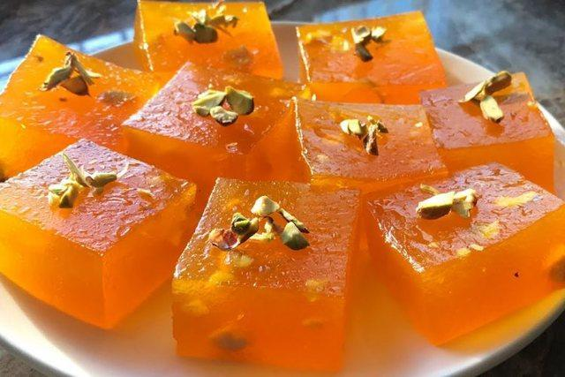

Hasude is a simple yet cherished dessert in Albanian cuisine, rooted in the country’s tradition of transforming humble ingredients into comforting sweets. This sweet pudding, thickened with starch and sweetened with sugar, is reminiscent of Ottoman-influenced dishes found across the Balkans and the Middle East. The addition of walnuts (arra) adds texture and richness, making it a versatile treat for celebrations, special occasions, or a quick homemade dessert. Its simplicity and ease of preparation have ensured its lasting popularity among families.

**Why It’s Beloved:**

Hasude me arra combines silky smooth pudding with the crunch and earthy flavor of walnuts, resulting in a delightful contrast of textures. The dessert’s straightforward preparation and pantry-friendly ingredients make it accessible, while its sweetness and nutty undertones give it an indulgent edge. Served warm or at room temperature, it’s a nostalgic favorite that evokes the warmth of Albanian hospitality.

**Ingredient Adjustments & Personal Touches:**

While the traditional recipe includes only a few ingredients, you can enhance the flavor with a splash of vanilla, a pinch of cinnamon, or even a drizzle of honey. The walnuts can be toasted for a deeper flavor or replaced with almonds or pistachios for variation. For a more decadent version, top the pudding with a dollop of cream or a sprinkle of grated chocolate.

**Serves:** About 4-6

**Time:** Approximately 30-40 minutes

**Ingredients:**

* 100 g (½ cup) cornstarch or wheat starch
* 1 L (4 cups) water or milk (for a creamier version)
* 200-250 g (1-1¼ cups) sugar (adjust to taste)
* 100 g (1 cup) walnuts, coarsely chopped
* 2 tbsp butter (optional, for richness)
* Optional: 1 tsp vanilla extract, a pinch of cinnamon, or a drizzle of honey

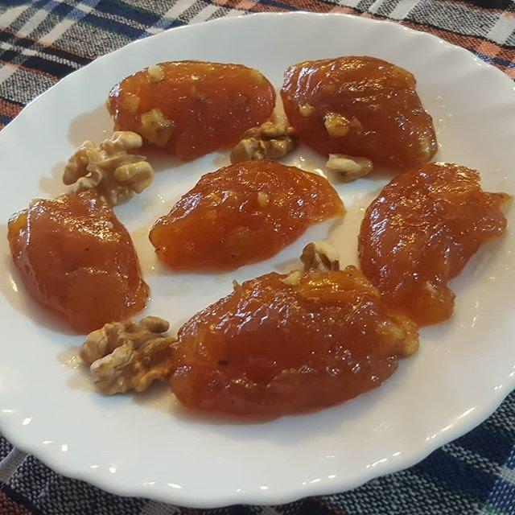

**Method:**

1. **Prepare the Starch Mixture:**

In a bowl, dissolve the cornstarch in 1 cup of water or milk, ensuring there are no lumps. Set it aside.

1. **Cook the Base:**

In a saucepan, combine the remaining water or milk and sugar. Heat over medium heat, stirring until the sugar dissolves. If using butter, add it now for a richer flavor. Once the mixture is warm, stir in the dissolved cornstarch.

1. **Thicken the Pudding:**

Continue cooking over medium heat, stirring constantly to prevent lumps. The mixture will gradually thicken and turn glossy. Once it reaches a pudding-like consistency and coats the back of a spoon, remove it from the heat.

1. **Incorporate the Walnuts:**

Stir in most of the chopped walnuts, reserving some for garnish. If you’re adding vanilla or cinnamon, stir it in at this stage for a burst of flavor.

1. **Set & Cool:**

Pour the pudding into individual serving bowls or a single dish. Smooth the surface with a spatula. Allow it to cool for a few minutes before garnishing with the remaining walnuts. For a decorative touch, drizzle honey or sprinkle cinnamon on top.

1. **Serve:**

Serve the hasude warm or at room temperature. It pairs beautifully with coffee or tea, making it a comforting end to any meal. The pudding can be stored in the refrigerator for up to 2 days, though it’s best enjoyed fresh.

**Your Adaptations:**

* Replace part of the water or milk with cream for a richer texture.
* Add a layer of crushed walnuts or biscuits at the bottom of the serving dish for added crunch.
* Experiment with different nut varieties or top with dried fruit for a unique twist.

**Hasude me arra** is a testament to Albanian culinary ingenuity—simple, satisfying, and rich in tradition, offering a taste of home and the sweetness of shared moments.

# Lokum (Turkish Delight)

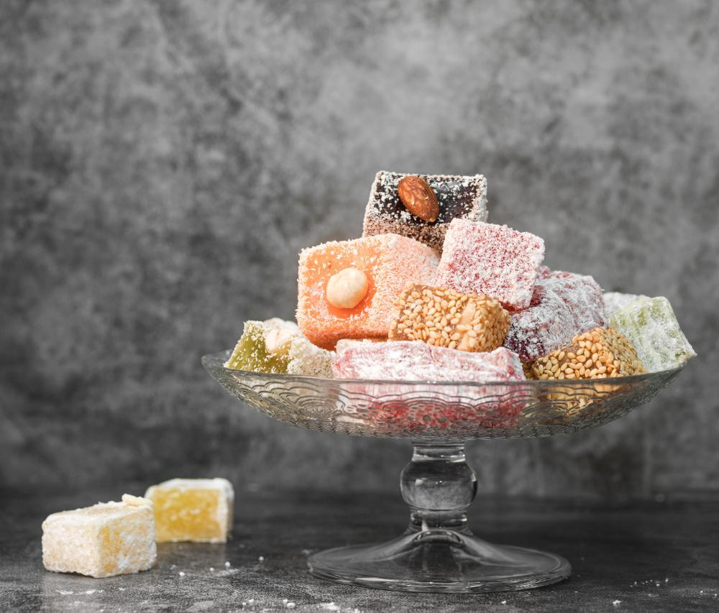

Llokum, known globally as Turkish Delight, is a confection with centuries-old roots, originating in the Ottoman Empire. This soft, chewy sweet became a symbol of refined hospitality and indulgence, often served with coffee or tea. In Albania, lokum has been embraced as a traditional treat, offered during celebrations, holidays, and to guests as a gesture of welcome. Its versatility in flavor and simplicity in preparation have made it a timeless favorite.

**Why It’s Beloved:**

Lokum’s delicate texture and subtle sweetness make it a treat that’s as elegant as it is satisfying. Whether flavored with rosewater, lemon, or pistachios, it offers a sensory experience—soft, fragrant, and slightly chewy. Its simplicity and adaptability mean that everyone can find a favorite variation, while its preparation can become a cherished family tradition.

**Ingredient Adjustments & Personal Touches:**

Traditionally flavored with rosewater, lokum can be adapted to include lemon, orange blossom water, vanilla, or even cinnamon. Nuts like pistachios, hazelnuts, or walnuts can be incorporated for texture. For a modern twist, consider dusting the pieces with cocoa powder or shredded coconut instead of the classic powdered sugar and cornstarch.

**Makes:** About 50 small pieces

**Time:** Approximately 2-3 hours (including setting time)

**Ingredients:**

* 400 g (2 cups) sugar
* 300 ml (1¼ cups) water
* 50 g (½ cup) cornstarch
* 1 tsp cream of tartar (optional, for better stability)
* 1 tsp rosewater or other flavoring (lemon, orange blossom water, or vanilla)
* A few drops of food coloring (optional)
* 50 g (½ cup) chopped nuts (optional, like pistachios or hazelnuts)
* For dusting:
* 2 tbsp powdered sugar
* 2 tbsp cornstarch

**Method:**

1. **Prepare the Pan:**

Grease a square or rectangular baking dish (about 8x8 inches) with a thin layer of oil. Line it with parchment paper and lightly oil the paper as well. This prevents sticking and ensures easy removal.

1. **Cook the Syrup:**

In a medium saucepan, combine the sugar and half the water (150 ml). Stir over medium heat until the sugar dissolves. Bring to a boil without stirring, and let it simmer until it reaches 115°C (240°F) on a candy thermometer (soft-ball stage). Remove from heat and set aside.

1. **Make the Starch Paste:**

In another saucepan, whisk the cornstarch, cream of tartar (if using), and the remaining 150 ml water until smooth. Heat the mixture over medium heat, stirring constantly, until it thickens and turns glossy, resembling a paste.

1. **Combine Syrup and Starch:**

Slowly pour the hot sugar syrup into the starch paste in a thin stream, whisking continuously to avoid lumps. Once combined, continue to cook over low heat, stirring constantly, for about 45-60 minutes. The mixture will become thick, glossy, and slightly golden.

1. **Flavor and Color:**

Stir in the rosewater or your chosen flavoring, along with a few drops of food coloring if desired. If using nuts, fold them into the mixture at this stage.

1. **Set the Lokum:**

Pour the hot mixture into the prepared pan, spreading it evenly with a spatula. Allow it to cool to room temperature, then cover and let it set for at least 4-6 hours or overnight.

1. **Cut and Dust:**

Combine the powdered sugar and cornstarch in a small bowl. Dust a clean surface with this mixture, then turn the lokum out of the pan. Peel off the parchment paper and dust the top. Using a sharp knife coated in the sugar-cornstarch mix, cut the lokum into small squares or rectangles. Toss each piece in the sugar-cornstarch mixture to coat completely.

1. **Serve and Store:**

Arrange the lokum on a plate or in an airtight container lined with wax paper. It will keep at room temperature for up to 2 weeks.

**Your Adaptations:**

* Add chopped dried fruits like apricots or figs for extra flavor and texture.
* Try layering different flavors (e.g., lemon and orange) for a two-tone effect.
* Coat the lokum in shredded coconut or finely chopped nuts instead of powdered sugar for a modern touch.

Llokum is more than a sweet treat—it’s a connection to Albania’s rich culinary traditions and the warmth of sharing delightful moments with loved ones.

# Walnut Preserve (Gliko arrë)

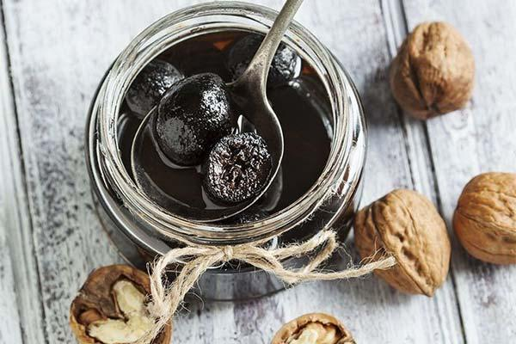

Gliko arrë is a traditional Albanian preserve made from young, green walnuts, beloved for its unique, slightly bitter-sweet flavor and aromatic syrup. This delicacy is part of Albania’s rich tradition of “gliko”—fruit preserves often served as a gesture of hospitality with coffee or water. Preparing gliko arrë requires skill and patience, as the walnuts must be carefully peeled and soaked to remove bitterness while preserving their tender interior. It’s a labor of love, passed down through generations, and is often made in late spring or early summer when green walnuts are in season.

**Why It’s Beloved:**

Gliko arrë captures the essence of seasonal abundance, transforming raw, unripe walnuts into a sweet, flavorful preserve that’s enjoyed year-round. The balance of the syrup’s sweetness with the walnuts’ unique texture and subtle bitterness creates a truly distinctive treat. Its luxurious, glossy appearance and complex flavor make it a favorite for special occasions, adding a touch of elegance to any table.

**Ingredient Adjustments & Personal Touches:**

Traditionally flavored with cloves, cinnamon, or lemon juice, the preserve can be customized with additional spices like vanilla or a splash of rosewater. Some recipes incorporate small amounts of brandy or rum into the syrup for depth. Adjust the sweetness of the syrup to your preference or include whole almonds or other nuts for variety.

**Makes:** About 4-5 small jars

**Time:** 3-4 days (including soaking and preparation)

**Ingredients:**

* 50-60 young green walnuts (about 1-1.5 kg)
* 1 kg (5 cups) sugar
* 1 L (4 cups) water
* Juice of 1 lemon
* Optional flavorings: 2-3 whole cloves, 1 cinnamon stick, or a splash of vanilla/rosewater

**Method:**

1. **Prepare the Walnuts:**

Select young green walnuts that can be pierced easily with a toothpick. Wear gloves to avoid staining your hands, as the walnuts release a dark liquid. Peel the outer green skin from the walnuts, revealing the tender inner nut. Pierce each walnut with a fork or skewer to allow the syrup to penetrate.

1. **Soak the Walnuts:**

Place the peeled walnuts in a large bowl of cold water. Soak for 5-7 days, changing the water twice daily. This process removes bitterness and excess tannins, leaving the walnuts tender and mild.

1. **Parboil the Walnuts:**

After soaking, rinse the walnuts thoroughly. Bring a large pot of water to a boil and add the walnuts. Parboil for 10-15 minutes, then drain and rinse under cold water. Repeat this process once more to further soften the walnuts and remove any remaining bitterness.

1. **Prepare the Syrup:**

In a large pot, combine the sugar, water, and lemon juice. Bring to a boil over medium heat, stirring until the sugar dissolves. If using cloves or cinnamon, add them now. Simmer the syrup for 10 minutes, then carefully add the prepared walnuts.

1. **Cook the Preserve:**

Simmer the walnuts in the syrup for 1-2 hours, or until they are tender and the syrup thickens to a glossy consistency. To test the syrup, place a drop on a cold plate—it should hold its shape without spreading too thinly. Remove from heat and let the preserve cool in the pot for several hours or overnight to allow the flavors to meld.

1. **Jar and Store:**

Remove the cloves and cinnamon (if used). Transfer the walnut preserve to sterilized jars, ensuring the walnuts are fully submerged in syrup. Seal tightly and store in a cool, dark place. Once opened, refrigerate and consume within a few weeks.

1. **Serve:**

Serve gliko arrë as a sweet treat alongside coffee, tea, or a glass of cold water. It can also be used as a topping for ice cream, yogurt, or pancakes, adding a luxurious touch to desserts.

**Your Adaptations:**

* Add a splash of brandy or rum to the syrup during the last few minutes of cooking for an adult twist.
* Try incorporating thin slices of orange or lemon peel for a citrusy note.
* Reduce the sugar slightly for a less sweet preserve, keeping the syrup’s balance intact.

Gliko arrë is a shining example of Albanian culinary artistry, turning nature’s raw bounty into a sophisticated and cherished delicacy.

# Cherry Preserve (Gliko qershie)

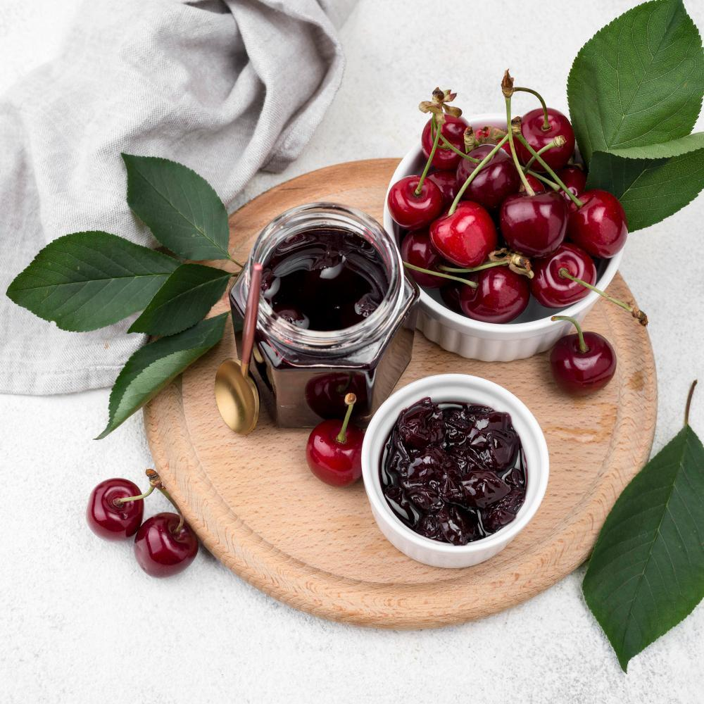

Gliko qershie is one of the most beloved Albanian fruit preserves, a part of the broader “gliko” tradition that includes a variety of fruits preserved in syrup. Cherry preserve showcases the rich, sweet-tart flavor of cherries at their peak ripeness, transforming them into a glossy, syrupy treat. Traditionally served as a gesture of hospitality with a glass of cold water or alongside coffee, it’s a staple in Albanian households and a testament to the country’s appreciation for seasonal fruits and artisanal preparation.

**Why It’s Beloved:**

The vivid color, luscious syrup, and vibrant flavor of gliko qershie make it a feast for the senses. Unlike jam, the cherries remain whole, creating a beautiful texture and presentation. Its versatility allows it to shine as a standalone sweet treat, a topping for desserts like yogurt or ice cream, or a filling for baked goods. For many, it evokes memories of family kitchens, summer harvests, and the joy of preserving nature’s bounty.

**Ingredient Adjustments & Personal Touches:**

Classic gliko qershie features cherries, sugar, and lemon juice, but you can customize the recipe with a hint of vanilla, a splash of brandy, or even a cinnamon stick for a subtle twist. Sweet or sour cherries can be used, depending on availability and taste preferences.

**Makes:** About 4-5 small jars

**Time:** Approximately 1.5 hours (plus cooling)

**Ingredients:**

* 1 kg (2.2 lbs) fresh cherries, pitted
* 800 g (4 cups) sugar (adjust based on sweetness of cherries)
* 1 lemon, juiced
* Optional: 1 cinnamon stick, 1 tsp vanilla extract, or a splash of brandy

**Method:**

1. **Prepare the Cherries:**

Rinse the cherries thoroughly, remove their stems, and pit them using a cherry pitter or a small knife. Be careful to keep the cherries as whole as possible for a beautiful final presentation.

1. **Combine with Sugar:**

In a large bowl or pot, layer the cherries and sugar. Let them sit for at least 1-2 hours (or overnight in the refrigerator) to allow the sugar to draw out the cherries’ natural juices.

1. **Cook the Preserve:**

Place the cherries and their juices in a large, heavy-bottomed pot. Add the lemon juice and any optional flavorings (like a cinnamon stick or vanilla). Heat over medium heat, stirring gently, until the sugar dissolves and the mixture begins to boil.

1. **Simmer:**

Reduce the heat to low and simmer the cherries for about 30-40 minutes, skimming off any foam that forms on the surface. Stir occasionally, being careful not to break the cherries. The syrup will thicken as the cherries cook.

1. **Test for Consistency:**

To check if the syrup is ready, place a drop on a cold plate—it should hold its shape and not spread too thinly. If the syrup is still too thin, continue simmering and test again after a few minutes.

1. **Cool & Jar:**

Once the preserve is ready, remove it from the heat and let it cool slightly. Remove any optional cinnamon stick or other flavorings. Carefully spoon the cherries and syrup into sterilized jars, ensuring the cherries are fully submerged. Seal tightly.

1. **Store & Serve:**

Store the jars in a cool, dark place. Once opened, refrigerate and consume within a few weeks. Serve gliko qershie as a sweet treat with coffee or tea, spooned over yogurt or ice cream, or as a topping for pancakes or waffles.

**Your Adaptations:**

* Add a few slices of orange or lemon peel during cooking for a citrusy twist.
* Use a mix of sweet and sour cherries for a more complex flavor.
* Stir in a splash of brandy or amaretto for an adult-friendly variation.

Gliko qershie is more than just a preserve—it’s a way to celebrate summer cherries and the joy of sharing sweet traditions with loved ones.

# Fig Preserve (Gliko Fiku) – Korça Style

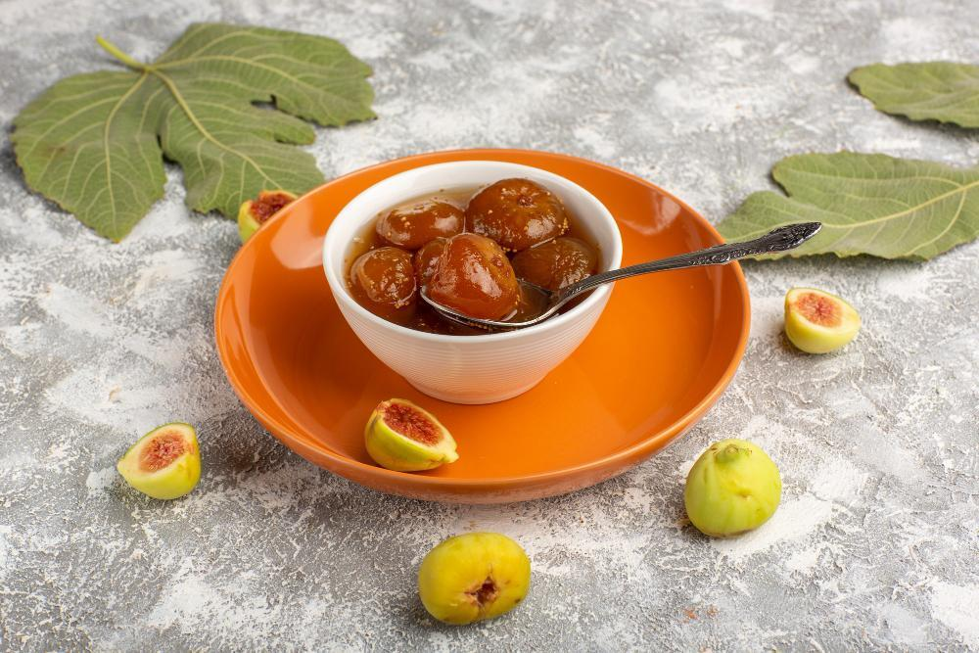

Gliko fiku, a fig preserve, is a hallmark of Korça’s culinary tradition. This region of southeastern Albania is renowned for its abundant fig trees, and the preserve reflects the area’s agricultural richness and artisanal heritage. Gliko fiku is a treasured delicacy, often prepared in late summer when figs are at their ripest and most flavorful. Its preparation is a labor of love, requiring care to keep the figs whole and achieve the perfect syrupy consistency. Traditionally served with a glass of cold water or alongside coffee, it symbolizes Albanian hospitality and the preservation of seasonal bounty.

**Why It’s Beloved:**

The soft, plump figs in a luscious, glossy syrup are as visually appealing as they are delicious. The natural sweetness of figs is enhanced by the syrup, creating a rich, honey-like flavor. The Korça-style preparation often includes hints of vanilla or lemon, elevating the preserve’s aroma. Gliko fiku is versatile, enjoyed on its own or as a topping for desserts like yogurt, pancakes, or ice cream.

**Ingredient Adjustments & Personal Touches:**

While the classic Korça-style preserve includes lemon juice for balance, you can add spices like cinnamon or cloves for warmth. A splash of brandy or orange blossom water can bring a sophisticated twist. Whether made with green or ripe figs, this preserve can be adjusted to suit your preferences.

**Makes:** About 4-5 small jars

**Time:** 1.5-2 hours (plus cooling time)

**Ingredients:**

* 1 kg (2.2 lbs) small, firm figs (green or ripe, but not overripe)
* 800 g (4 cups) sugar
* 1 L (4 cups) water
* Juice of 1 lemon
* Optional: 1 vanilla bean or 1 tsp vanilla extract, 1 cinnamon stick, or a splash of orange blossom water

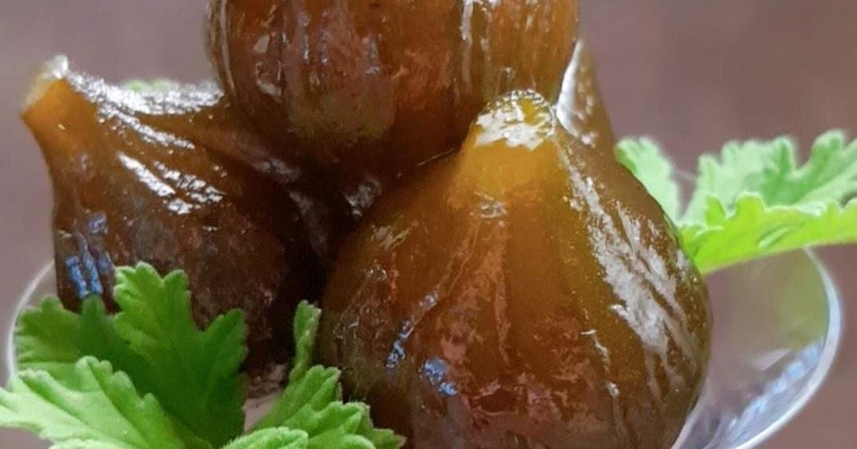

**Method:**

1. **Prepare the Figs:**

Rinse the figs gently under cold water to avoid bruising. Trim the stems slightly but leave enough for the figs to hold their shape. Using a toothpick, prick each fig a few times to help the syrup penetrate.

1. **Parboil the Figs:**

Bring a large pot of water to a boil. Add the figs and boil for 3-5 minutes. Drain and rinse them under cold water. Repeat this process once more to soften the figs and reduce their bitterness.

1. **Prepare the Syrup:**

In a large, heavy-bottomed pot, combine the sugar, water, and lemon juice. If using vanilla or cinnamon, add it now. Heat over medium heat, stirring until the sugar dissolves. Bring the mixture to a gentle boil.

1. **Cook the Figs:**

Add the prepared figs to the syrup. Reduce the heat to low and simmer for about 30-45 minutes, occasionally stirring gently to avoid breaking the figs. Skim off any foam that forms on the surface. The syrup will thicken and take on a glossy appearance.

1. **Check the Syrup:**

To test the syrup, place a drop on a cold plate. It should hold its shape and not spread too thinly. If it’s too thin, continue cooking and test again after a few minutes. Remove the cinnamon stick or vanilla bean if used.

1. **Cool & Jar:**

Let the preserve cool slightly. Carefully spoon the figs and syrup into sterilized jars, ensuring the figs are fully submerged. Seal tightly.

1. **Store & Serve:**

Store the jars in a cool, dark place. Once opened, refrigerate and consume within a few weeks. Serve gliko fiku as a sweet treat with coffee, tea, or a glass of cold water. It’s also perfect as a topping for desserts or paired with cheeses for a sophisticated platter.

**Your Adaptations:**

* Use green figs for a firmer texture or ripe figs for a sweeter, softer preserve.
* Infuse the syrup with spices like cloves or star anise for added depth.
* Add a handful of chopped walnuts to the syrup before jarring for a nutty variation.

Gliko fiku from Korça is more than a preserve—it’s a taste of Albanian tradition, celebrating the flavors of late summer and the art of preserving nature’s treasures.

# Violets/Rose Preserve (Gliko Manushaqe / Trendafili)

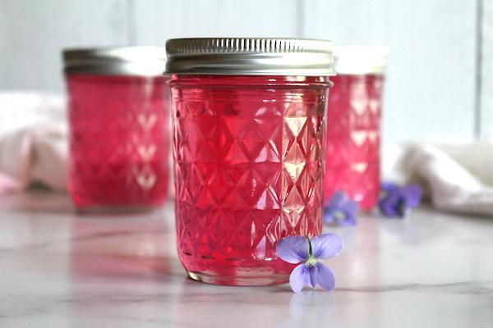

Gliko manushaqe, a unique and delicate preserve made from violet flowers, exemplifies the artistry of Albanian “gliko” traditions. This rare and aromatic preserve has its roots in the rural countryside, where violets bloom in abundance during spring. Historically, it was a prized treat, often reserved for special occasions or as an offering to esteemed guests. Its preparation requires meticulous care, as the flowers are delicate and must be handled gently to retain their vibrant color and fragrance.

**Why It’s Beloved:**

The preserve captures the enchanting aroma and flavor of violets in a sweet, glossy syrup, creating a dessert that is both visually stunning and delightfully fragrant. Gliko manushaqe is cherished for its novelty and elegance, symbolizing the fleeting beauty of spring. It is often served with coffee or tea, spooned over yogurt, or simply enjoyed on its own as a luxurious treat.

**Ingredient Adjustments & Personal Touches:**

While the classic recipe uses only violets, sugar, and lemon juice, you can enhance the syrup with a hint of vanilla or orange blossom water. Some versions include a splash of rosewater for additional floral complexity. Adjust the sweetness of the syrup to your taste, and consider using organic violets to ensure the flowers are free from pesticides.

**Makes:** About 2-3 small jars

**Time:** Approximately 1 hour (plus time for flower preparation)

**Ingredients:**

* 200 g (about 2 cups) fresh violet flowers, or rose petals, gently rinsed and dried
* 500 g (2½ cups) sugar
* 500 ml (2 cups) water
* Juice of 1 lemon
* Optional: 1 tsp vanilla extract or a splash of rosewater/orange blossom water

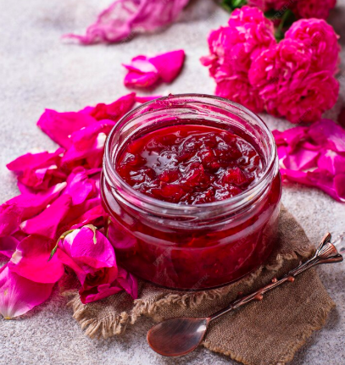

**Method:**

1. **Prepare the Violets/Rose:**
2. Gently rinse the violet/rose flowers in cold water to remove any dirt or insects. Spread them out on a clean kitchen towel and let them air dry. Trim any stems or green parts, keeping only the petals and purple parts of the flower.
3. **Prepare the Syrup:**
4. In a large saucepan, combine the sugar, water, and lemon juice. Heat over medium heat, stirring until the sugar dissolves completely. Bring the mixture to a gentle boil, then reduce the heat and let it simmer for about 10-15 minutes, or until slightly thickened.
5. **Add the Violets:**
6. Carefully add the prepared violet flowers to the syrup. Stir gently to ensure the flowers are evenly distributed. Simmer for another 5-10 minutes, allowing the flowers to infuse the syrup with their color and fragrance. If using vanilla, rosewater, or orange blossom water, add it during the last few minutes of cooking.
7. **Check the Consistency:**
8. To test the syrup, place a drop on a cold plate. It should hold its shape and not spread too thinly. If the syrup is too thin, simmer for a few more minutes and test again.
9. **Cool & Jar:**
10. Remove the pot from heat and let the preserve cool slightly. Carefully spoon the flowers and syrup into sterilized jars, ensuring the flowers are evenly distributed and fully submerged. Seal tightly.
11. **Store & Serve:**
12. Store the jars in a cool, dark place. Once opened, refrigerate and consume within a few weeks. Serve gliko manushaqe as a sweet treat with coffee or tea, drizzle it over yogurt or desserts, or enjoy it as a beautiful topping for cakes and pastries.

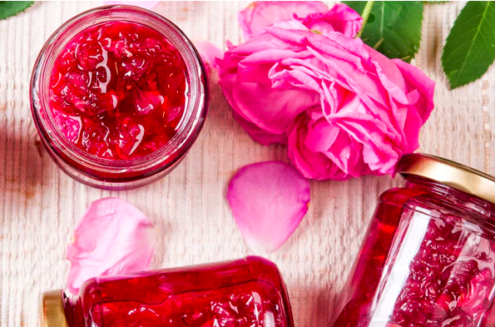

**Your Adaptations:**

* Add a few edible pansies or lavender flowers for a mixed floral preserve.
* Use a small piece of orange peel in the syrup for a hint of citrus.
* Reduce the sugar slightly for a less sweet preserve while maintaining the balance with lemon juice.

Gliko manushaqe is a testament to the beauty of Albanian culinary traditions, preserving the fleeting fragrance of violets in a way that delights the senses and honors the arrival of spring